JavaJam Description (taken from the text p.66)
Julio Perez, owner of the JavaJam Coffee House, has opened his cafe to sell food and drinks, however recently, local folk musicians and those of a young age have been visiting the shop, in which Perez wishes to create a website that will attract more customers and welcome more venues for entertainment. In order to make his dream a reality, Julio Perez has requested that programmers create a website promoting JavaJam that includes a home page and a menu page that addresses entertaining events and employment through the JavaJam location.

Circle each HTML, CSS code fragment and each web page screenshot in red with the number corresponding to the specification number of the Case Study task. For example Task 2 p.68 item 4c should be described T2-4c.

Below is a fragment of index.html with circle textbook references (not all references are shown in the example), see page p.68 Task 2 item 4 of the textbook:
<!--*******************************************************************
Name: Christopher Smith
Class: CMPS 218, section 002
Assignment #: Ch2P, Ch2: Case Study: JavaJam Coffee House
Date Due: 9/18/XX
Problem: Create web pages for the JavaJam Coffee according to the description on p.66-70
*************************************************************-->
c
T2-4a
<h2>Relax at JavaJam</h2>
<ul>
<li>Speciality Coffe and Tea</li>
T2-4b
<li>Bagels, Muffins, and Gluten free Pastries</li>
<li>Organic Salads</li>
<li>Music and Poetry Readings</li>
<li>Open Mic Night</li>
</ul>

<p>12010 Garret bay Road</p><p>Ellison Bay, WI 54210</p> T2-4c
<p>888-555-5555</p>
</div>
</main>
<footer>
Copyright &copy; 2018 JavaJam Coffee House
<a href="mailto:Christopher@Smith.com">contact@ChristopherBanando</a>
</footer>
</body>
</html>
</footer>
</html>
The webpage: index.html should have corresponding references as well:
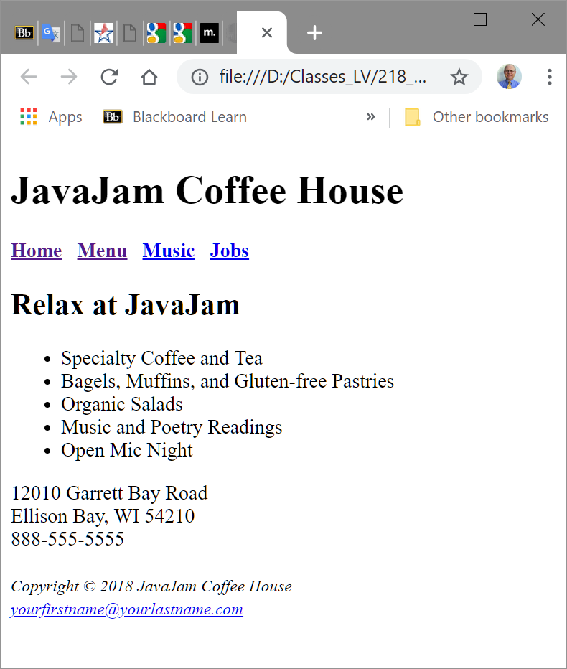
T2-4c
T2-4b
T2-4a
c
