Go to FileZilla at https://filezilla-project.org/ click on all platforms button and install it.
- Click on File => Site Manager => New site
- Fill out the following:
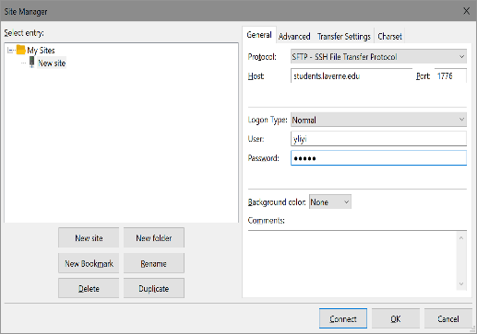
- You may save password
- Click OK => OK
- If something goes wrong: click File => Site Manager and correct entries
- If everything is OK you should get the layout similar to the one below:
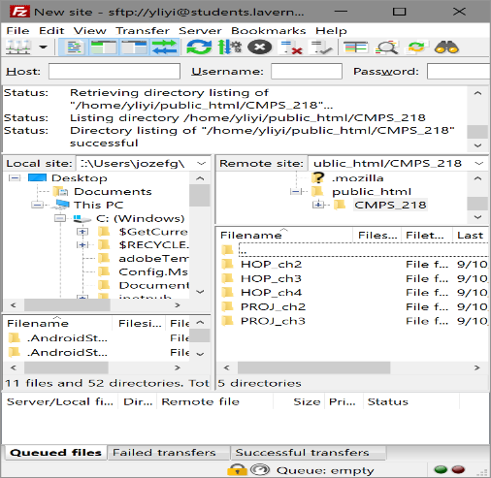
- Now you should follow 14 and so on of 1_WinSCP-install+app-setup+dir-setup.docx.

