- Notepad++ Editor. Use Notepad++ (or Dreamweaver if you have) to all next HOPs and projects. Download Notepad++ from https://notepad-plus-plus.org/downloads/ by clicking the latest release button, then DOWNLOAD button for 32 bit x86. While you get the file on your computer click it on follow the instructions. You can download from my class website as well.

- Activate all extensions for all files in order to see all extensions (such as .html, .css) in your windows directories (it applies to all windows operating systems):

- Select the search icon (next to your Start button at the left bottom of your window) => type Control Panel => File Explorer Options =>View tab => under settings section: “Files and Folder”
  - Uncheck “Don’t show hidden files, folders, or drives”,
  - Uncheck “Hide extension for known file types”,
  - Check “Show hidden files, folders and drives”.

- Detail view for each file and directory of each folder (it applies to all windows operating systems):
First select any directory from Explorer=>select right panel of the directories and files but right click outside of any directories and files =>view=>details

- My straight forward solution – helper for HOP 2.1:
right click on the desktop => New => Text Document => click on “New Text Document.txt” => change name to index.html => the pop up window ask you “Are you sure to change it?” => Yes => open Notepad++ (it can be available if you right click on index.html or search for Notepad++) => type Your First Web Page on p. 30 of your textbook as you see below
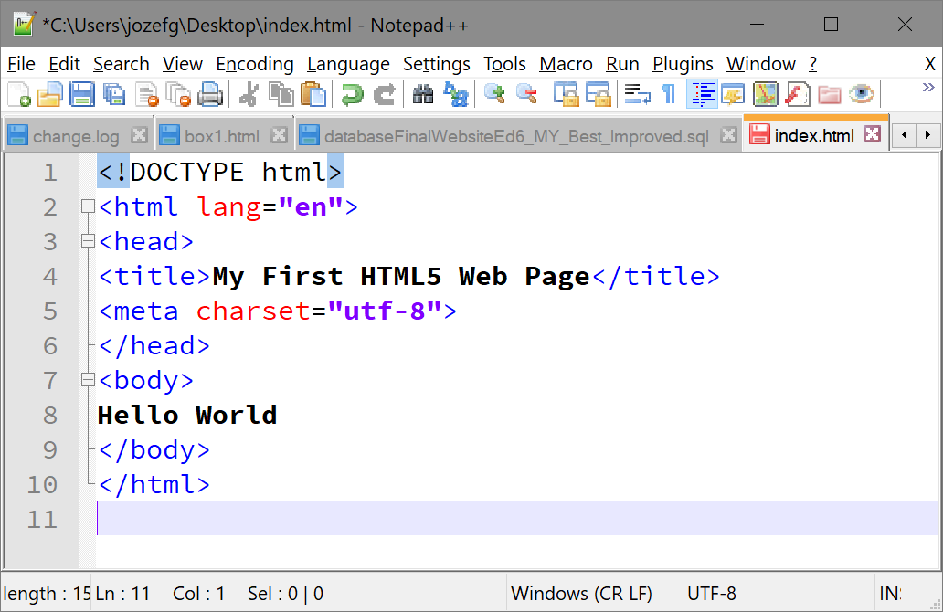

- Select File then Save or just <Ctrl> + S => in order to run your 1st web page double click on index.html and the result is shown below:
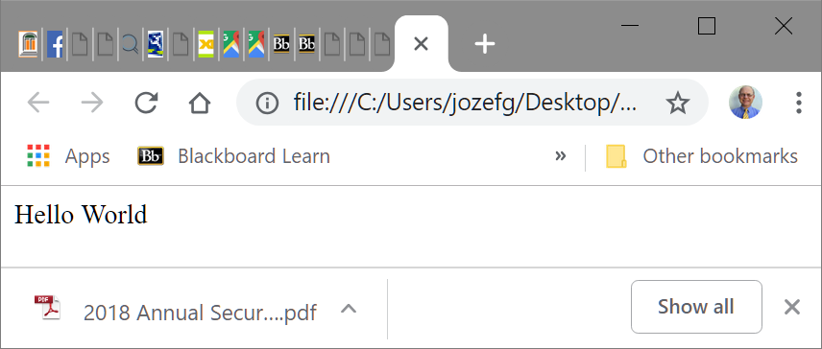

- Use <ctrl> + u to see the code.
- Alternative approach: The textbook file save solution in HOP 2.1 solution p.31.

Go to the Create a Folder section – p.30 at the textbook using Notepad and remember to save the file as index.html (p.31 Figure 2.4) with “Save as type” field
as it is shown below:
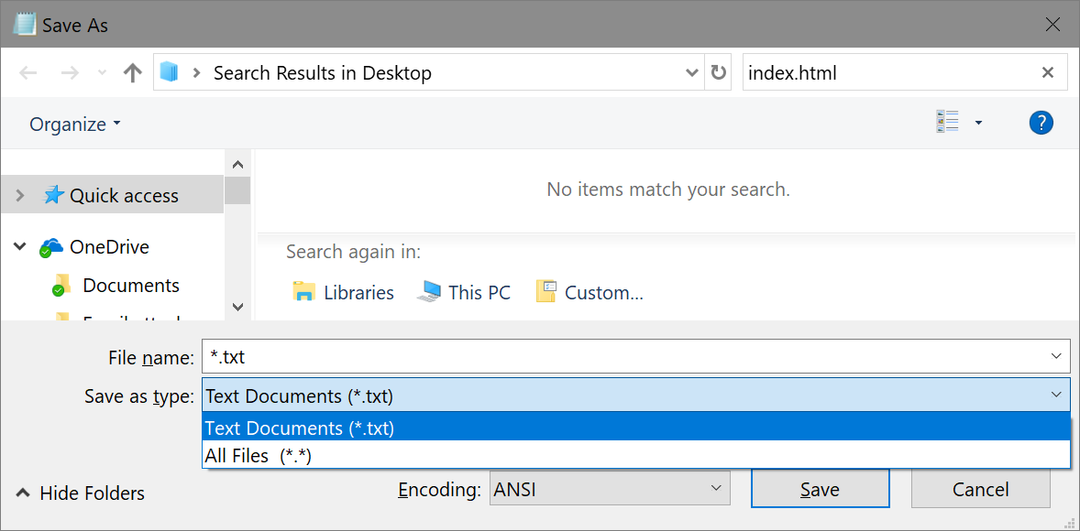
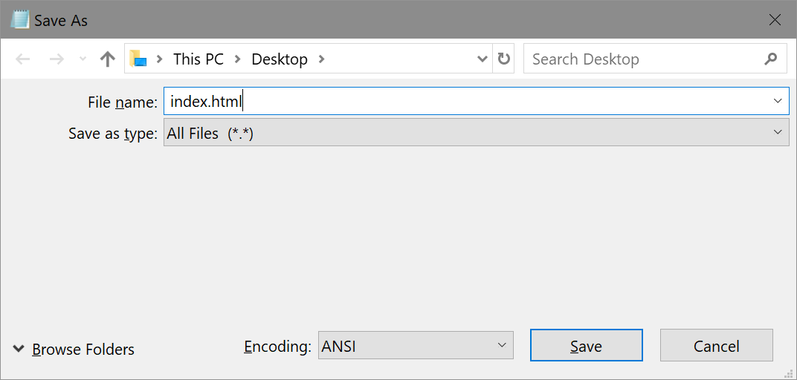
click on “Save” and you can now right click on index.html => open with => look for Notepad
=> type your first page on p. 30 as you see below

- Select File then Save or just <Ctrl> + s => in order to run your 1st web page double click on index.html and the result is shown below:

- Use <ctrl> + u to see the code.

