Test Plan and Results:
Replace Listing, Financing with classes.html and schedule.html in the Ch2 project Yoga Studio.
(Replace Listing with Menu, Financing with Music in the Ch2 project JavaJam)
Keep in bold all actions!

- Page name | - Test item  Schema: click  action => reaction  Legend:  => means  land in (specify a hyperlink if a site is online) | - Validation | Resolution  1280*800  -desktop,  Or specify yours
index.html | Home txt link => home page  Music  Listings txt link =>Listings page  Financing txt link => Financing page  Contact txt link => not implemented  E-mail => popup an e-mail form | Correct using http://validator.w3.org –  See above  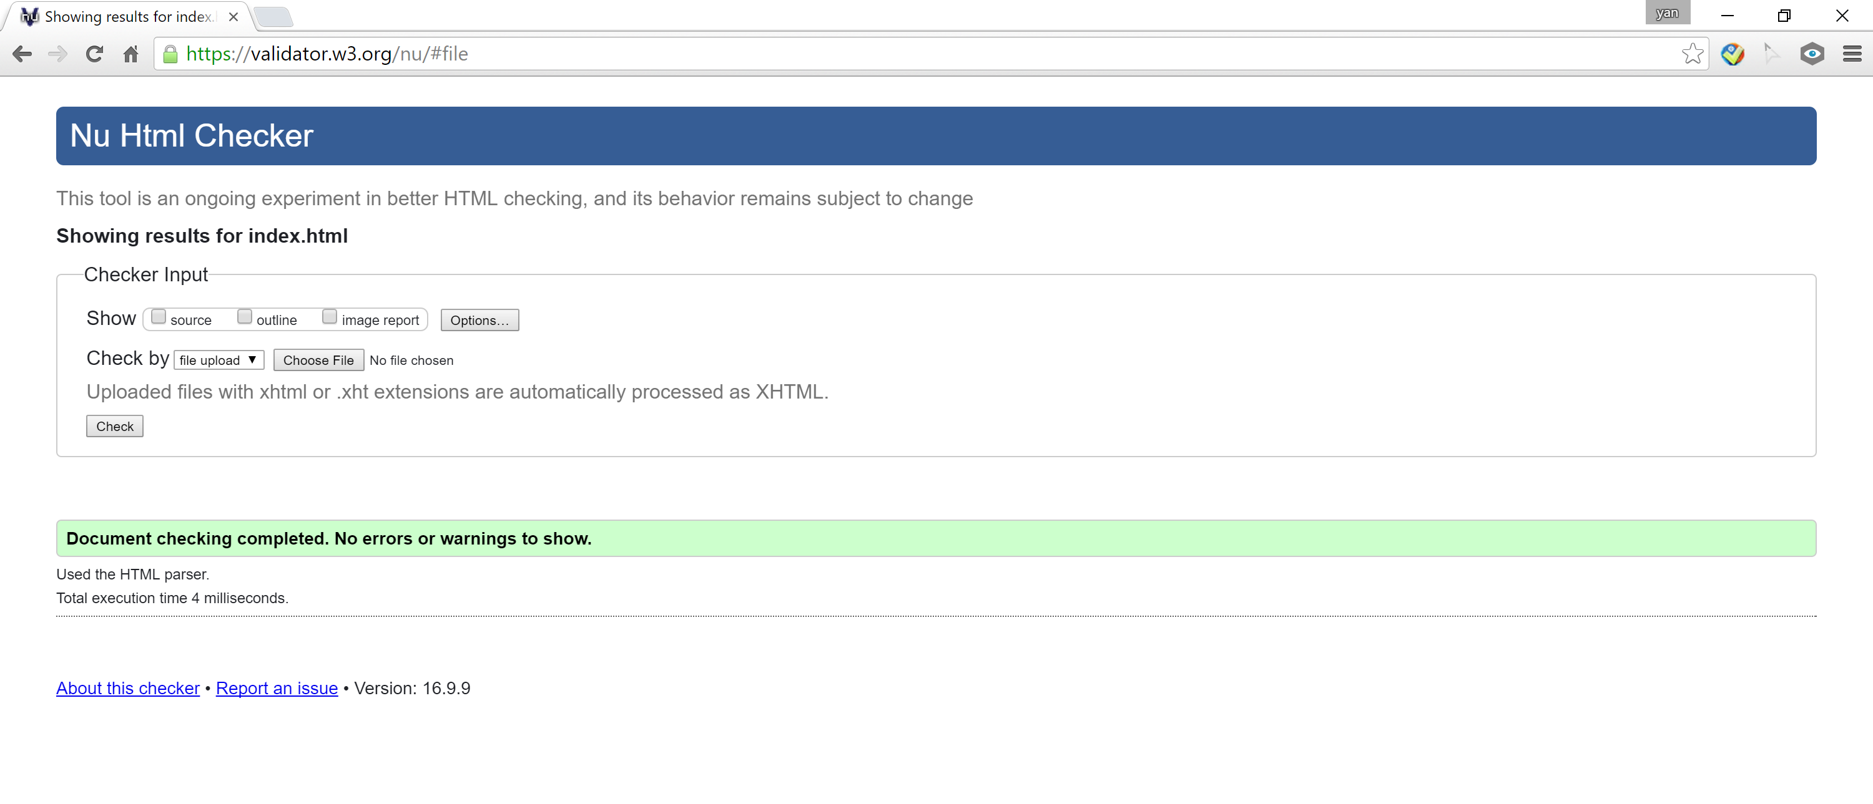 | - Good display in Chrome.  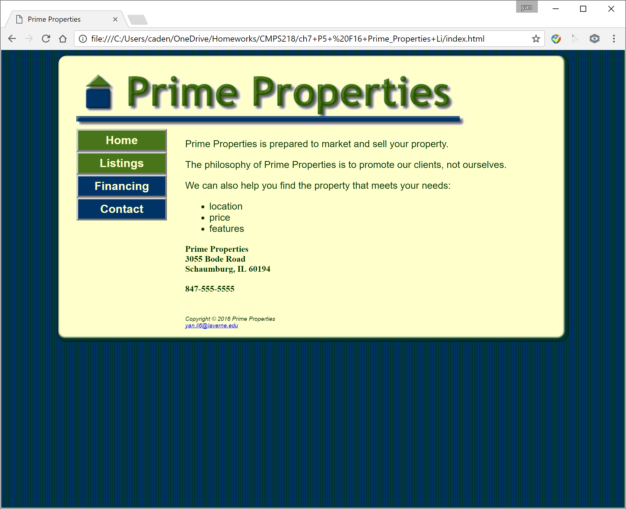  - Good display in Mozilla.  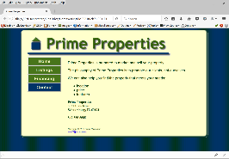
listings.html | Home txt link => home page  Listings txt link  =>Listings page  Financing txt link => Financing page  Contact txt link => not implemented  E-mail => popup an e-mail form | Correct using http://validator.w3.org  See above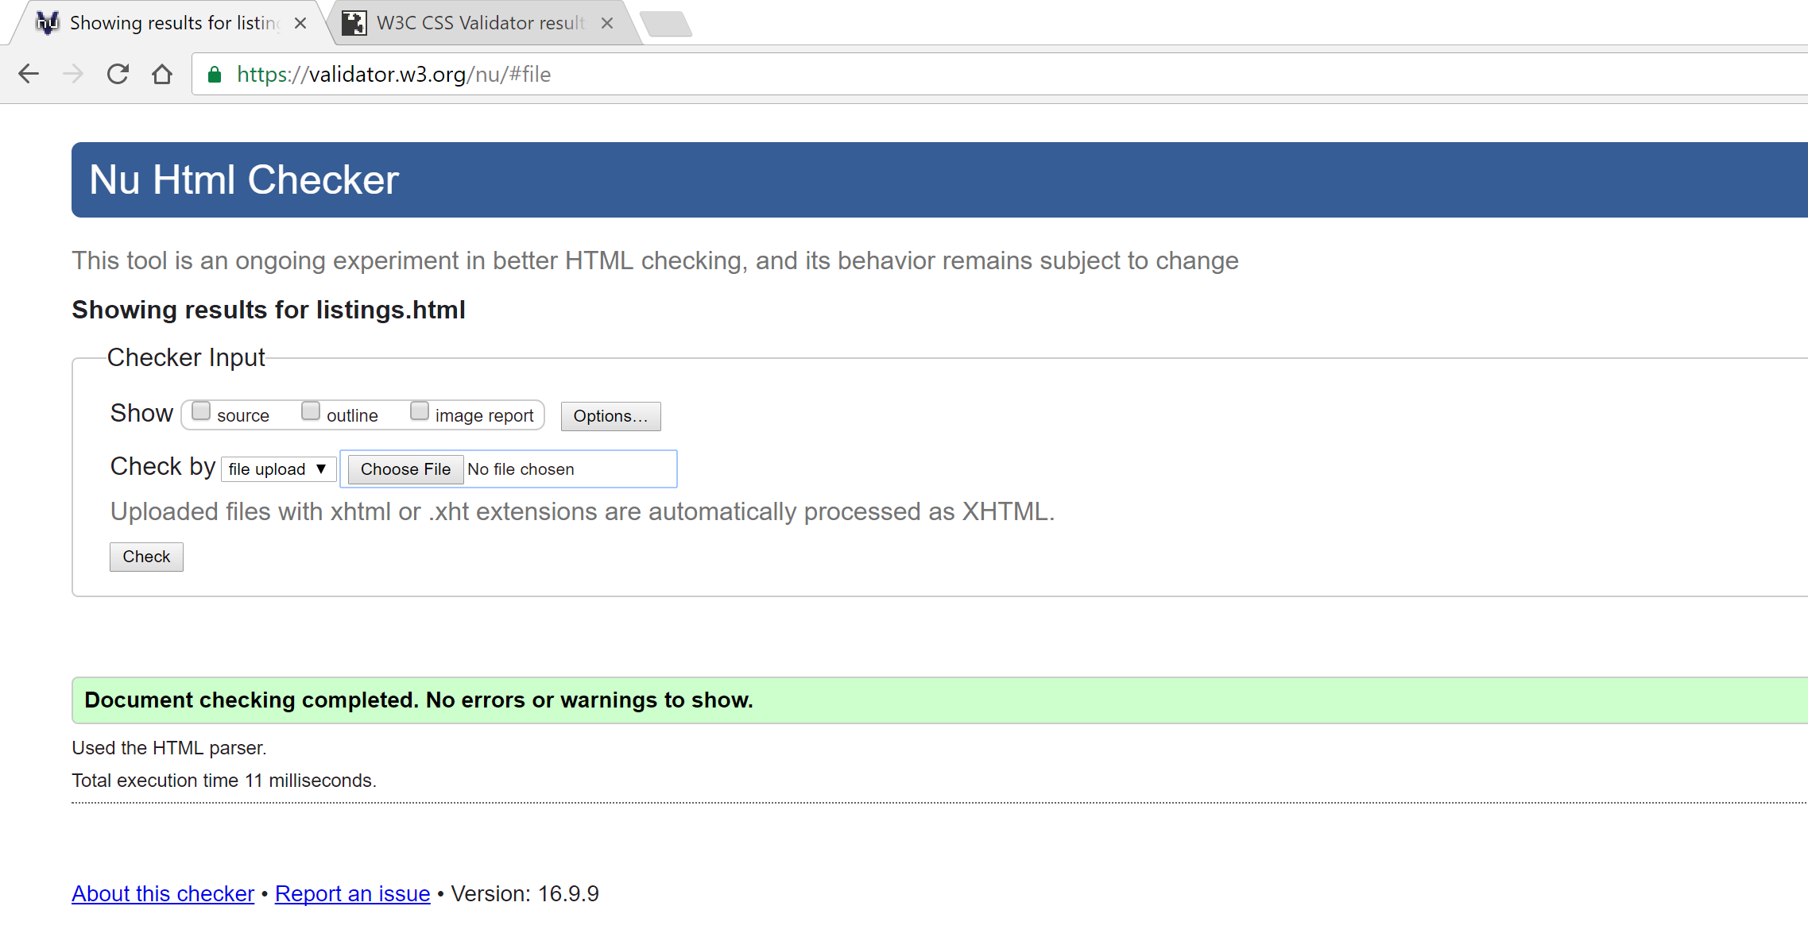 | - Good display in Chrome.  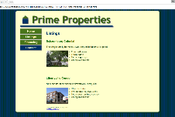  - Good display in Mozilla.  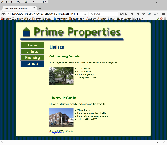
financing.html | Home txt link => home page  Listings txt link  =>Listings page  Financing txt link => Financing page  Contact txt link => not implemented  E-mail => popup an e-mail form | Correct using http://validator.w3.org  See above  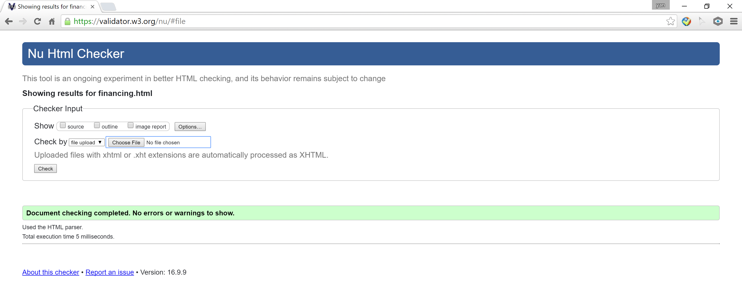 | - Good display in Chrome. 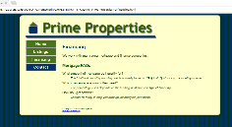  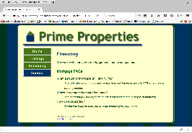  - Good display in Mozilla

