Main project components are showing below (place 5 components of each web page as it is shown on page 3):

Design:
Site Map:

Wireframe Desktop view:

Wrapper
Header
Nav Main
Image
Footer

Wireframe Tablet View:
Provide here

Wireframe Mobile View:
Provide here

Website File Organization:
Provide here

<!--***********************************************************************
*Name: Joe Smith
*Class: CMPS 218 OL
*Assignment #: Project 6 : Case Study – Ch7: JavaJam Coffee House
*Date Due: 11/11/19
*Problem: Modify existing pages for JavaJam Coffee House to display in mobile devices using a single-column layout and modify the desktop style for the home, menu and music pages according to the description on p. 359-360.
**************************************************************************-->
T2-2

T2-1

<!DOCTYPE html>
<html lang="en">
<head>
<title>JavaJam Coffee House</title>
<link href="javajam.css" rel="stylesheet">
<meta charset="utf-8">
<meta name="viewport" content="width=device-width, initial-scale=1.0">
</head>
<body>
<div id="wrapper">
<header>
<h1>JavaJam Coffee House</h1>
</header>
<nav>
<ul>
<li><a href="index.html">Home</a></li>
<li><a href="menu.html">Menu</a></li>
<li><a href="music.html">Music</a></li>
<li><a href="jobs.html">Jobs</a></li>
</ul>
</nav>
<main>
<div id="heroroad"></div>
<h2>Follow the Winding Road to JavaJam</h2>
<p>We're a little out of the way, but take a drive down Garrett Bay Road to JavaJam today! Indulge in our locally roasted free-trade
coffee and home-made pastries. You'll feel right at home at JavaJam!</p>
<h3>JavaJam Coffee House features:</h3>
<ul>
<li>Specialty Coffee and Tea</li>
<li>Bagels, Muffins, and Gluten-free Pastries</li>
<li>Organic Salads</li>
<li>Music and Poetry Readings</li>
<li>Open Mic Night</li>
</ul>
<div>
12010 Garrett Bay Road<br>
Ellison Bay, WI 54210<br>
<a id="mobile" href="tel:888-555-5555">888-555-5555</a> <span id="desktop">888-555-5555</span><br><br>
</div>
</main>
<footer>
Copyright &copy; 2018 JavaJam Coffee House<br><a href="mailto:trishia@banes.com">
trishia@banes.com</a>
</footer>
</div>
</body> </html>

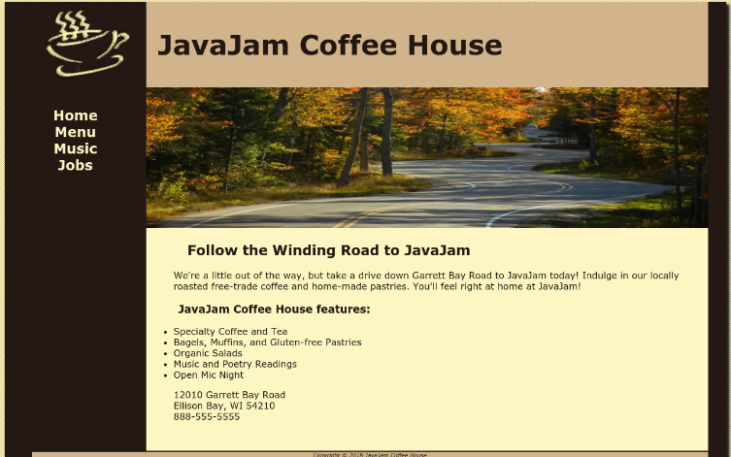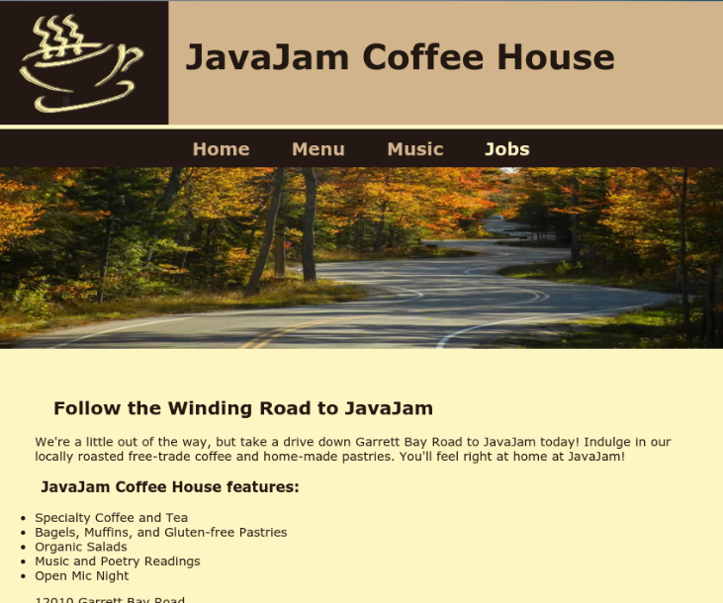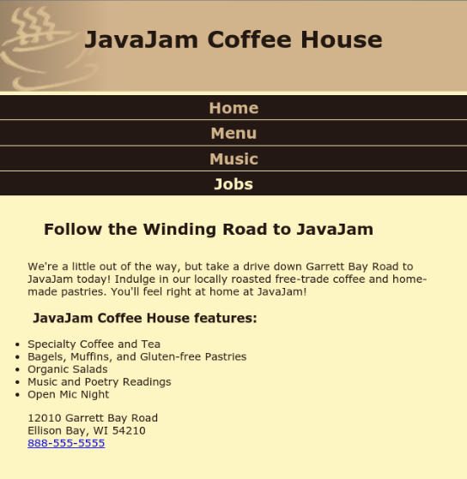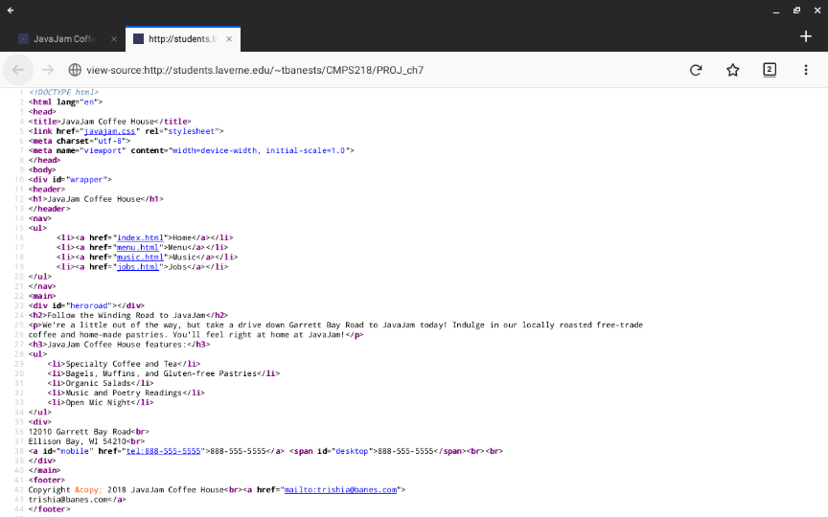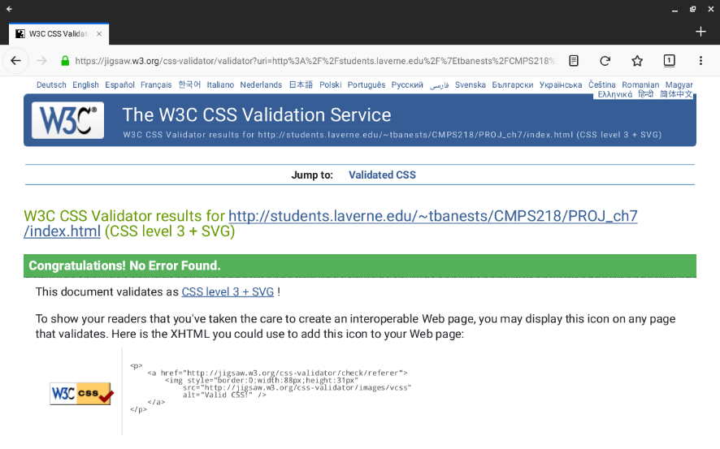
T2-2

T2-1

T2-2

TABLE 2 – Test Plan and Results

Page #/name | Test item | Validation | Resolution  1200 x 800  Desktop | Resolution  1024 max  Tablet | Resolution  768 max  Mobile
1. index.html | Home txt link => home page  Menu txt link => menu page  Music txt link => music page  Jobs txt link => inactive link  Contact E-mail txt link => popup e-mail form | Correct using http://validator.w3.org/  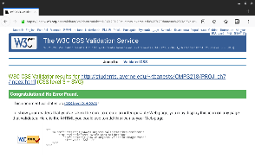 | Good display in Firefox.  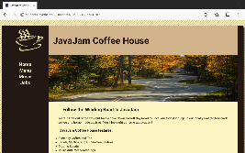  Good display in Chrome.  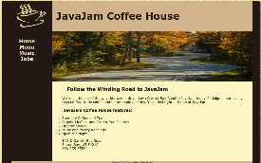 | Good display in Firefox.  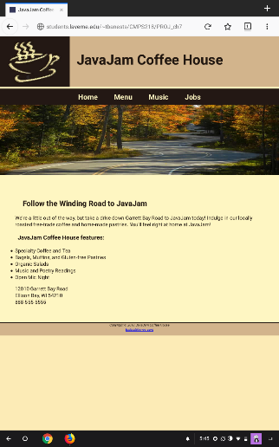  Good display in Chrome.  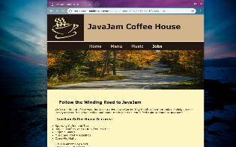 | Good display in Firefox.  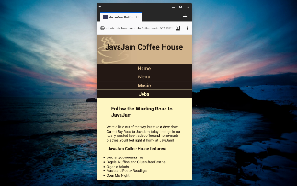  Good display in Chrome.  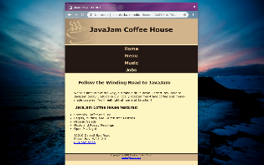
javajam.css | stylesheet | Correct using http://validator.w3.org/  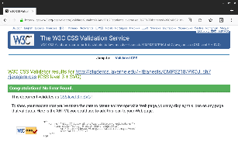 | 