SET UP WEB-HOSTING
You will be using WinSCP app.
WinSCP is an open source SFTP client and FTP client for Windows. Its main function is the secure file transfer between a local and a remote computer. Beyond this, WinSCP offers basic file manager functionality. It uses Secure Shell (SSH) and supports, in addition to Secure FTP, also legacy SCP protocol. [More]
- Download WinSCP from https://winscp.net/eng/download.php => select DOWNLOAD WINSCP green button with the current version (example 5.17.7 (9.4 MB)

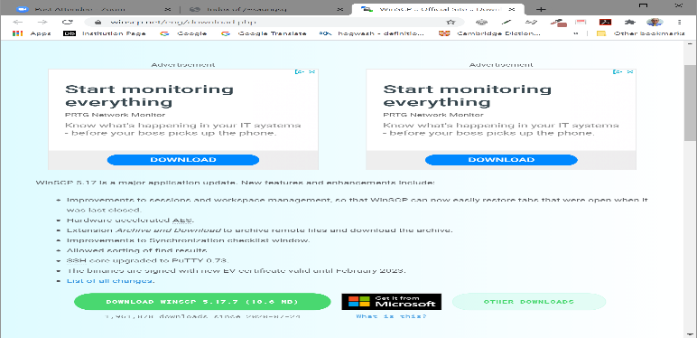
- It will ask you where to save it. You may save on your desktop.
- Save it.
- Follow instructions. Allow to have a desktop shortcut icon.
- Click on the shortcut icon.
- Click on the New Site on the left site (left pane).
- Setup all fields on the right site as shown below, replace the userLogin by yours:
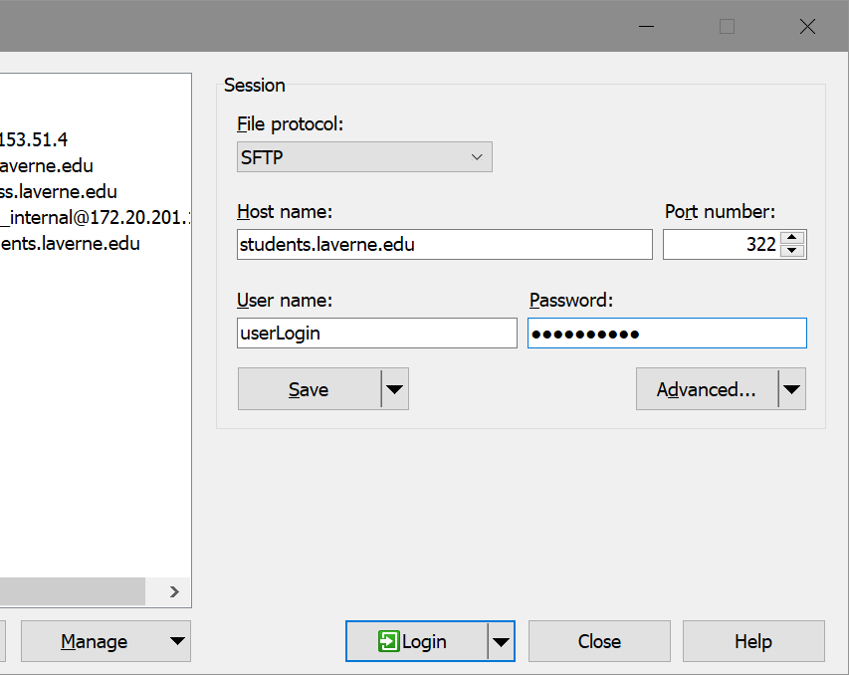
- Click the Save button. You will receive a screen below:
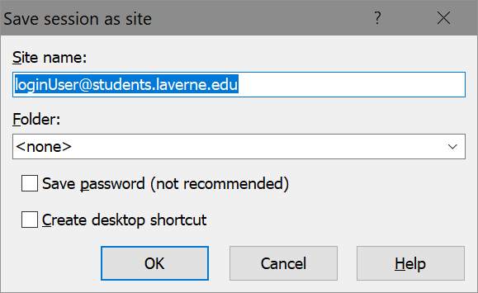
- Make sure that the userLogin is replaced by your user Login:
userLogin@students.laverne.edu
- You may save password in order to go directly to your web server site.
- You may check “Create desktop shortcut”
- Click OK.
- Click Login to connect to your web server site.
- You will get the screen below:
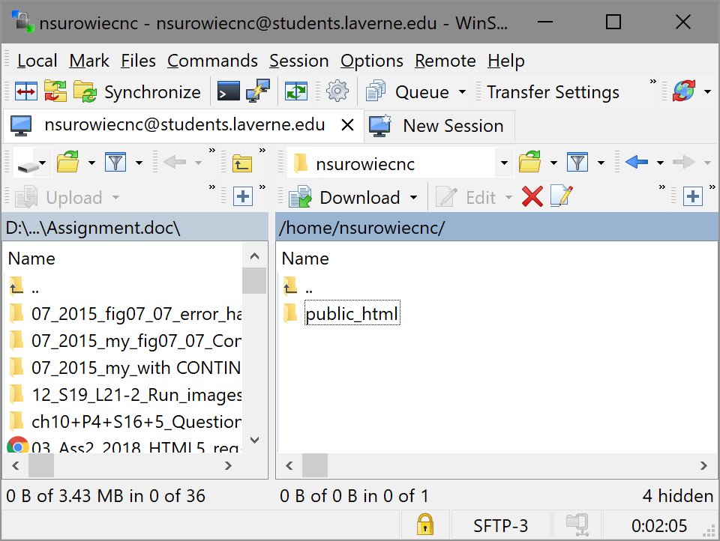

- Double click on public_html. You may remove cgi-bin directory..
- Create CMPS218 directory by right clicking below public_html directory and selecting New option and then Directory.
- Enter a New Folder Name CMPS218. See below.
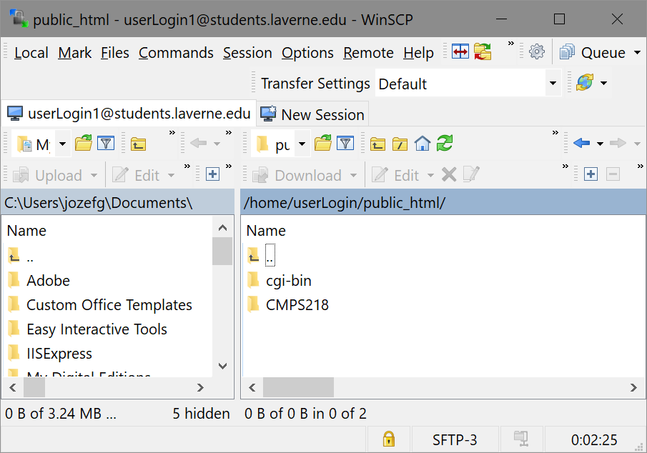
- Double click on CMPS218.
- Create HOP_ch2 directory by right clicking the empty field and selecting New option and then Directory.
- Enter a New Folder Name HOP_ch2. Click OK. See below.
- Create PROJ_ch2 directory by right clicking the empty field and selecting New option and then Directory.
- Enter a New Folder Name PROJ_ch2. Click OK. See below.
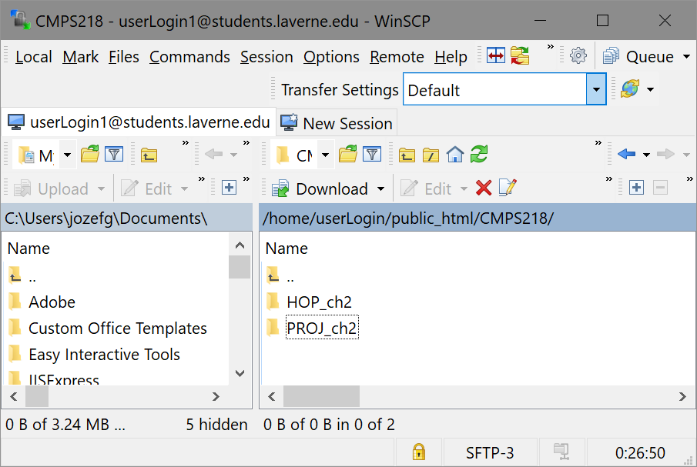

- Repeat steps 20 to 22 for each chapter 3, 4, 5, …, till ch14. If you create a wrong name directory, click on it and select the Delete option or the Rename option. You should have all directories as follows:
- HOP_ch2
- HOP_ch3
- HOP_ch4
- HOP_ch5
- HOP_ch6
- HOP_ch7
- HOP_ch8
- HOP_ch9
- HOP_ch10
- HOP_ch11
- HOP_ch12
- HOP_ch13
- HOP_ch14
- PROJ_ch2
- PROJ_ch3
- PROJ_ch4
- PROJ_ch5
- PROJ_ch6
- PROJ_ch7
- PROJ_ch8
- PROJ_ch9
- PROJ_ch10
- PROJ_ch11
- PROJ_ch12
- PROJ_ch13
- PROJ_ch14
- Create FINALProj directory by right clicking the empty field and selecting New option and then Directory.
- Enter a New Folder Name FINALProj. See below.
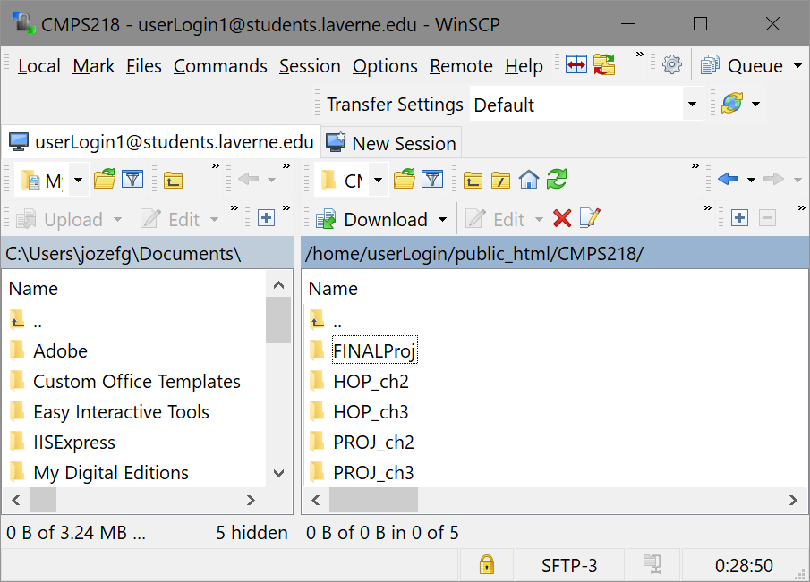

- If want to navigate to the parent directory click on empty icon directory above.
- Add to the list in item 23 the following directories:
Ass1, Ass2, Ph1-2, Ph3-4, Ph5-6 as well.
In order to upload your HOP file(s) to let’s say directory HOP_ch2.
- Click on WInSCP and login to your Web server site, then navigate to your HOP_ch2 directory.
- If you have some file(s) in HOP_ch2, remove the file(s) there (right click on the file => delete).
- Then you need to create 15 directories 2.1, 2.2, 2.3, …, 2.15 (just numbers), see steps 19 and 20.
- Post each HOP to the corresponding directory (for example: drag your file of HOP 2.1 and drop to the directory 2.1, then drag your file of HOP 2.2 drop to the directory 2.1 and so on). See below:
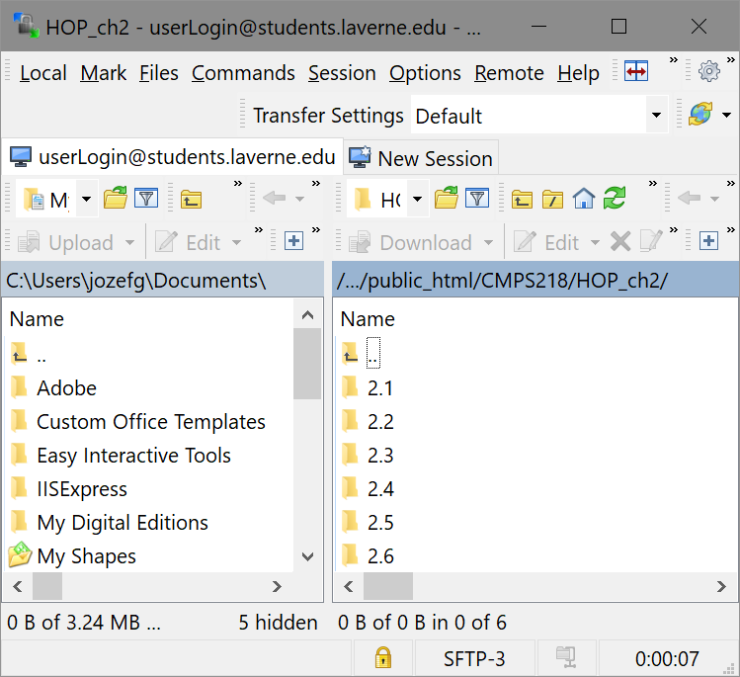

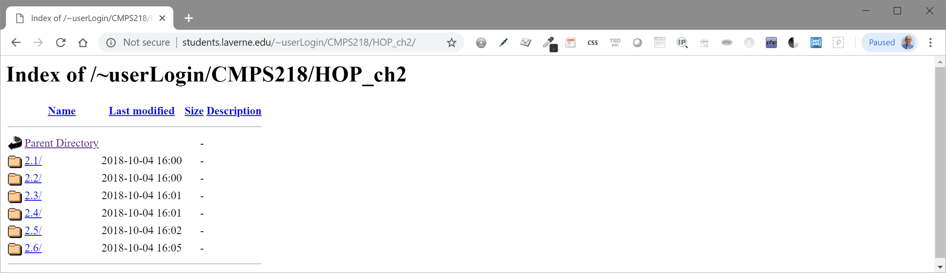
- Go back to PROJ_ch2 and drag and drop all your project files.
- Drag and drop your project document as Ch2+P2+F20+JavaJam+your_Initial_First.yourLastName.docx,
for example Ch2+P2+F20+JavaJam+your_J.Smith.docx
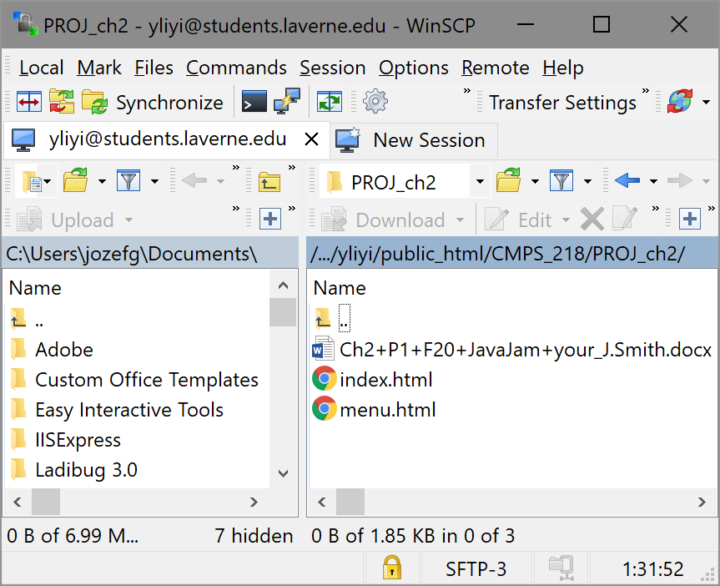
- Repeat steps 28 and 29 for each project.
- Test your HOPs and your project. Each of you will have a website address in the following format: http://students.laverne.edu/~userLogin/. Please replace the user Login with your user login which has already emailed to you and test your website at http://students.laverne.edu/~userLogin/.
See the example below with adding a path to the address.s

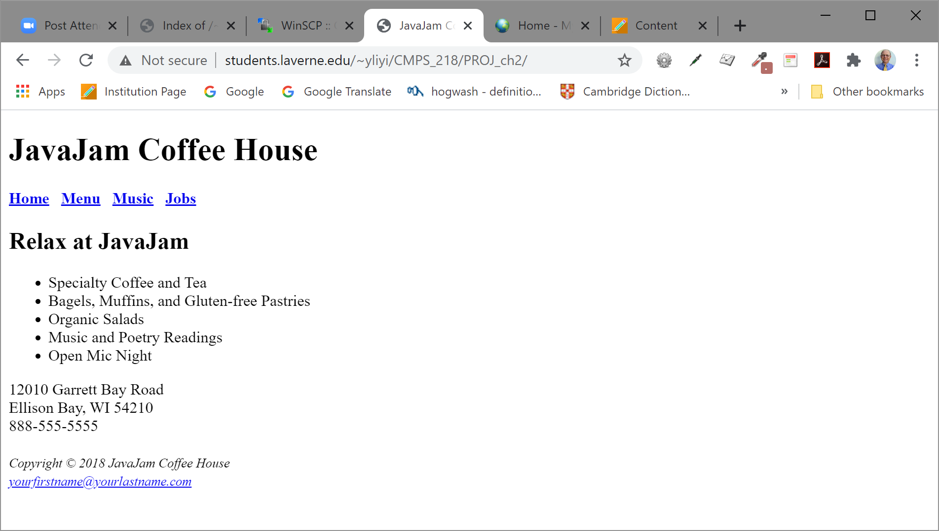

Good Luck,
Your professor
J/G

