Go to FileZilla at https://filezilla-project.org/ click on all platforms (FileZilla Client) button, a few times click Next button and install it.
- Click on File => Site Manager => New site
- Fill out the following:
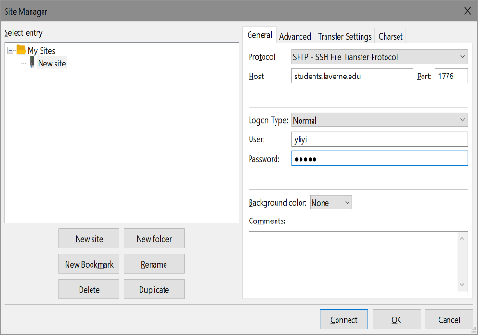
- You may save password:
- Click OK => OK
- Click File => Site Manager and click Connect button.
- The server’s host key is unknown etc. => click OK
- If everything is OK you should get the layout similar to the one below:
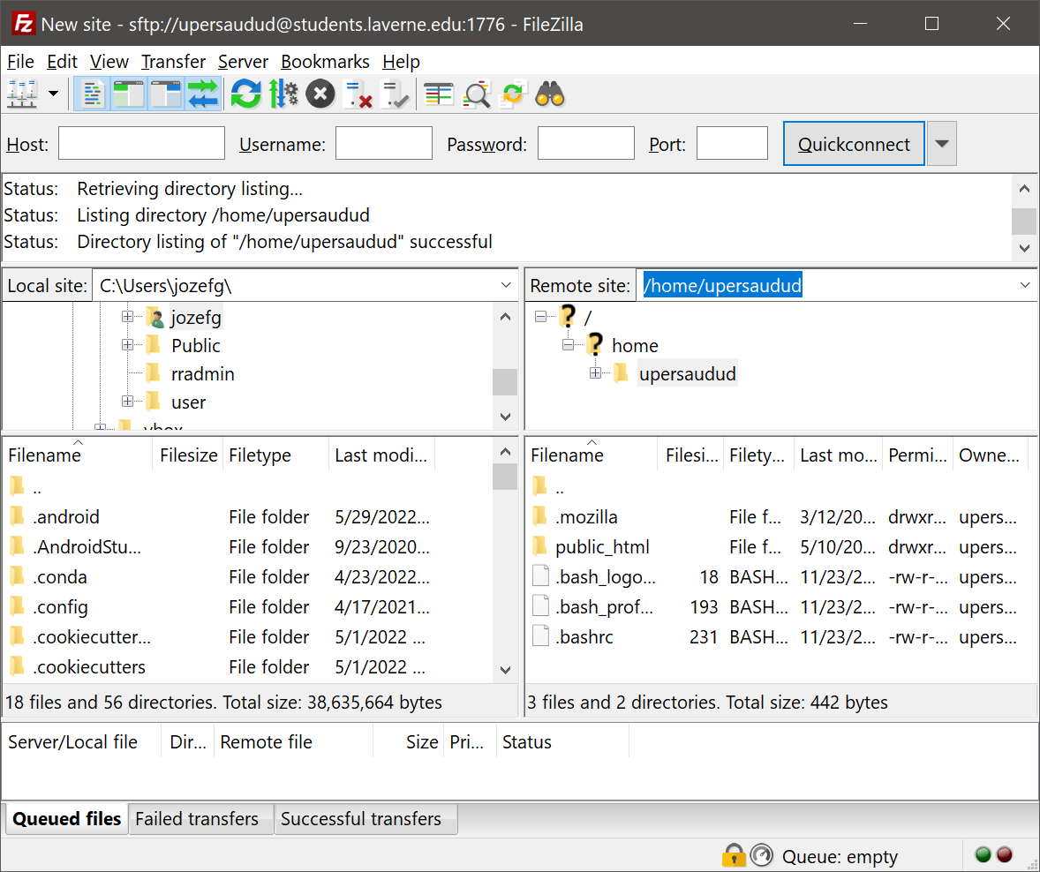
- Click public_html directory. You will drag and drop your files into public_html directory. Now you should follow 14 and so on of 1_WinSCP-install+app-setup+dir-setup.docx.

