Handouts for CMPS 499 to help you in developing your proposal and final project prepared by prof. J. Goetz

Post this doc on OneDrive as follows (collect all current phases in the same document):
Year_Semester+your_fullName+capitalized_projectTitle+PHASES.docs
Example:
F24+John_Dock+DATABASE_INVENTORY+PHASES.docs

Info: GitHub Student Developer Pack: This all in one package of technology resources gives students free access to the best developer tools in one place so they can learn by doing. This pack offers a huge bundle of free resources for students ranging from Canva, Microsoft Azure, a variety of code editors, applications, and more.
https://education.github.com/pack

Please treat each phase delivery as a single weekly report. Post a word document with all items from 1 – 7 on OneDrive.
Phase 1A:

Prepare a 1 - 2 pages single spaced written answer separately to each item below (include questions):
- Your first and last name.
- What is the title of the project – use CAPITAL letters only

- Introduction
Example: This proposal provides a brief overview of the goals of my senior project, which will incorporate (what ?) the Web design best practices, responsive web design, secured, password protected database driven app with admin components. Knowledge and skills HTML 5, CSS 3, JavaScript, PHP, MySQL, C# will be used to create the app.

Problem Statement
A problem statement should describe the problem, describe its causes, and identify potential approaches or solutions to the problem through the use of literature reviews. A problem statement should identify the problem, describe its causes, and identify potential solutions or improvements.

Description of the Current System
Explain the current hardware/software used by the company.
Provide the website link with a short description if you are going to improve the website or app design etc.
Include if appropriate for your project:
  - Underlying business processes
  - Hardware
  - Software (application and system)
  - System processes
  - Information
  - System interfaces

- Description and Requirements for the Proposed Project
Analise requirements. These requirements include software, hardware, physical, and functional requirements. Add requirements specification.
Description of the proposed project, what the current problem will be solved in your proposed project.

Include if appropriate for your project:
- Underlying business processes
- Hardware
- Software (application and system)
- System processes
- Information
- System interfaces
- Website interfaces
- Software tools needed
- Functional requirements

6.1 Scope of the project
How your project will solve a problem, define the goal and the scope of your project.
- Who is your intended audience?

Phase 1B:

- Application Design

Design a Software or Hardware or Information Solution or Website Map
Designing a software or hardware or information solution to the requirements specification.
- Use the Functional Flowchart/Diagram (it shows the function flow) to describe the functional requirements. See examples below.
- Use a Case Diagram. See examples below.
- Outline the interface to your application.
- If your app uses a database provide the name of tables with possible fields names.
- Example for a website. Public and Admin Website map: name each page - show a graphical hierarchy of pages and the relationships between the pages. See the examples as follows:

Register
Home
User
List
Contact Us
Q & A

Log-in/out
Reviews List
Q & A
Manage Reviews
Contact Us
Manage Categories
Manage Games
Home
Register

The word "manage" should include a list and buttons add, edit, delete.
The layout of functions for each Manage page is as follows:
- Manage Categories (list, add, edit, delete) or
- Manage Reviews (list, add, edit, delete)
- Manage Games (list, add, edit, delete)

- Introduce Database Design if applicable - A database design is based on a template from the textbook of CMPS 320: Filled in the two column table below. Apply the NOTE below. Name each table in relationship to tables in our Joke Management System as follows:
NOTE:
  - columns in bold are primary keys,
  - columns in italic are foreign keys,
  - the order of tables is matching with the order of the table relationship,
  - use a blue color to match author.

Comparison Table: An example of my project is defined in the 3 – 5 columns:

Joke Management System tables | Joke Management System table columns | My project tables | My project table columns | Related Manage Menu Item
category | id, name | category | id, name | Manage category
jokecategory | jokeId, categoryId | titlecategory | jokeId, categoryId
joke | id, joketext, jokedate, authorId | title | id, titletext, releasedate, averagerate, titledate, userId | Manage title
author | id, name, email, password, permissions | user | id, firstname, lastname, email, password, permissions | Manage user
 |  | review | id, userId, titleID, description, rate, date | Manage review

- Database table relationships: Show the relationship between tables - see p.189 and 204 of CMPS 320 Textbook. 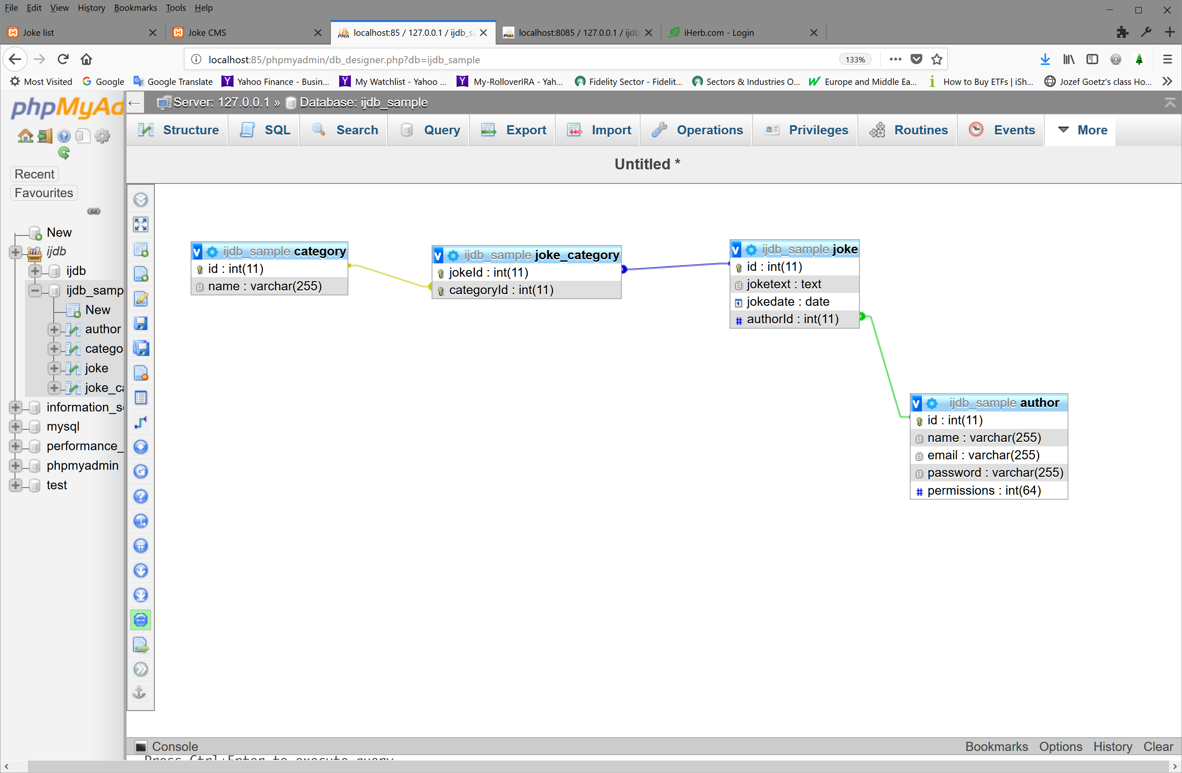
Piece of advice:

There are dependencies between tables.
Before the foreign keys are defined, the table(s) you refer to in the foreign key should be defined first.
Try again define 1st all independent tables and then with foreign key base tables on dependencies.
When you report a problem, show all SQL statements with click on details.
Follow the table order like in the document databaseFinalWebsiteEd6_MY_Best_Improved.sql.

GENERIC Senior Project

Gen a. Application Design

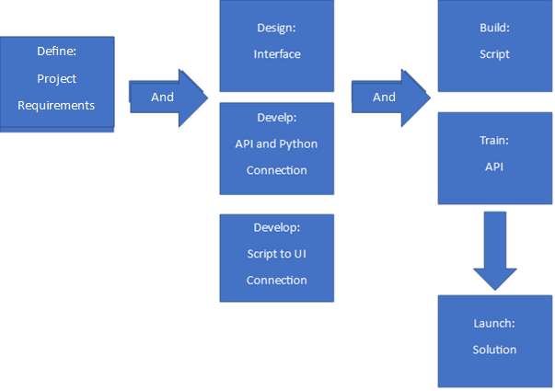

GEN b. App Interface

User Interface:
The NSERS application should have a user-friendly interface that allows security administrators to easily navigate through the system, view real-time monitoring data, and respond to security incidents promptly. Clear and intuitive design elements such as dashboards, alerts, and status indicators can enhance the user experience and facilitate efficient incident management.(see below Figure)
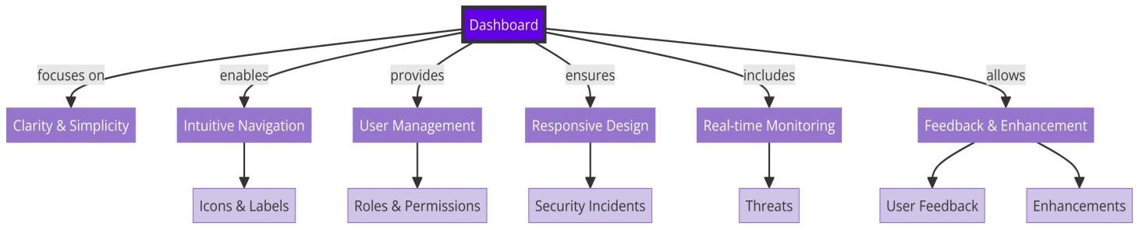
GEN c. Functionality
The application should incorporate essential functionalities such as real-time monitoring, automated incident response, anomaly detection, user management features, and report generation capabilities. These functionalities are crucial for detecting, analyzing, and mitigating security incidents effectively.(see below Figure)
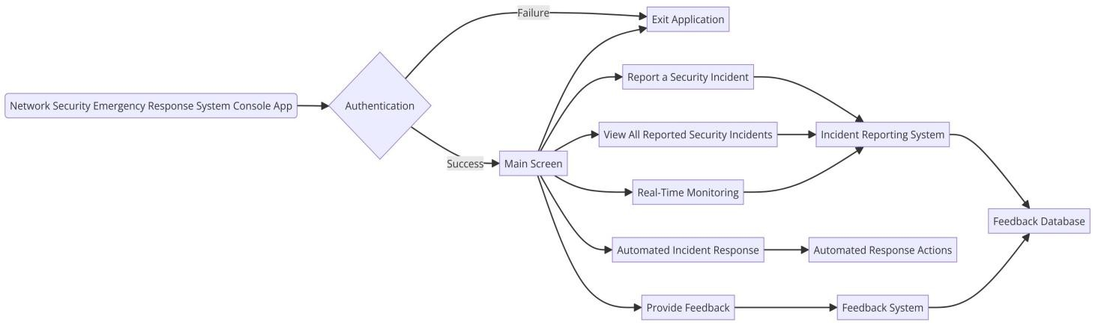

or
Functional Diagram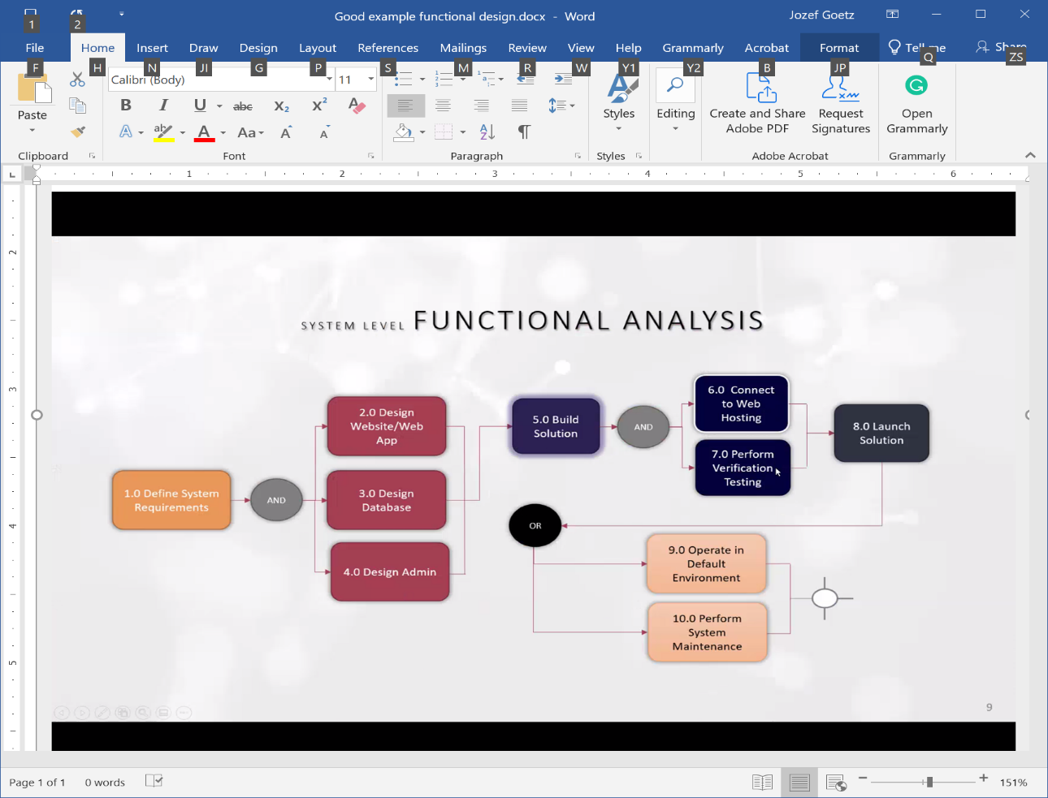
or
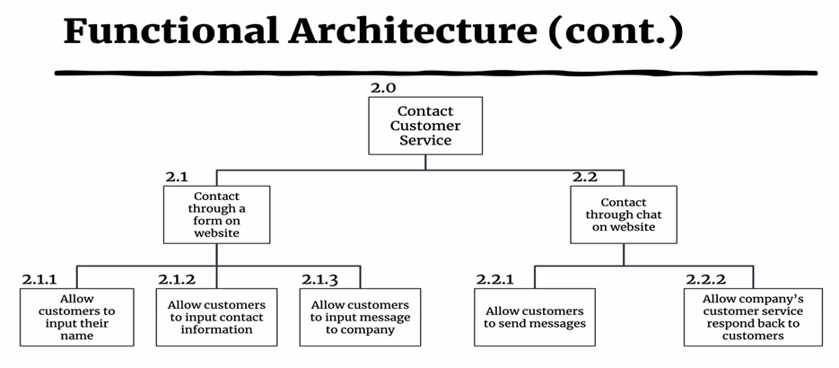

Phase 1C:

GEN d.
Use Case Diagram

REMOVE: A use case diagram at its simplest is a representation of a user's interaction with the system that shows the relationship between the user and the different use cases in which the user is involved.

Introduce your own sentence here: e.g.
The Case Diagrams show the interaction of the admin and user with the system. The user interactions are shown below in the diagram. A logged out user will be able to view …. A logged in user will be able to manage …. as well as create reports. Provide two total scenarios, one for the admin and one for the user.

Use one of the Case Diagrams Examples:

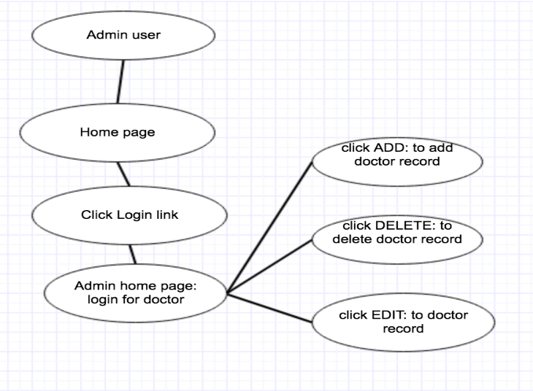
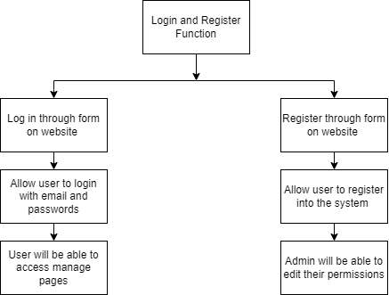

GEN e. - optional
System Architecture:
Developing a robust and scalable system architecture is key to the NSERS application's reliability and resilience. By following best practices in software design, modularization, and component-based development, the system can adapt to changing requirements, scale efficiently, and maintain high availability.

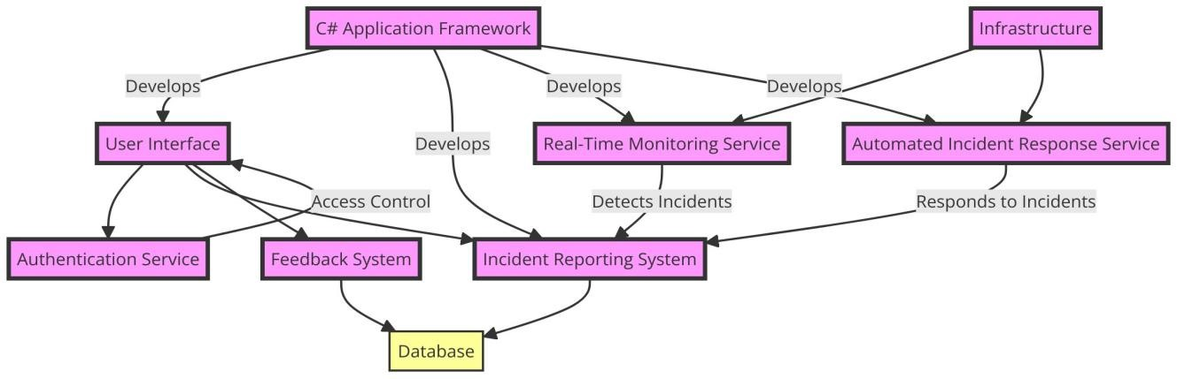

- Examples of Database apps using (tables in blue are matching the author table):
- Student Award Track System. Keep track of all awarded students in different category awards Joke Menu: Admin includes manage joke, author, category
My Menu: Admin includes: award, student, category, Public: award
Tables:
Joke Management System tables | Joke Management System table columns | My project tables | My project table columns | Related Manage Menu Item
category | id, name | category | id, name | Manage category
jokecategory | jokeid, categoryId | awardcategory | awardId, categoryId
joke | id, joketext, jokedate, authorId | award | id, awardtext, awarddate, studentId | Manage awards
author | id, name, email, password, permissions | student | id, firstname, lastname, email, password, permissions,  major, concentration, telnum | Manage students

The password should satisfy all today’s standards.

- Testimony Management System: Keep the track of testimonies, questions and appointments.
Joke Management System tables | Joke Management System table columns | Review Management tables | Review Management  table columns
category | id, name | category | id, name
jokecategory | jokeId, categoryId | question | id, categoryId, questiontext, questiondate, userId
joke | id, joketext, jokedate, authorId | testimony | id, testimonytext, testimonydate, url, categoryid, userId
author | id, name, email, password, permissions | user | id, firstname, lastname, email, password
 |  | appointment | id, name, categoryId,  duration, appointmentdate, email, userId

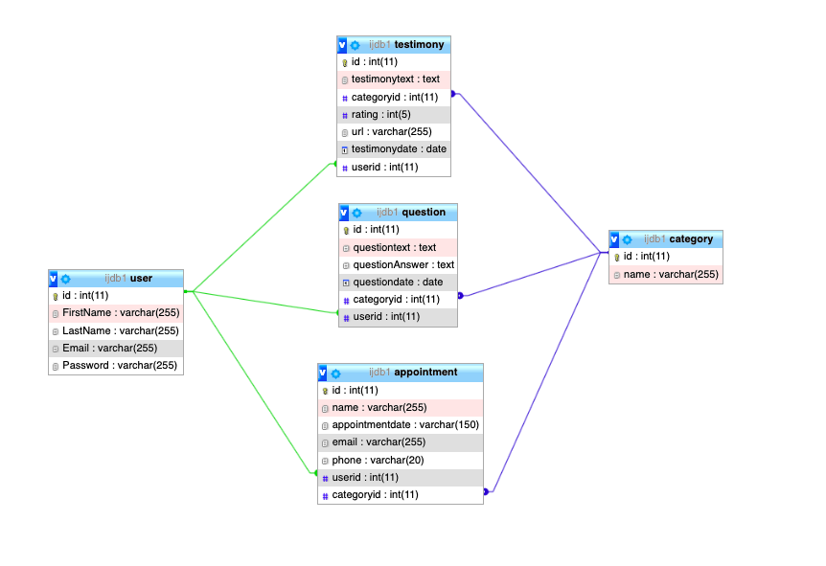
- Certificate Management Website. Track of certificates, users, required courses.
Comparison Table:
Joke Management System tables | Joke Management System table columns | My project tables | My project table columns | Related Manage Menu Item
category | id, name | category | id, name | Manage Category
jokecategory | jokeId, categoryId | certificatecategory | certificateId, categoryId
joke | id, joketext, jokedate, authorId | certificate | id, userId, certificatedetailsId, studfname, studlname, major, concentration, certificatecomplete, certificatedate, | Manage Recipients
author | id, name, email, password, permissions | user | id, firstname, lastname, email, password, permissions | Manage User
 |  | certificatedetails | id, certificatename, certificatedescription | Manage Certificate
 |  | requiredcourses | id, coursename, coursenumber, coursedescription | Manage Courses
 |  | certificaterequiredcourses | certificatedetailsId,  requriedcoursesId

Database Tables Relationship

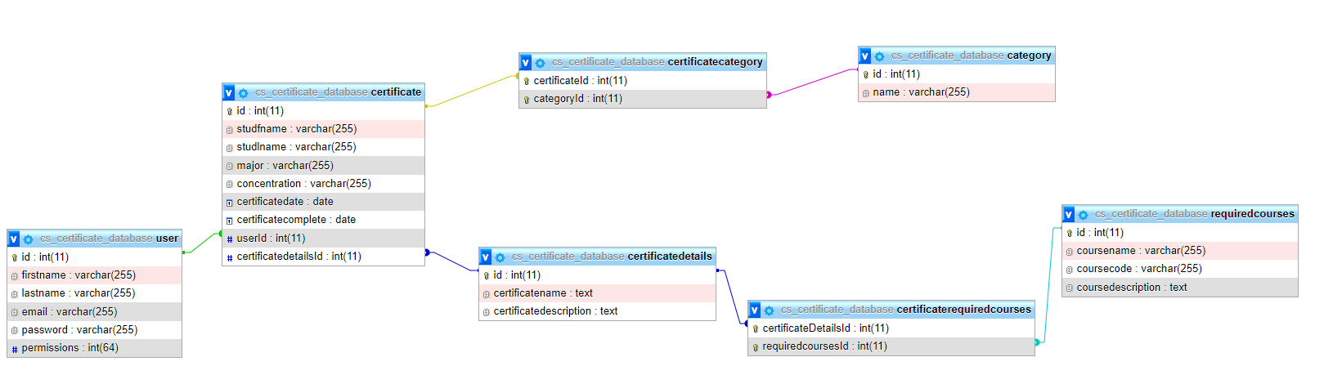

- Club Pie - http://www.klubpie.com/web/en/
Track of:
- Presentation abstracts
- Picture Gallery
- Business list
- Monitor Glucose Level
- Category - dangers, moderate, prediabetic etc.
- Results – measured by the user
- User
- Photographer Award Track System
Track of:
- Award
- Photographer
- Category
- Guest Book with names and notes
Track of:
- Notes
- Names
- Category
- Transaction of the individual expenses
Track of:
- Transactions
- User
- Category
- Monitor Temperature (Covid)
Track of:
- Temperature
- User
- Category
- Monitor Emergency Calls
Track of:
- Calls
- Crew
- Category
- Monitor Membership
Track of:
- Group
- User
- Category
- Monitor Different Food and Drink
Track of:
- Drink
- Food
- User
- Category
- Local Pizza/Water Delivery - accept delivery orders through the web
Track of:
- Order
- Customer (expand fields)
- Category

Phase 2:
  - SQL Statements
  - Interface
Some projects will not implement SQL Statements.

Goal: Define field types and populate data tables
- Specify the values range (or a concrete list of values) for each defined field in each table.
- Attach to each admin page the SQL statements.
- Give example of at least 5 data records for each table in a database (screenshots).
- Provide the .sql file.

Please follow the example a – d for each your table.

A. Create Table SQL Statement  CREATE TABLE `shopping` (  `id` int(11) NOT NULL AUTO_INCREMENT,  `text` text DEFAULT NULL,  `date` date NOT NULL,  `images` blob NOT NULL,  `quantity` int(11) DEFAULT NULL,  `unitprice` decimal(3,2) DEFAULT NULL,  `price` decimal(5,2) DEFAULT NULL,  `customerid` int(11) DEFAULT NULL,  PRIMARY KEY(`id`),  FOREIGN KEY (`customerid`) REFERENCES customer (id)  ) ENGINE=InnoDB DEFAULT CHARSET=utf8mb4; | 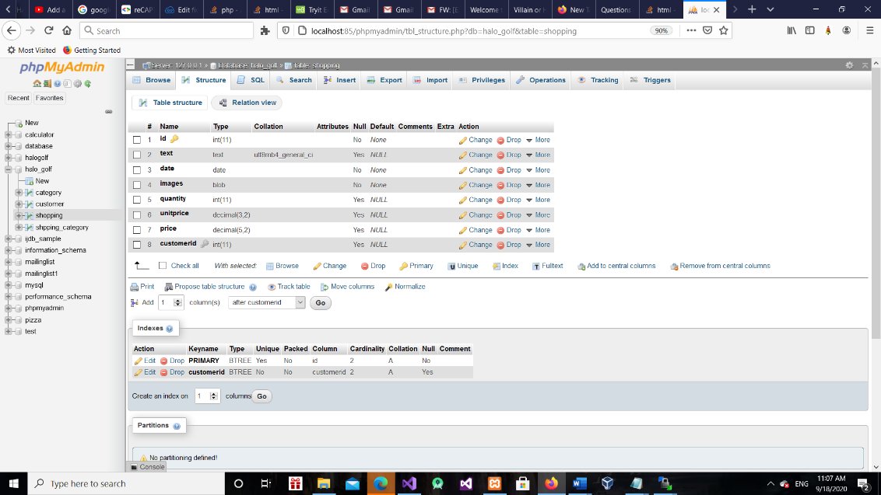  B. Structure
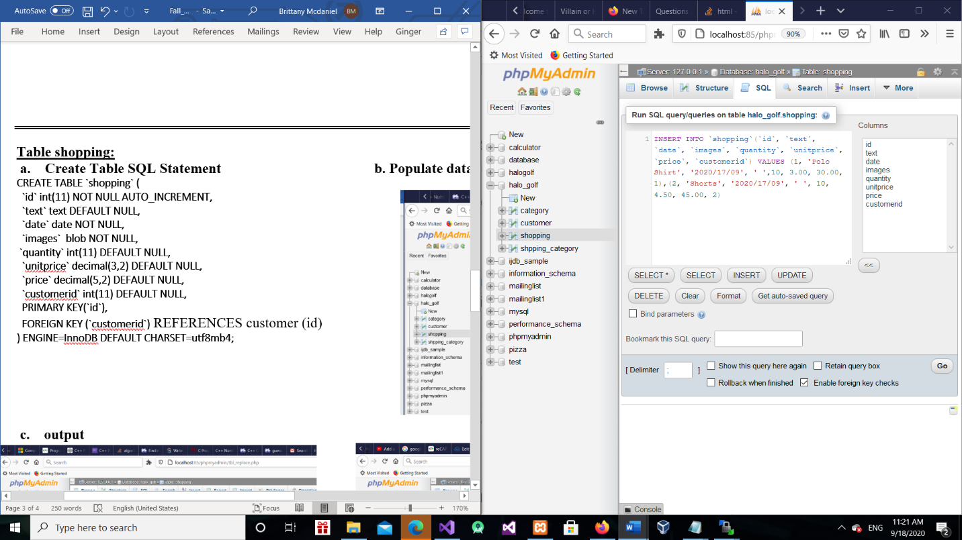  - Populate data SQL statement | 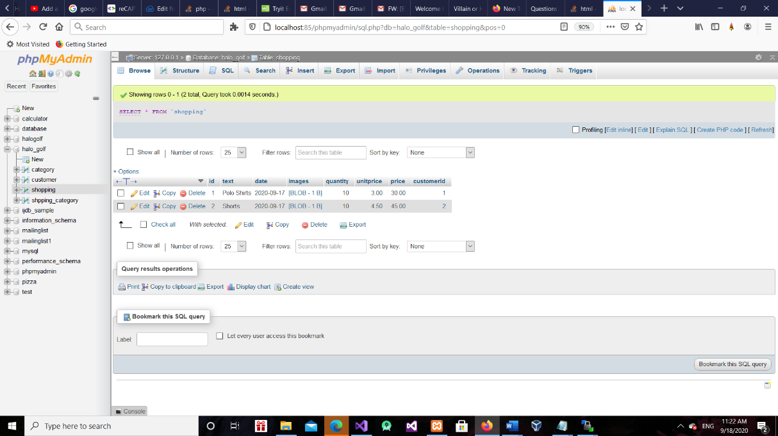  - Output

E. Relationship diagram - show the table itself and neighbor tables and put the corresponding table in a circle.

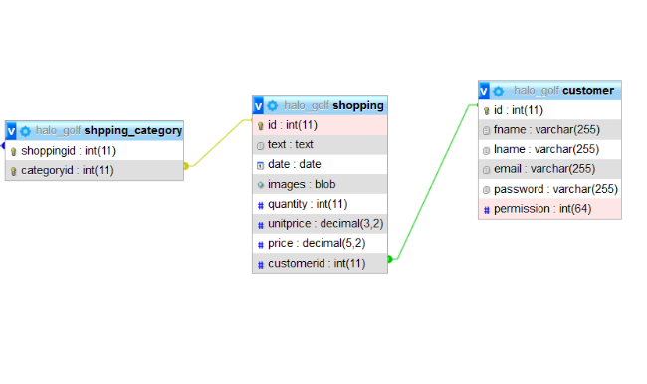

b. Interface

Example: An interface of each Web/app page is as follows: you may use wireframes or you may create your interactive design using Adobe Experience Design as working model without any code behind - https://www.youtube.com/watch?v=wrMBuqjtjpk. Please try to use figma.com/education (easy to use, design interactions and user flows) or a draw.io (diagrams.net) or justinmind.com tools as well.
Include wireframes for a desktop, tablet and smartphone for public at least 2-column pages. You may reuse code from CMPS 218 ch7 at to create a responsive design. I would like to see wireframes on the clickable element levels, so show buttons and links.

Each webpage should be preceded with one sentence purpose description.
Remember: The password should satisfy all today’s standards in your registration.

If you use AI (ChatGPT, Gemini etc.) with many entries (such as a text, image, voice) provide a screenshot of the interface and the description of usage.

Men’s/Women’s/Boy’s/Girl’s Manage Category Page:
This page is available to a logged in user. The user has the option of selecting any item they have chosen to either edit, add, or delete. If user edits, it will send user back to customer list page of that selected style (shorts, shirts, pants, or shoes). This page will display all the sales for the day so far and allow you to add, delete or edit sales.

Manage Category (list, add, edit, delete) – Desktop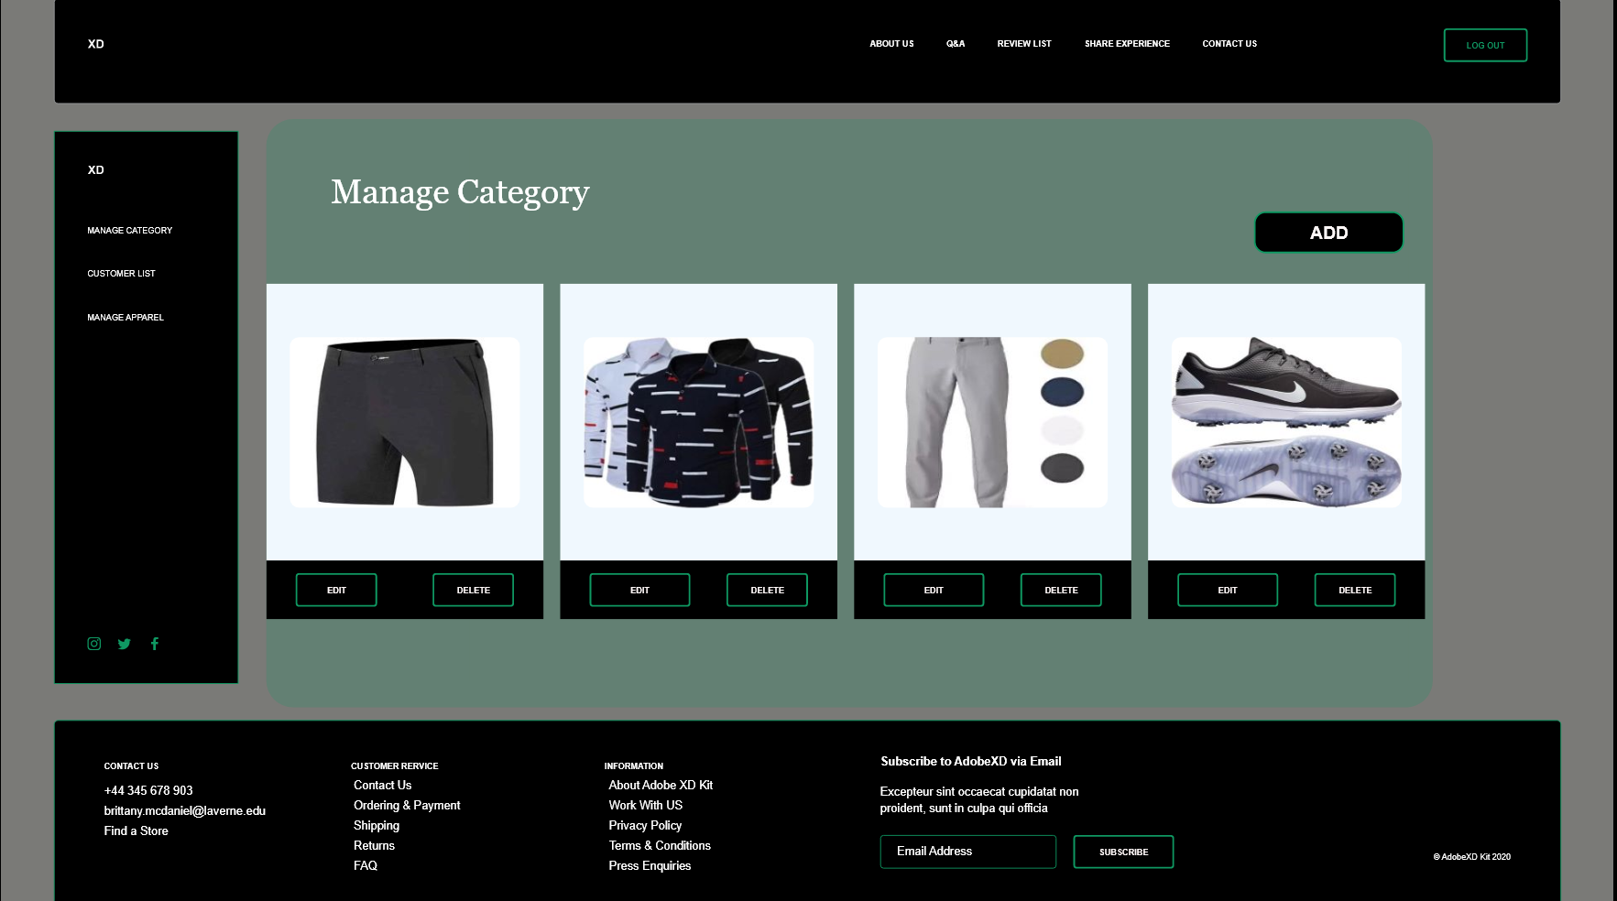

Manage Category –Tablet Manage Category – Phone
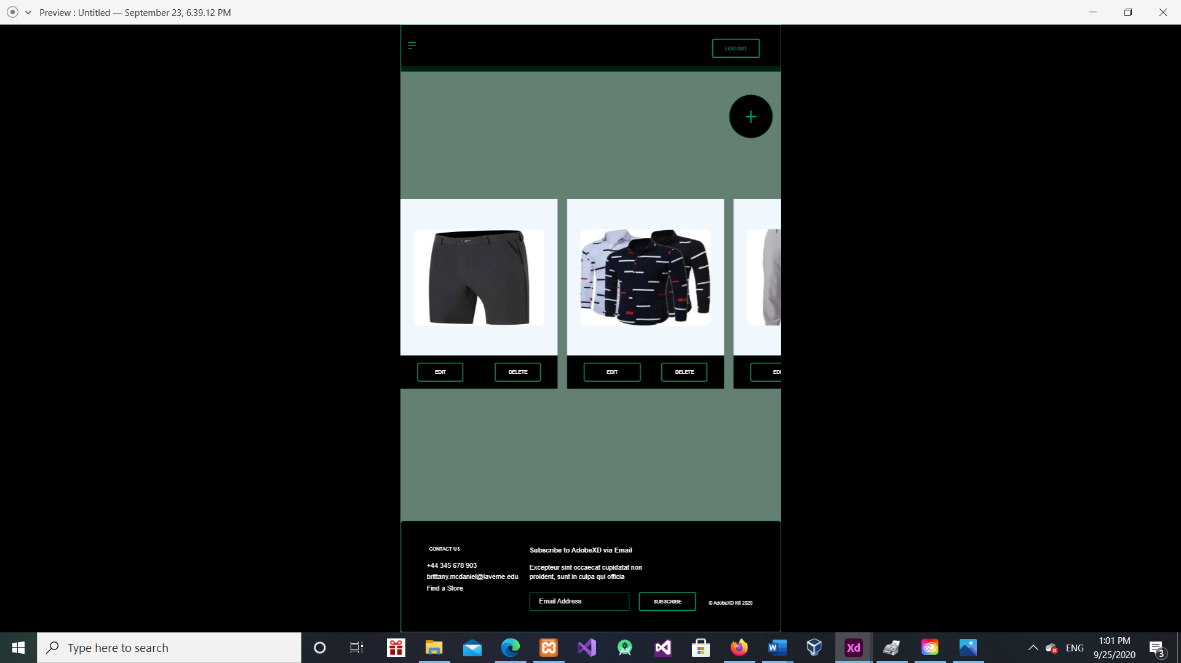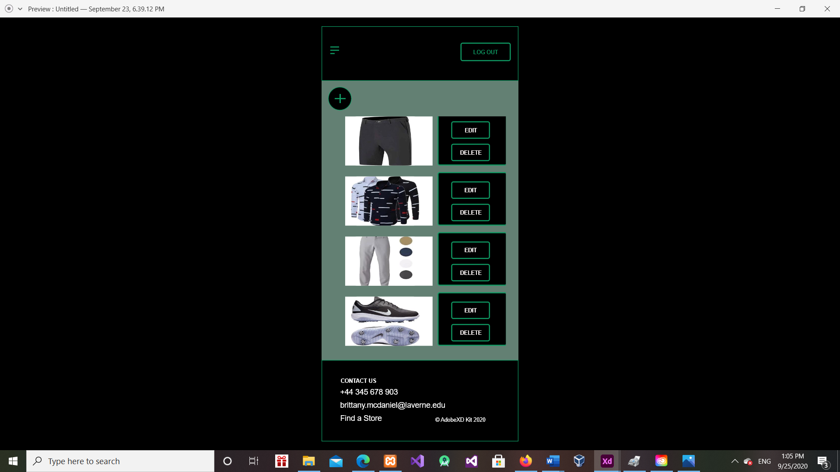
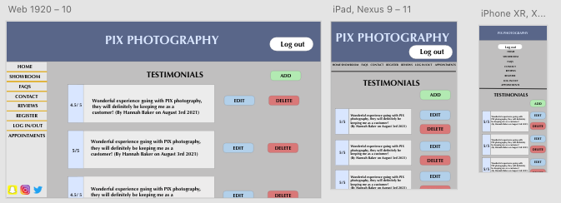
Example of the Testimonials Page. This page will be available to logged in users if they have a review/s, they can add, edit. The delete function will be only available to (SUPER USER)
Recommendation: Put the Edit and Delete buttons on the left side of each record.
All the public pages should use responsive design.
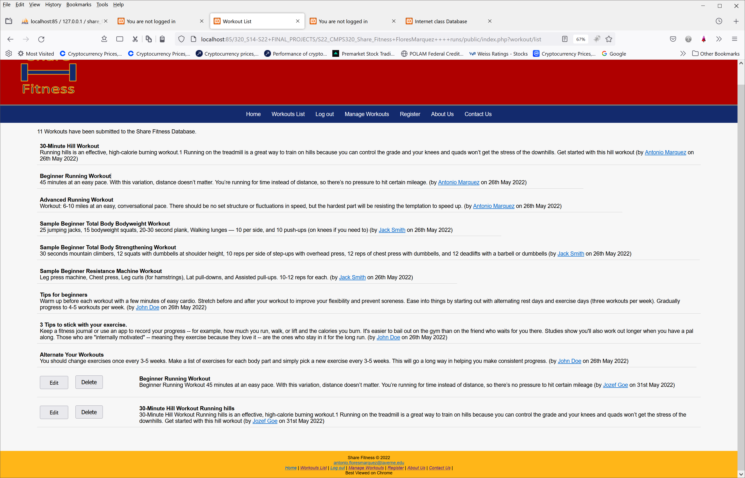

Example of an Interface (as wireframes) to run application/project.

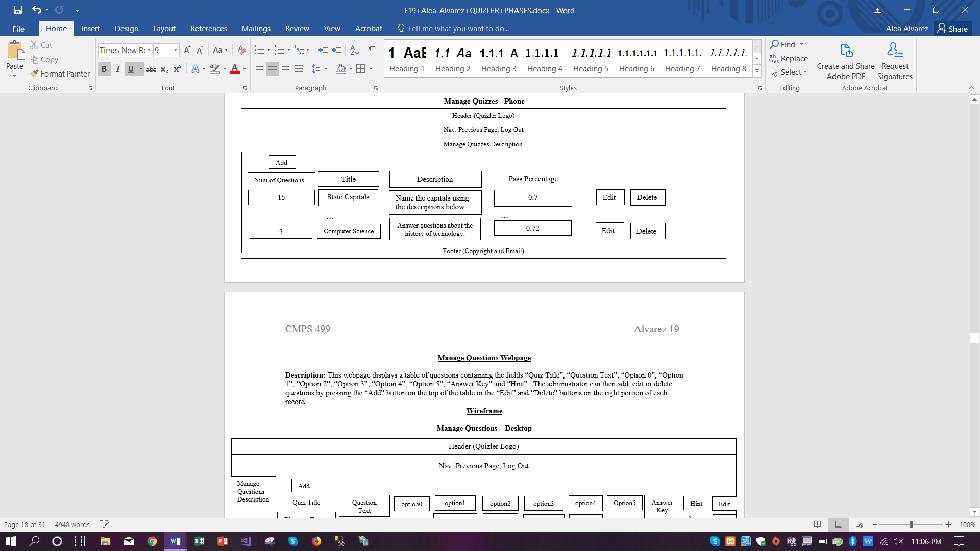
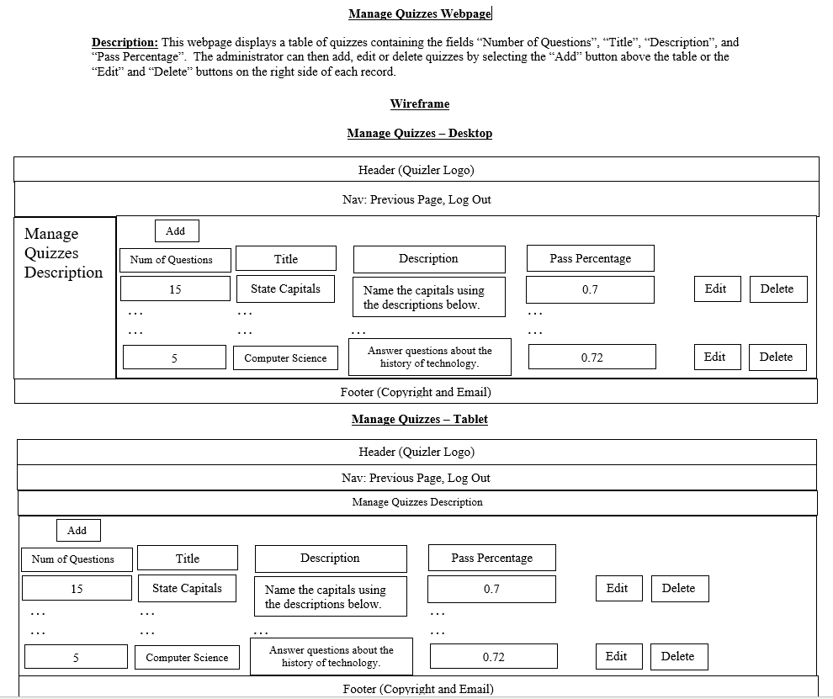

Phase 3:
Attached tested items - fill out the first two columns:

TEST TABLE

Page #/name –  list all pages | Test item  - list hyperlinks,  fields, buttons, videos,  images,  GUI controls, web pages  Schema: select action => reaction  Legend:  => land in | Validation each web page using http://validator.w3.org and  http://jigsaw.w3.org/css-validator/ - if applicable;  attached screenshots with each page name | Outcome  in Mobile  Phone  - specify a device model, version  and source code web server location (- specify your URL | Outcome in  - tablet.  Resolution  1024x768.  Outcome  in Chrome or/and Firefox or Internet Explorer (Edge)  - specify a browser version  and source code web server location (- specify your URL | Outcome in  - desktop.  Resolution  1280*800.  Outcome  in Chrome or/and Firefox or Internet Explorer (Edge)  - specify a browser version  and source code web server location (- specify your URL
Joke List | Test all links:  Logged with full privileges:  - category: Programming Jokes => display all jokes belongs to this category;  - a joke with a Delete button => deletes a joke;  - a joke with a Edit button => edit joke page;  - author => popup an e-mail form | Correct using http://validator.w3.org – attached a screenshot with a page name.  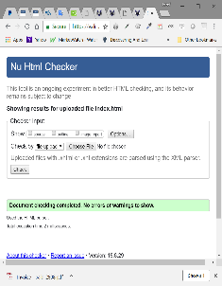 | -Attach a screenshot with a page name.  - Good display.  - All the buttons show without having to drag the horizontal lift on the right or left. | 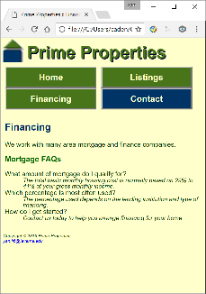  -Attach a screenshot with a page name.  - Good display.  - All the buttons show without having to drag the horizontal lift on the right or left. | -Attach a screenshot with a page name.  - Good display.  - All the buttons show without having to drag the horizontal lift on the right or left.
About | LOGGED OUT:  About=>about.html,  Live Map => map.html,  Contact Us => contact.html  Login => login  Sign Up => create account  LOGGED IN:  About=>about.html,  Live Map => map.html,  Contact Us => contact.html  Dashboard => dashboard.html | Test upon completion of individual pages –  To Be Determined | Test upon completion of individual pages –  To Be Determined | Test upon completion of individual pages –  To Be Determined | Test upon completion of individual pages –  To Be Determined
Login | LOGGED OUT:  About=>about.html,  Live Map => map.html,  Contact Us => contact.html  Login => login  Sign Up => create account  LOGGED IN:  About=>about.html,  Live Map => map.html,  Contact Us => contact.html  Dashboard => dashboard.html
Contact | LOGGED OUT:  About=>about.html,  Live Map => map.html,  Contact Us => contact.html  Login => login  Sign Up => create account  LOGGED IN:  About=>  about.html,  Live Map => map.html,  Contact Us => contact.html  Dashboard => dashboard.html  Both:  Send => send information entered in form
Manage Category | Test all links:  Logged with full privileges:  - category: Programming Category => display all category images that belong to this category;  - a category image with a Add button => add another category  - a category image with a Delete button => deletes category image;  - a category image with a Edit button => manage category page;
Manage Shopping | Test all links:  Logged with full privileges:  - category: Programming Shopping => display all shopping images that belong to this category;  - a shopping image with a Edit button => manage shopping page;  - a shopping image with a Delete button => subtracts from total calculation;  - a shopping image with a Add button => adds to total calculation;

