Test Plan and Results:
Page name | Test item | Validation | Outcome  In mobile phone | Resolution  1024x768  -tablet | Resolution  1280*800  -desktop
index.html | - Home txt link => home page  - Listings txt link =>Listings page  - Financing txt link => Financing page  - Contact txt link => not implemented  - E-mail => popup an e-mail form | Correct using http://validator.w3.org –  See above  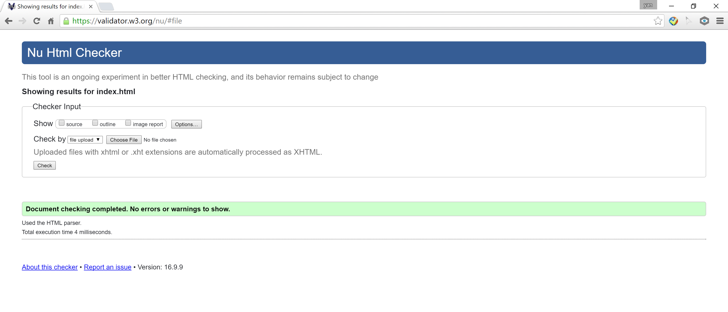 | - Good display in Chrome.  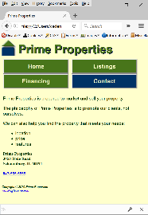  - Good display in Mozilla.  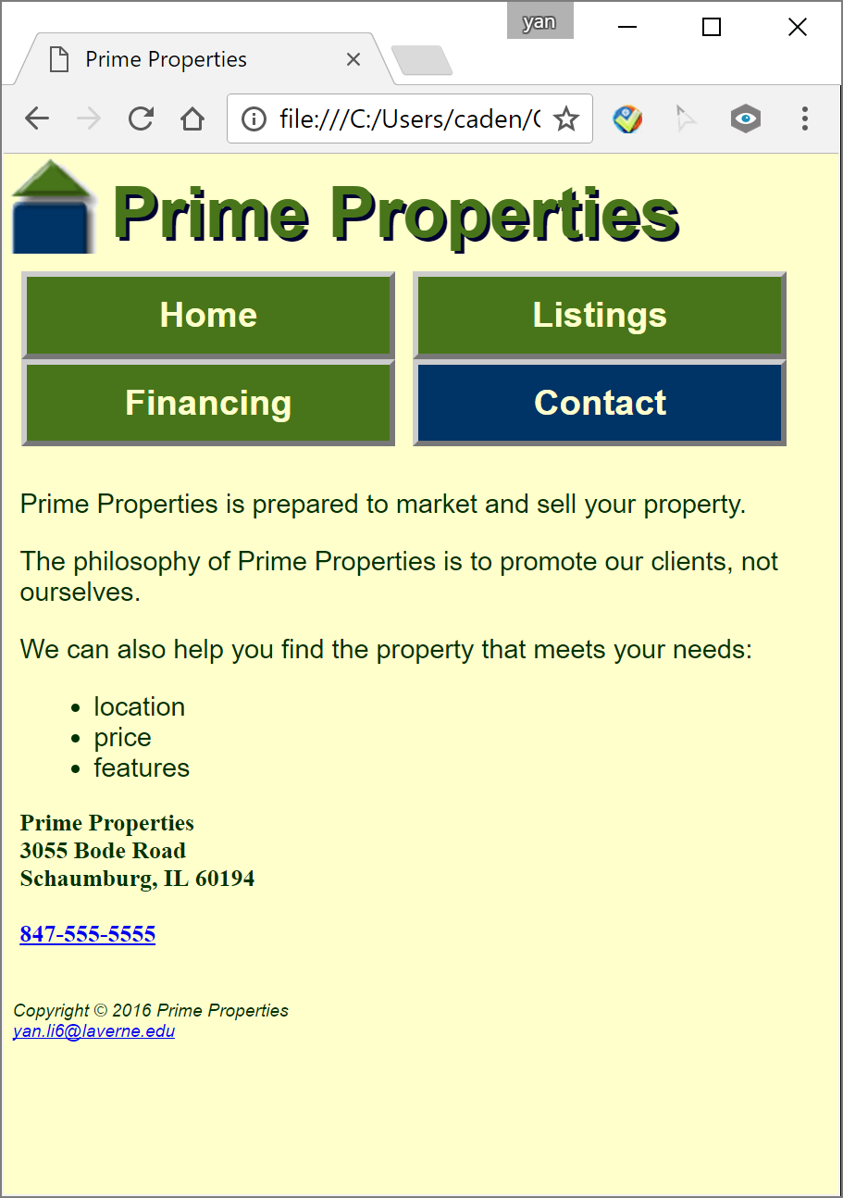 | - Good display in Chrome. 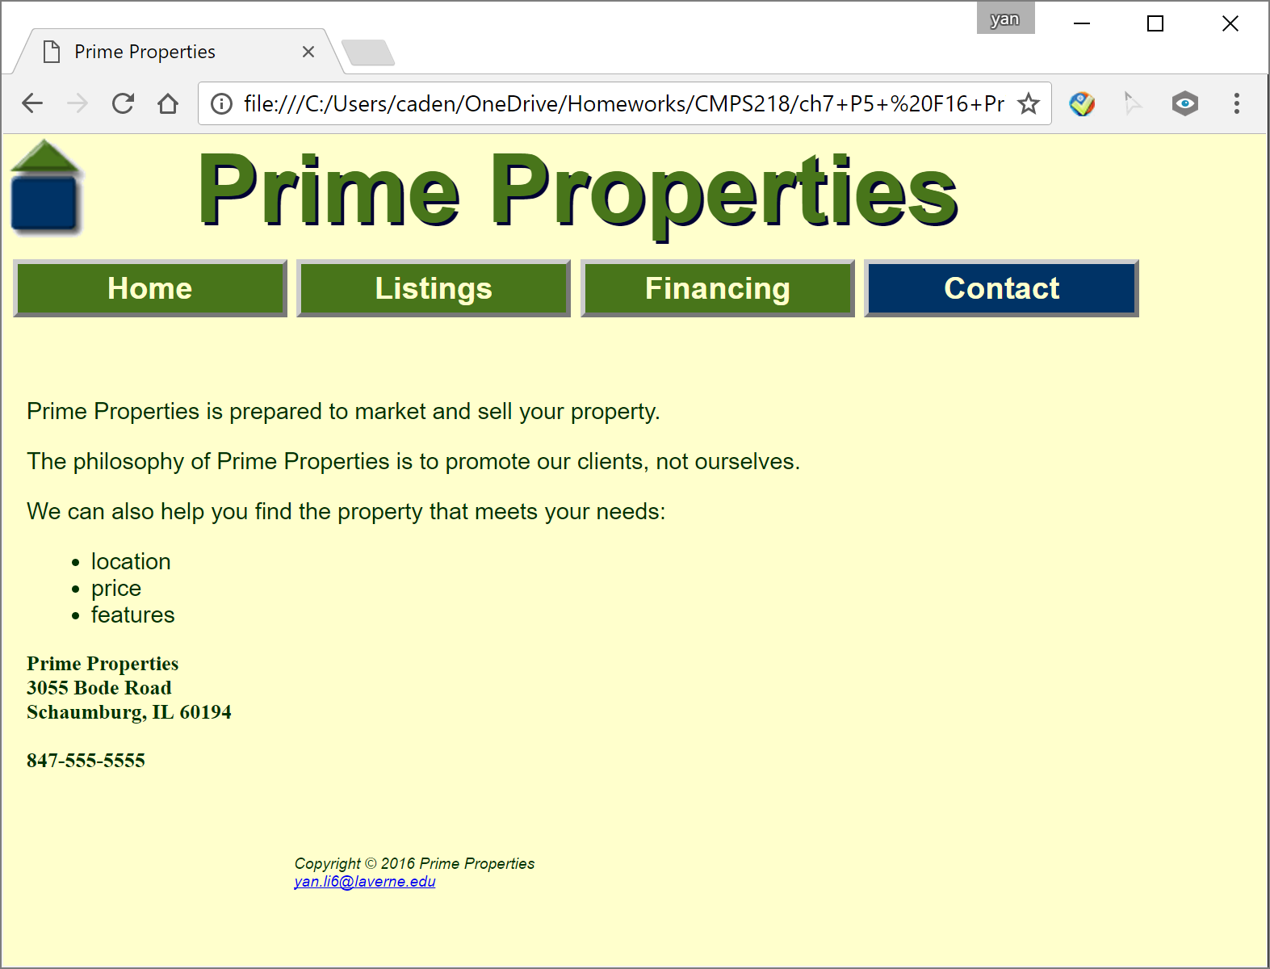  - Good display in Mozilla.  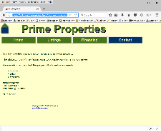 | - Good display in Chrome.  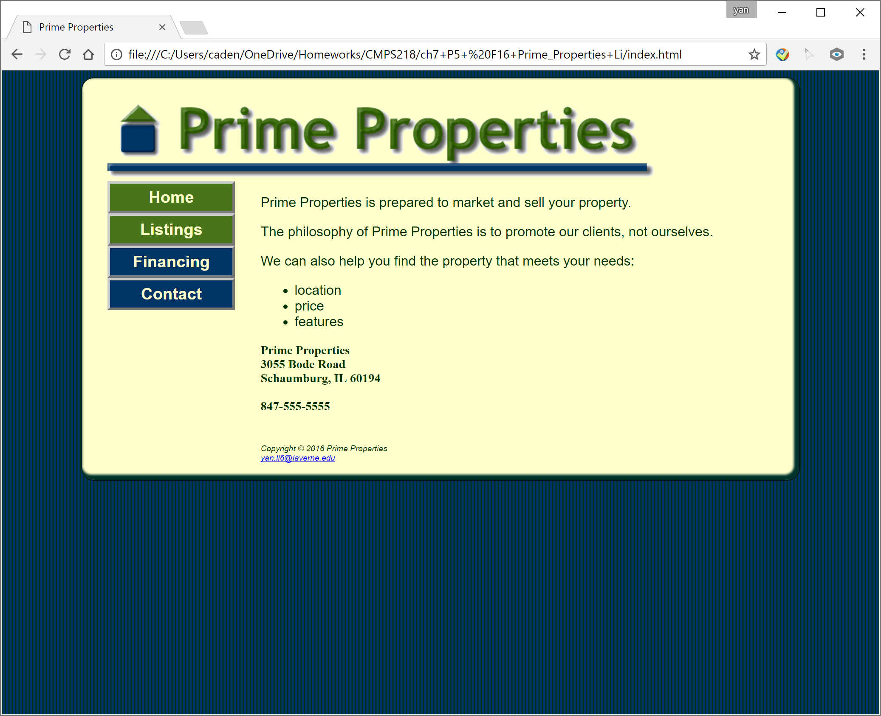  - Good display in Mozilla.  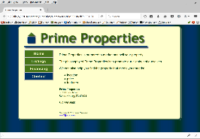
listings.html | - Home txt link => home page  - Listings txt link =>Listings page  - Financing txt link => Financing page  - Contact txt link => not implemented  - E-mail => popup an e-mail form  - Schaumberg thumbnail => Load up the full size image.  - Libertyville thumbnail => Load up the full size image. | Correct using http://validator.w3.org  See above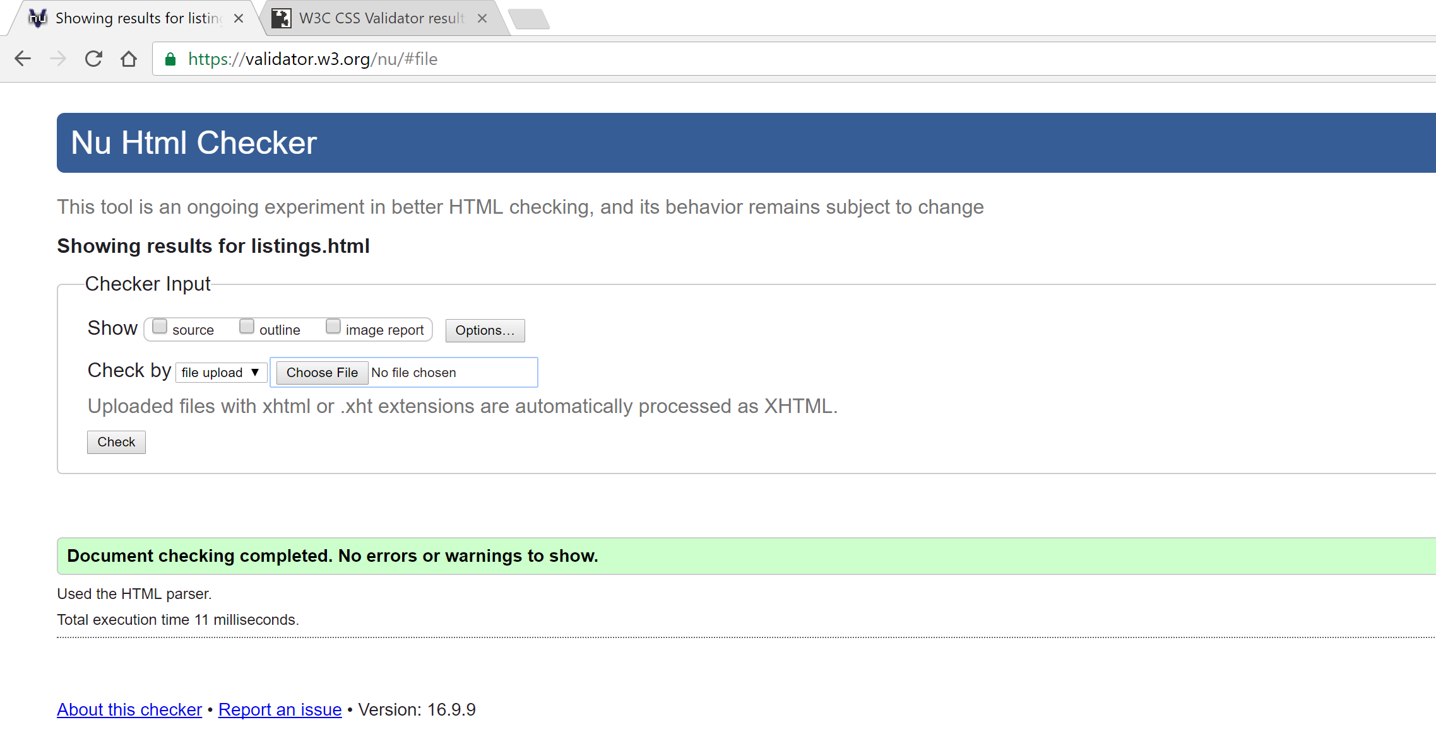 | 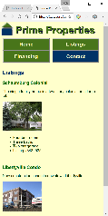  - Good display in Chrome.  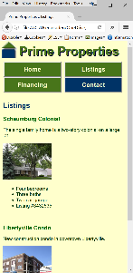  - Good display in Mozilla. | - Good display in Chrome. 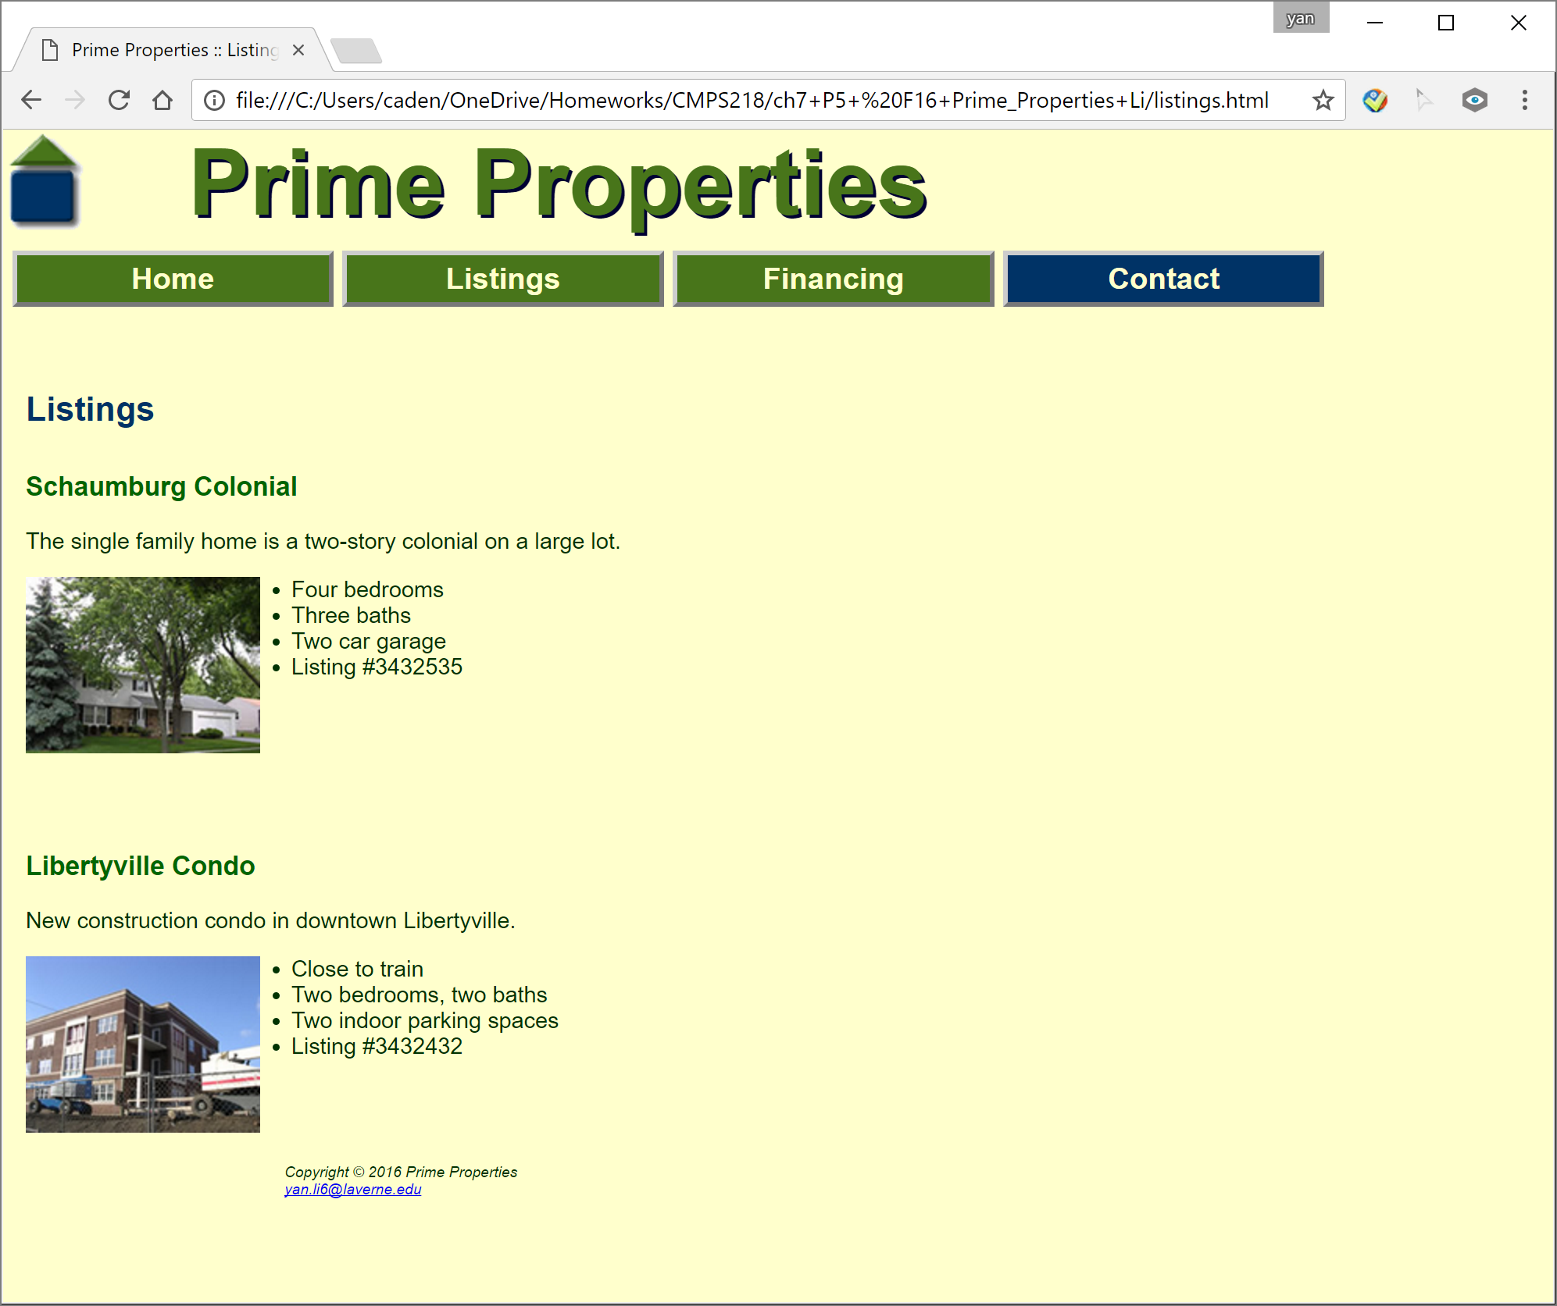  - Good display in Mozilla.  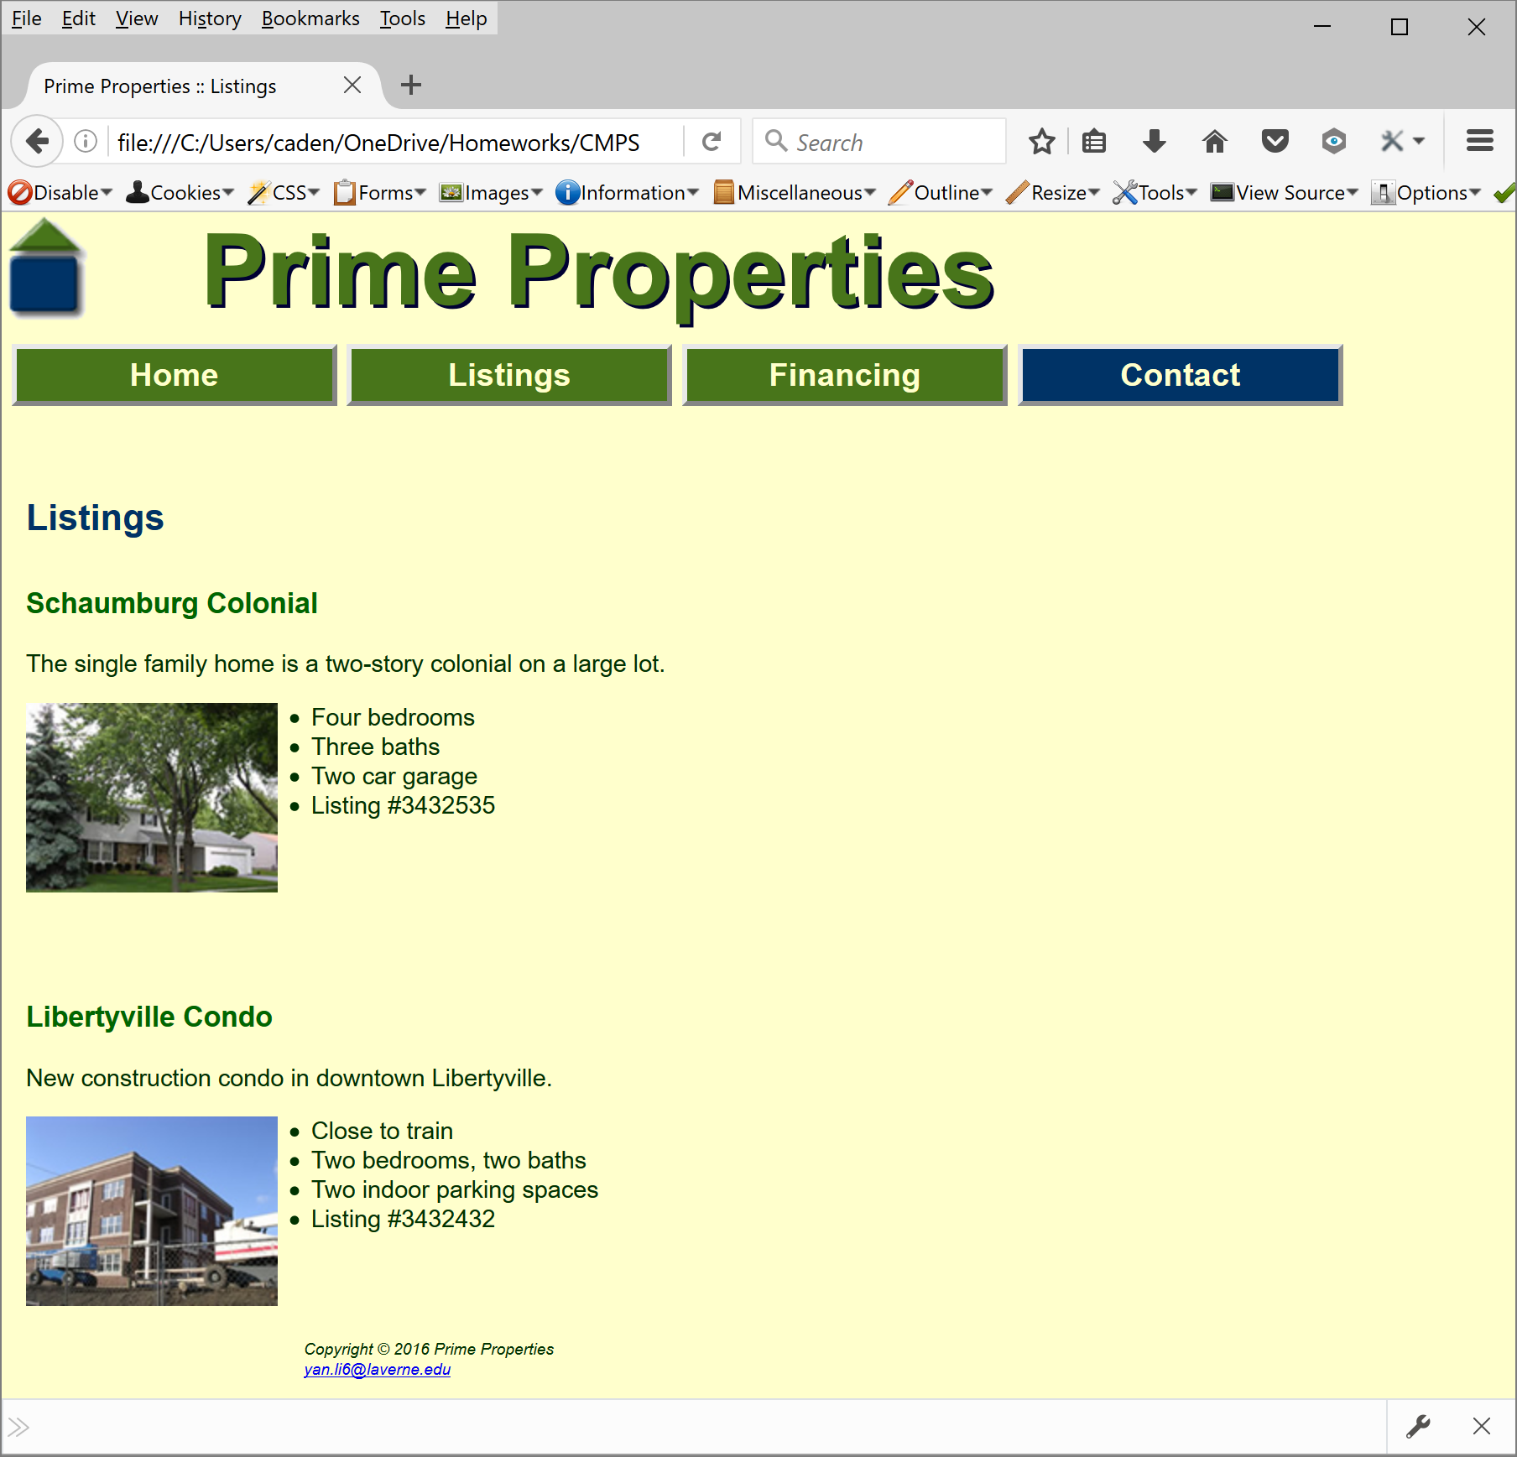 | - Good display in Chrome.  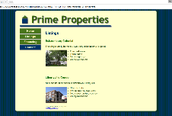  - Good display in Mozilla.  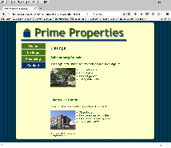
financing.html | - Home txt link => home page  - Listings txt link =>Listings page  - Financing txt link => Financing page  - Contact txt link => not implemented  - E-mail => popup an e-mail form | Correct using http://validator.w3.org  See above  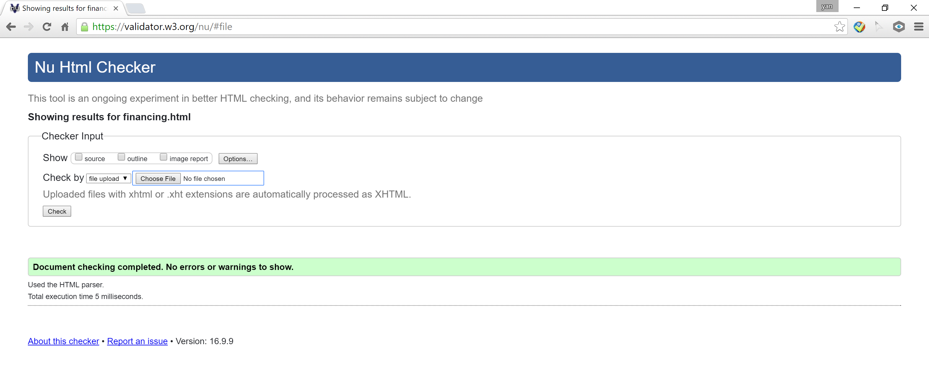 | 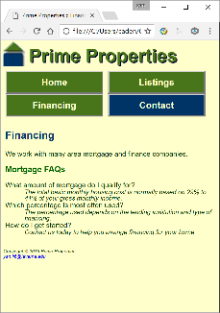  - Good display in Chrome.  - Good display in Mozilla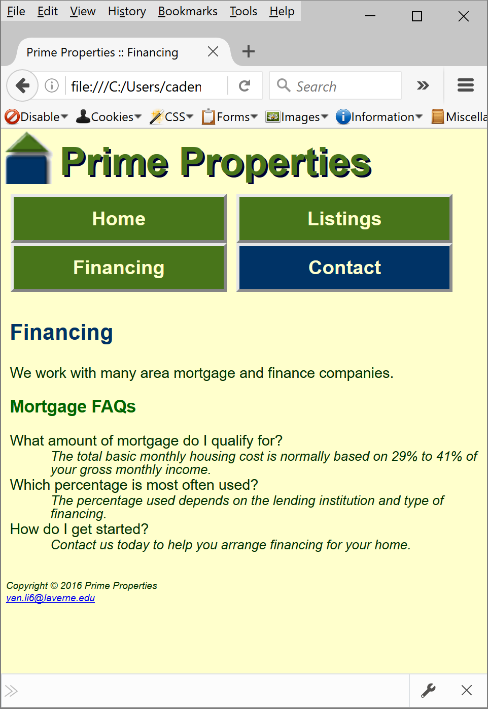 | 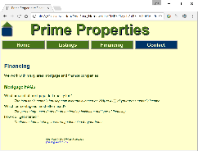  - Good display in Chrome  - Good display in Mozilla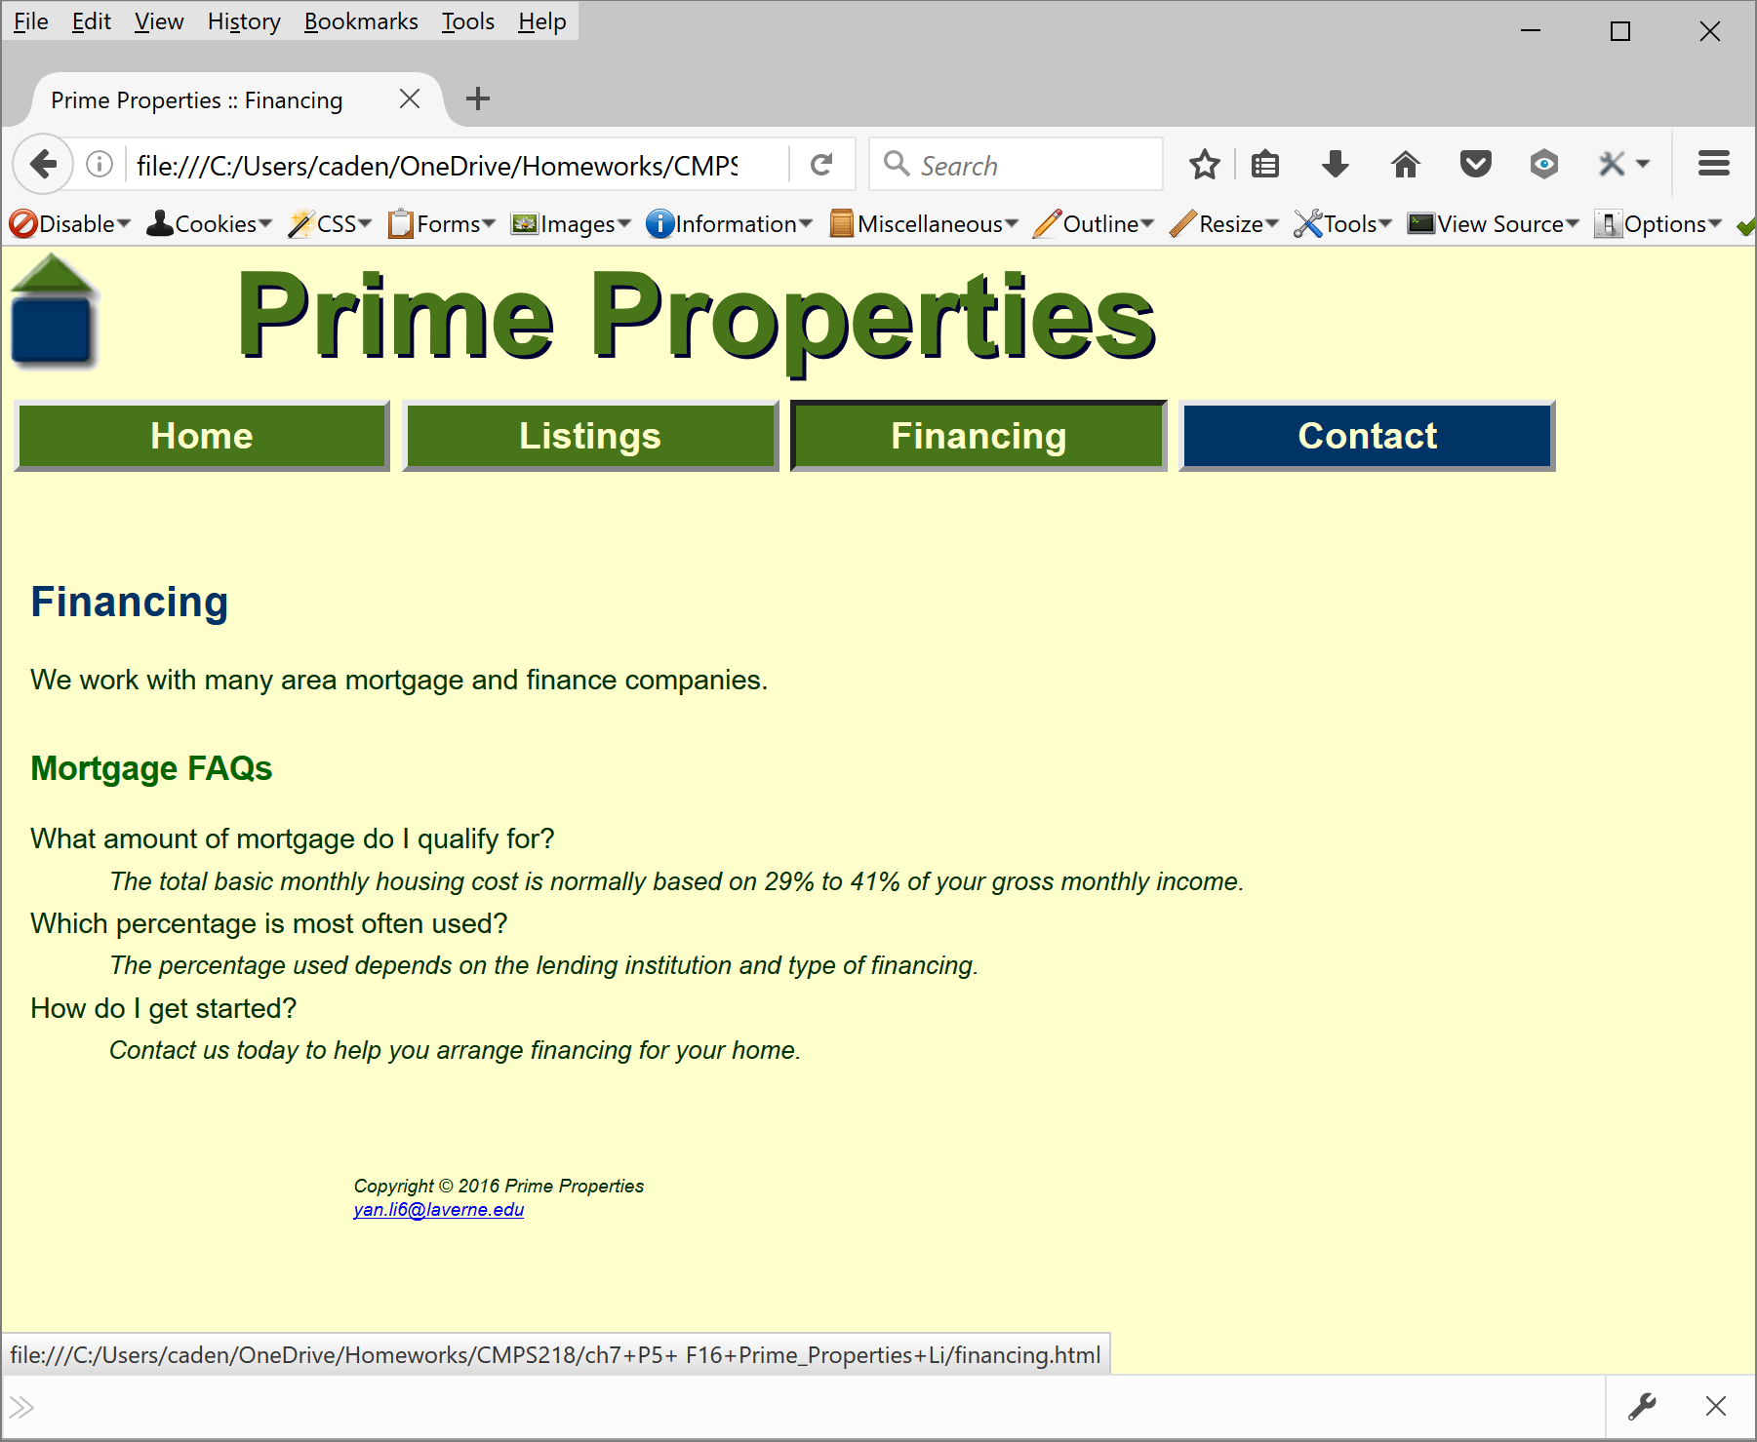 | - Good display in Chrome. 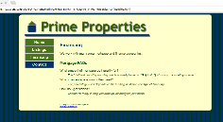  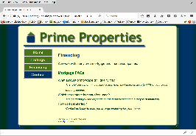  - Good display in Mozilla
contact.html | - Home txt link => home page  - Listings txt link =>Listings page  - Financing txt link => Financing page  - Contact txt link => Contact page  - E-mail => popup an e-mail form | Correct using http://validator.w3.org  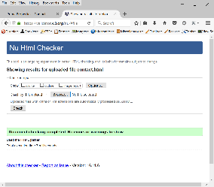 | 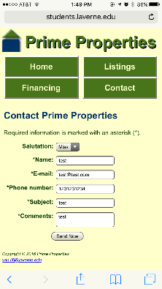  - Good display in smartphone. | - Good display in tablet  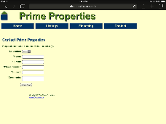 | 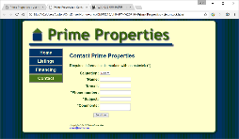  - Good display in Chrome.  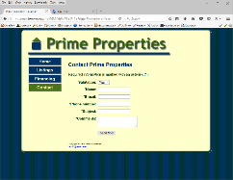  - Good display in Mozilla
contact.html | - Salutation => drop menu select salutation, not required | 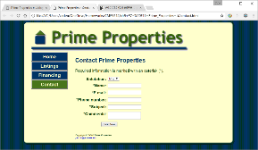
contact.html | - Name => input name, leaving blank page will prompt error msg | 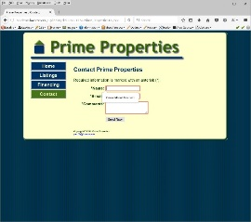
 | - Email => input email. Leaving blank or incorrect format page will prompt error msg. | 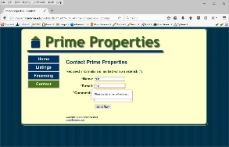  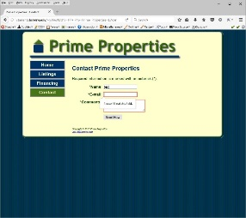  Leave blank  Wrong format
 | - Phone #=>  Input phone #, leaving blank will prompt error mgs. In safari incorrect format will not be allowed | 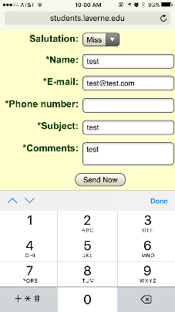  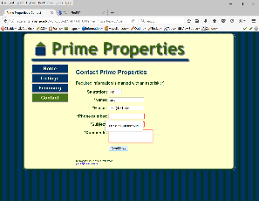  leave blank  in iphone
 | - subject  =>input subject, leaving blank will prompt error msg. | 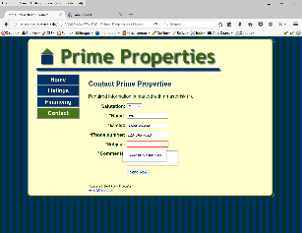
 | - Comments  =>input comments, leaving blank page will prompt error msg | 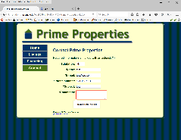
 | - send now  =>  submit the form | 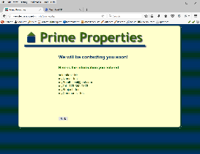
Prime.css |  | Correct using http://jigsaw.w3.org/css-validator/  See above