Course Name (CMPS-218)
Fall 2021
T 6:00 – 9:20 pm

Project #: 1
Title: Path of Light Yoga Studio Chapter 2
Due Date: 09/07/21
GROUP #: (Don’t have a number yet)

Specify only your two student group names below:
Grade:
e-mail: Vicky.baquerizo@laverne.edu Submitted by Vicky Torres, class id:
major: Information Technology concentration: N/A
Grade:

Grade Rubric:
Y  I=N= | Description = 10%,  a lack of  Legend:  Incomplete  No | Y  I  N | 2. Design = 10%,  a lack of | Y  I  N | 3.  Screenshots = 20% , a lack of | Y  I  N | 4.  Code = 45%,  a lack of | Y  I  N | 5.  Test Plan and Results = 15%,  a lack of
   | reduction
  poor descr | -5%
  cover page | -5%
   | reduction
  site map | -5%
  wirefra-me | -5%
  screenshot of proj  location | -5%
   | reduction
  web  pages | up to  -10%
  code | up to  -10%
  validators | up to  -10%
   | reduction
  references | up to  -20%
  highlights changes | up to  – 20%
  personal comments | up to  -20%
   | reduction
  page names | up to  -10%
  test items | up to  -10%
  validator screens | up to  -10%
  outcome | up to  -10%

Submitted to
Prof. Jozef Goetz
University of La Verne, La Verne

Description-
Path of Light Yoga Studio is a small, recently opened yoga studio. The owner, Ariana Starrweaver, would like a website to showcase her yoga studio and provide information for both new and current students. Arian would like a home page, a classes page that contains information about the types of yoga classes offered, a schedule page, and a contact page.

Design-
Site Map:

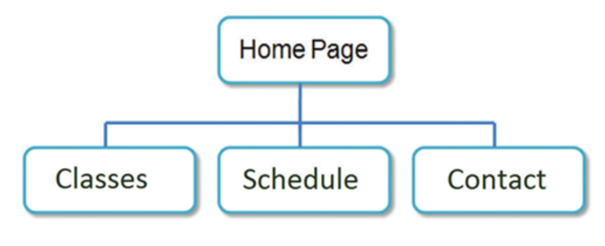
Wireframe:

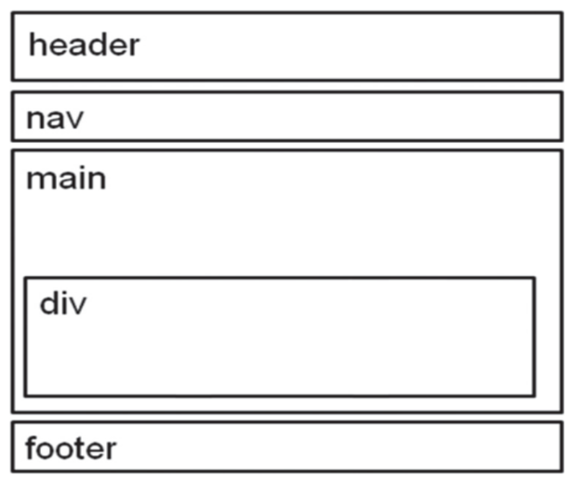

Website Project Location:
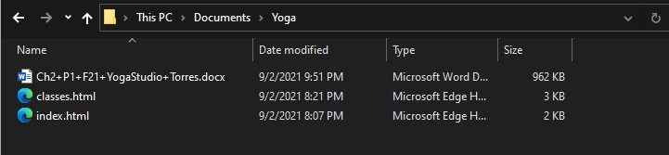

Screenshots of “HOME” page:
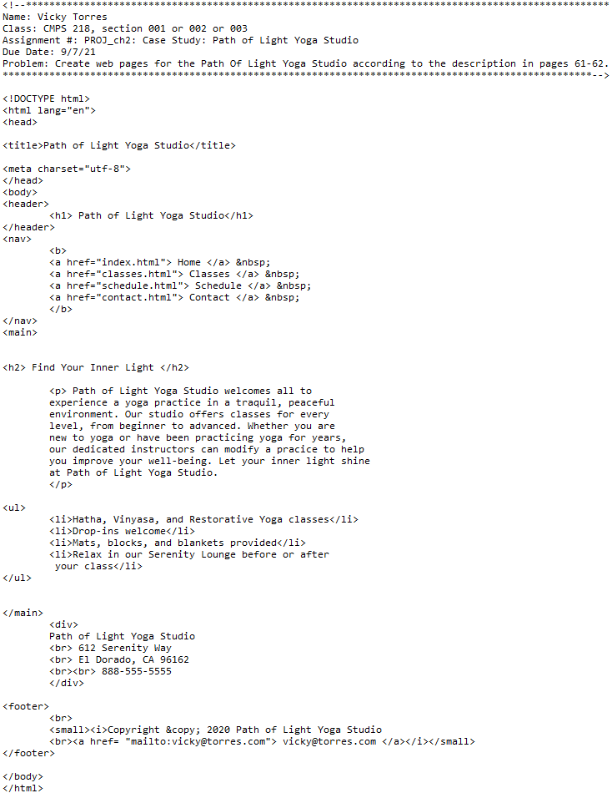
T2-1
T2-1
T2-2
T2-3
T2-4a
T2-4b
T2-4c
T2-4d
T2-5
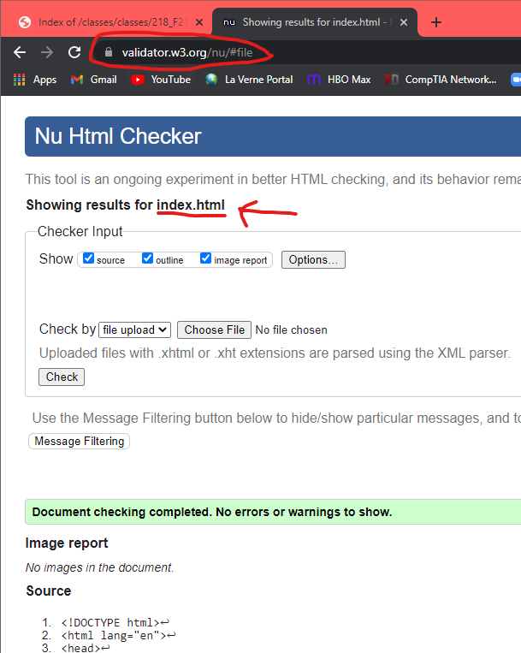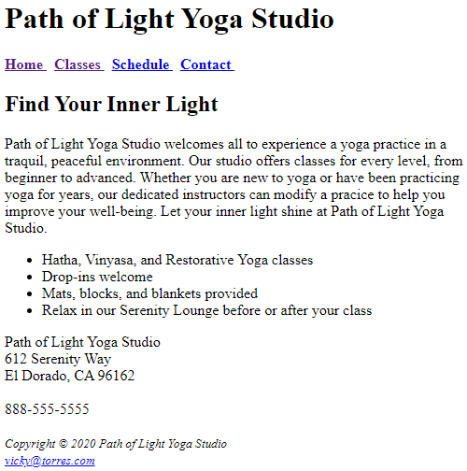
T2-3
T2-2
T2-5
T2-4d
T2-4c
T2-4b

T2-4a
Screenshots of “CLASSES” page:
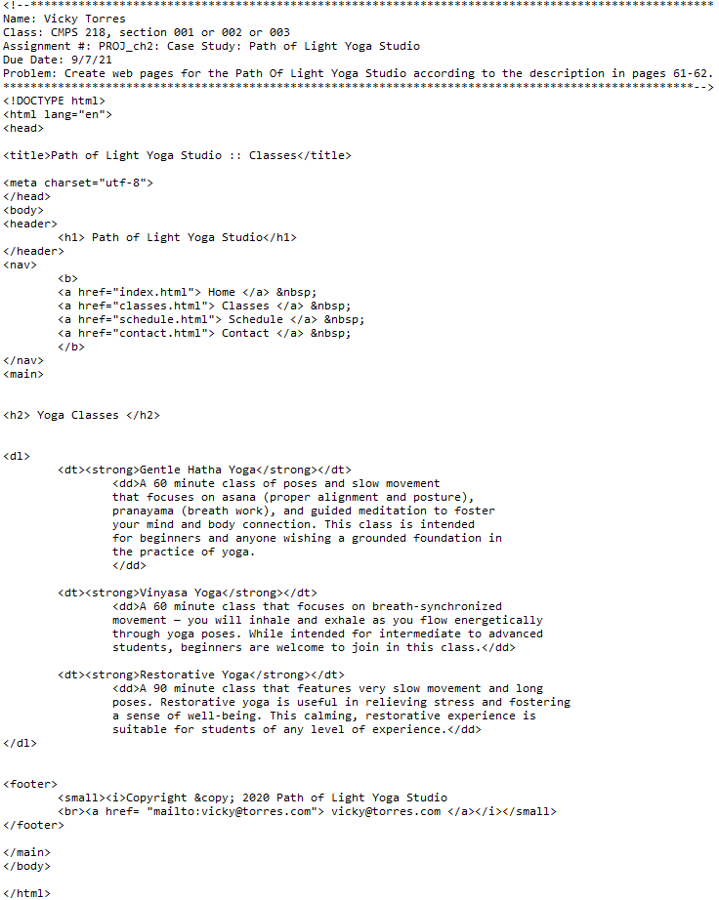
T3-1
DONE
T3-2a
T3-2c
T3-2c
T3-2b
T3-1
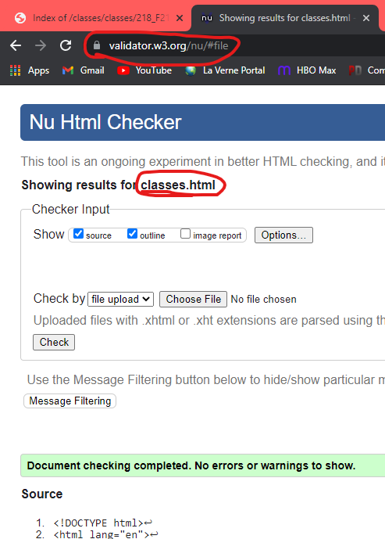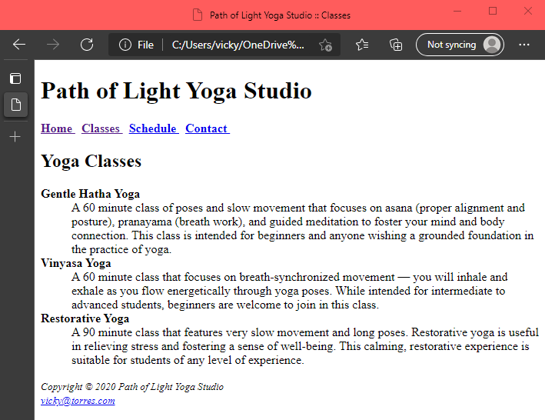
T3-2b
T3-2c
Test Plan and Results:
- Page name | - Test item | - Validation | Resolution  1280*800 Desktop
index.html | Home txt link => home page  Classes txt link =>classes descriptions  Schedule txt link => not implemented yet  Contact txt link => not implemented yet  E-mail => popup an e-mail form | Correct using http://validator.w3.org –  See above  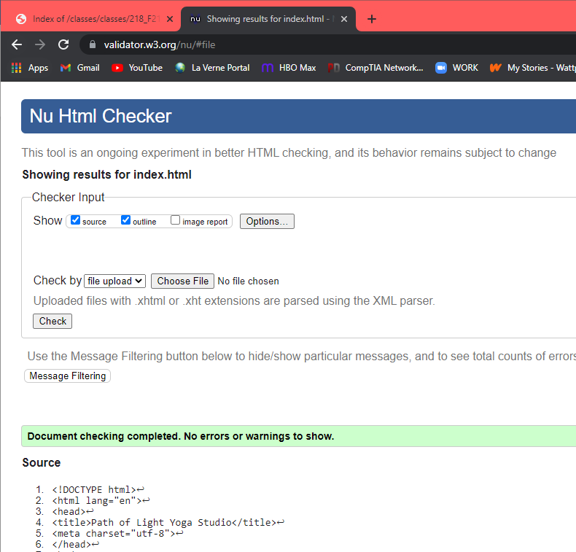 | - Good display in Chrome.  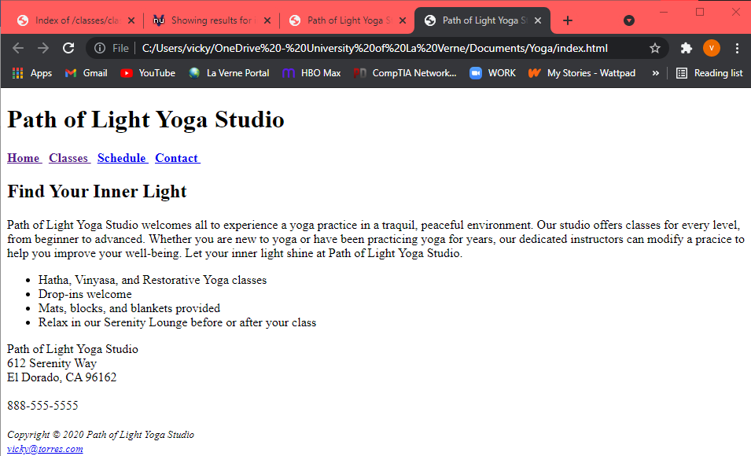  - Good display in Microsoft Edge  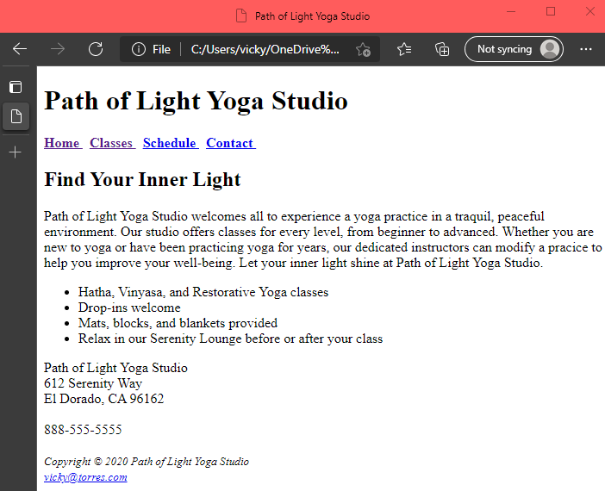
classes.html | Home txt link => home page  Classes txt link  =>classes descriptions  Schedule txt link => not implemented yet  Contact txt link => not implemented yet  E-mail => popup an e-mail form | Correct using http://validator.w3.org  See above  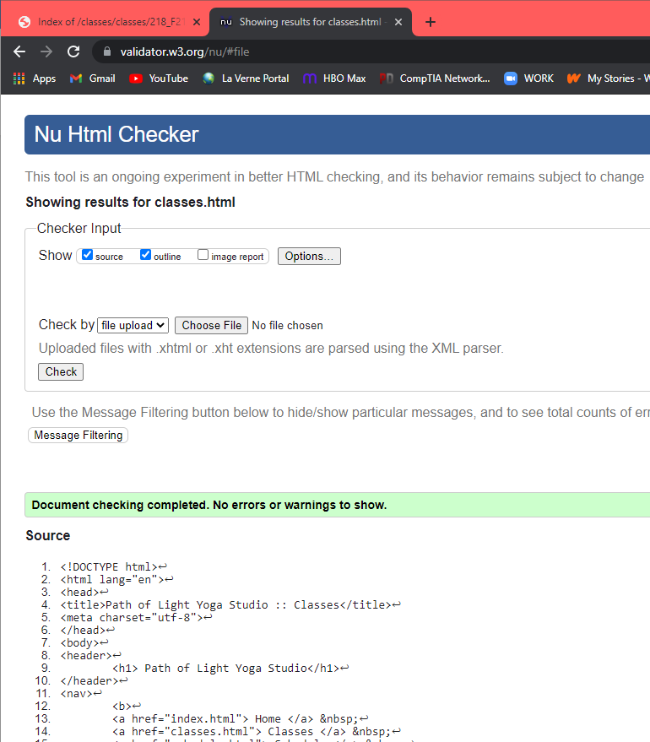 | - Good display in Chrome.  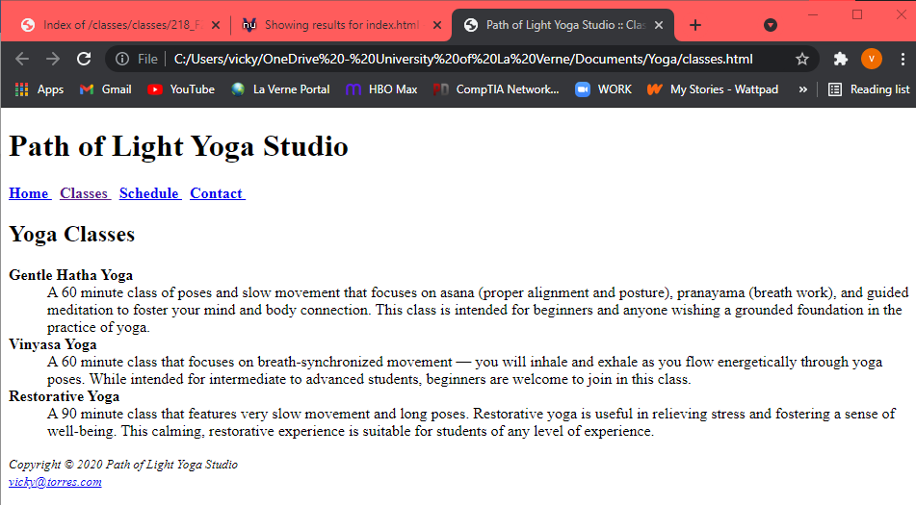  - Good display in Microsoft Edge.  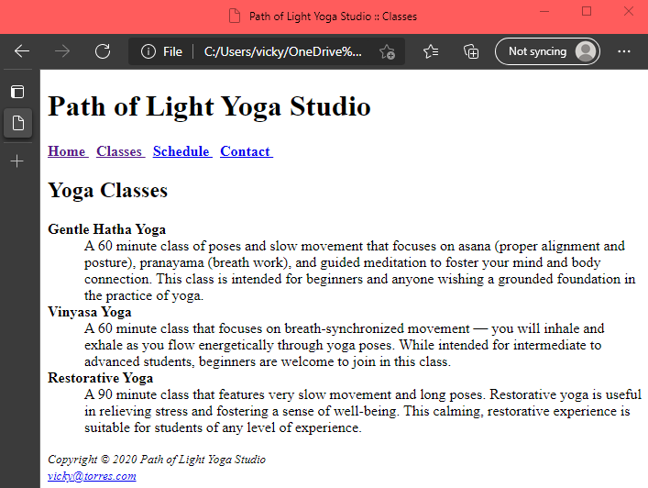
Email to: “vicky@torres.com ” | Home txt link => home page  Classes txt link  =>classes descriptions  Schedule txt link => not implemented yet  Contact txt link => not implemented yet  E-mail => popup an e-mail form | Correct using http://validator.w3.org | Link works in Chrome  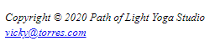  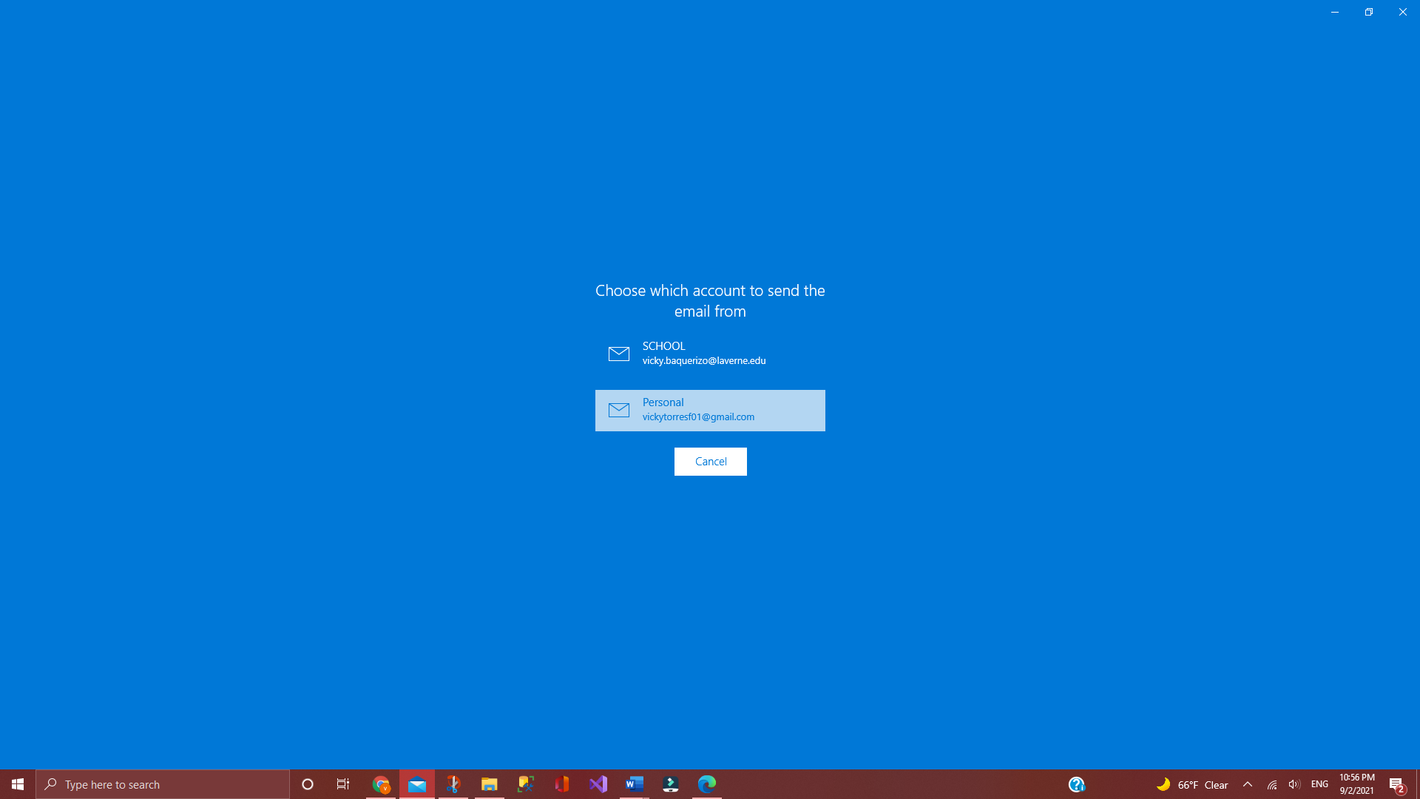  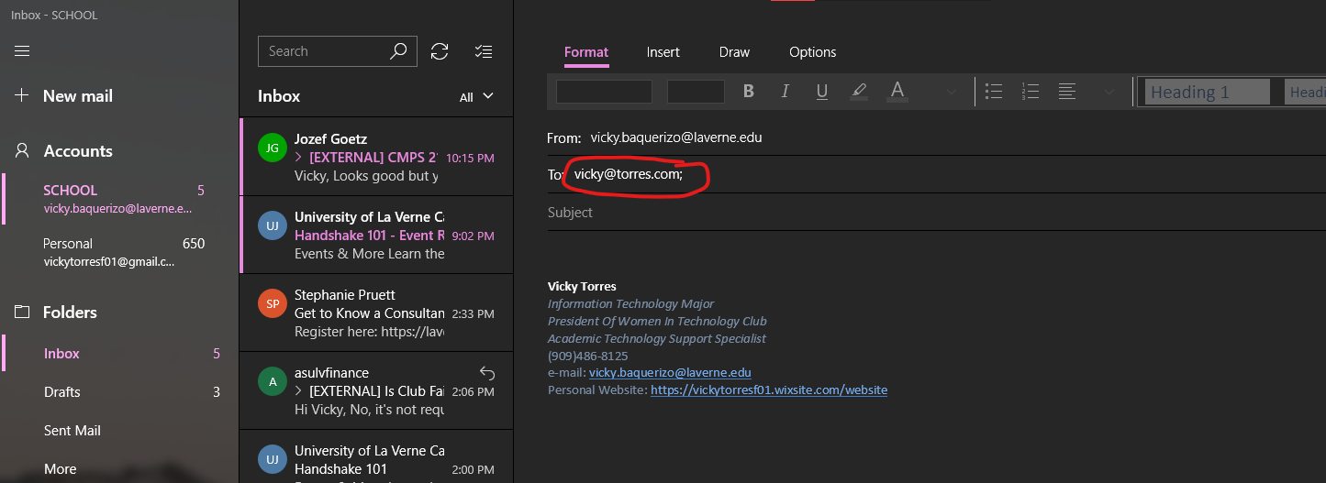  Link works in Microsoft Edge  