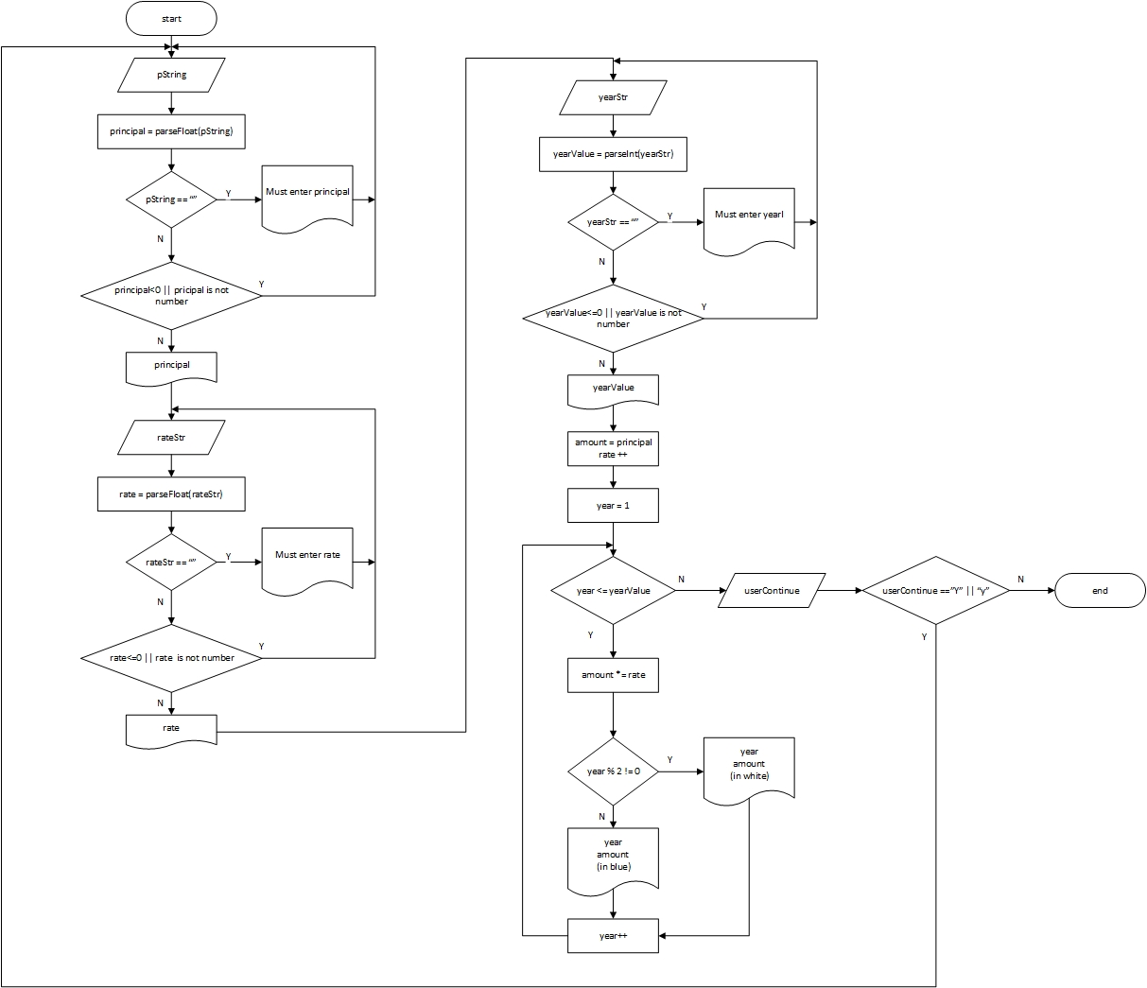
Flowchart – interest rate with user entering principal, rate and years

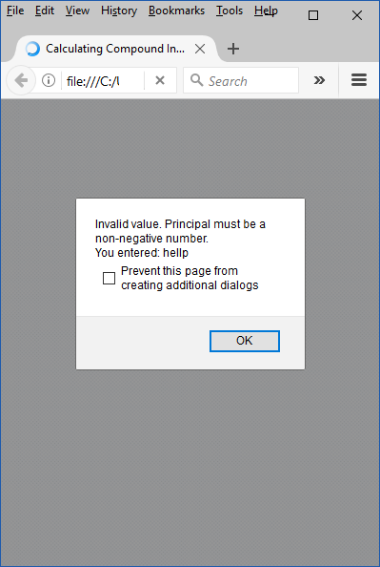
Screenshots of the output and error handling
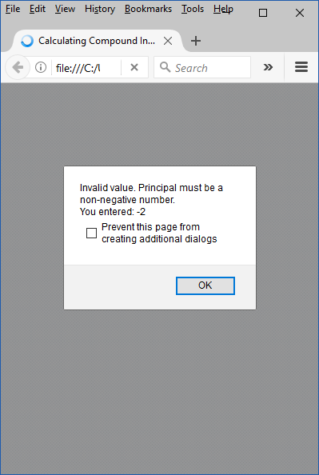
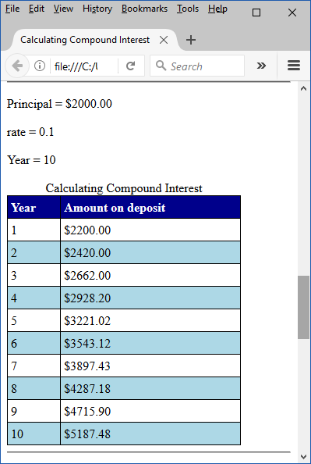
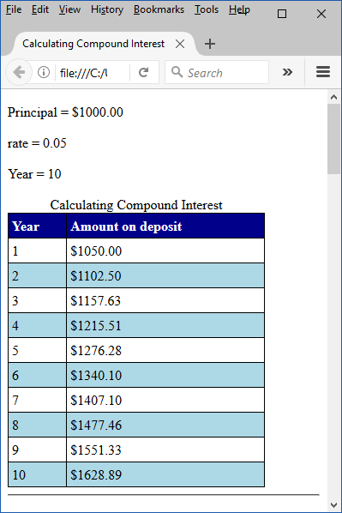

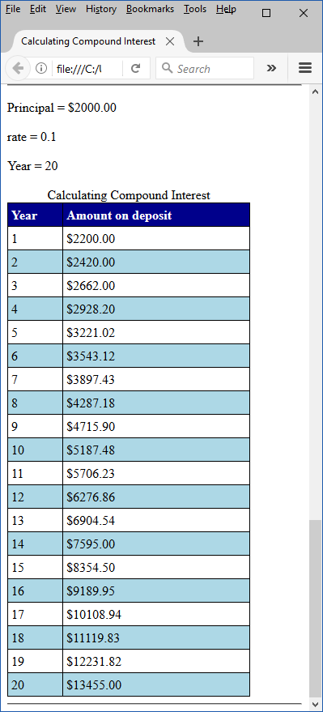
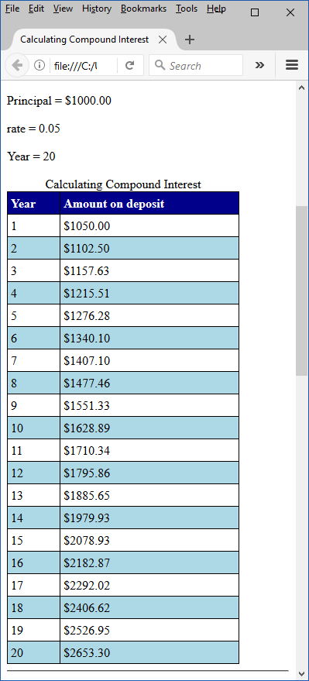

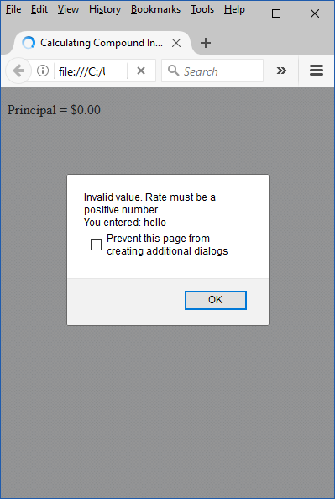
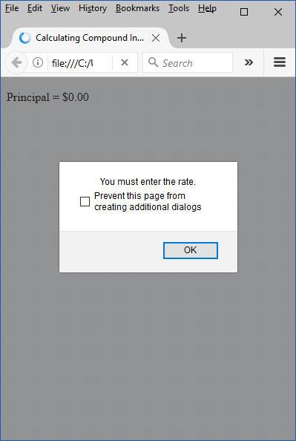
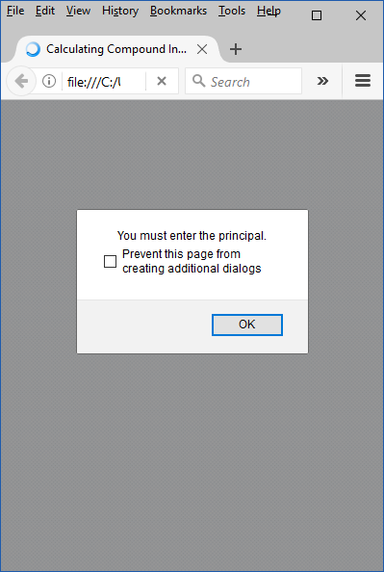

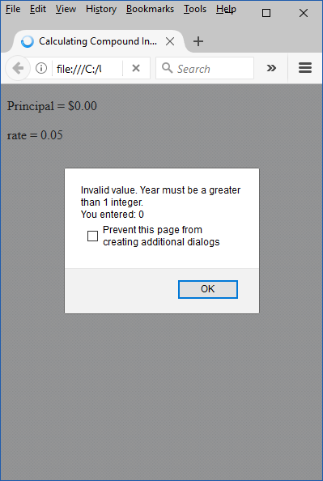
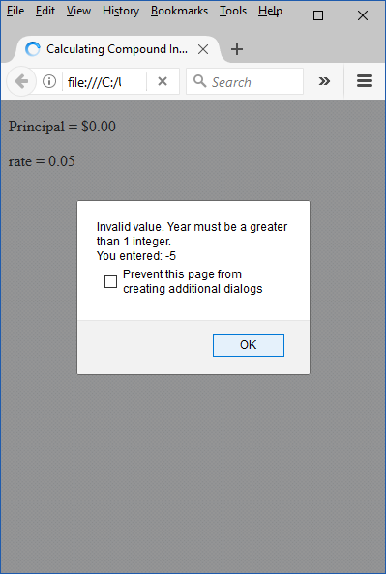
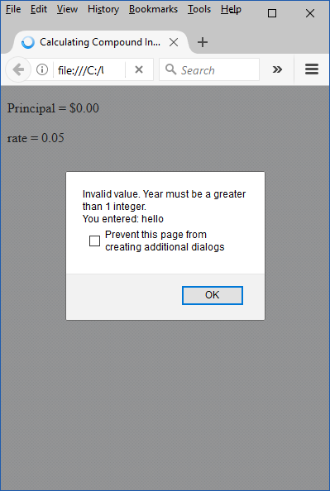
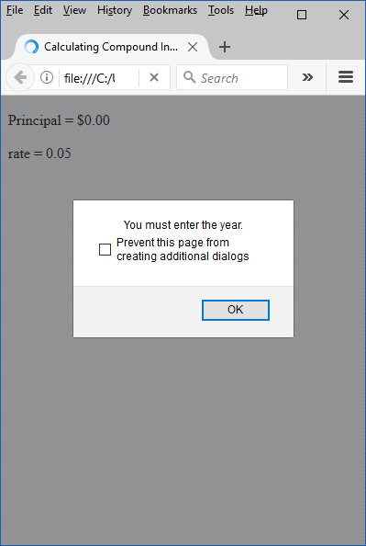
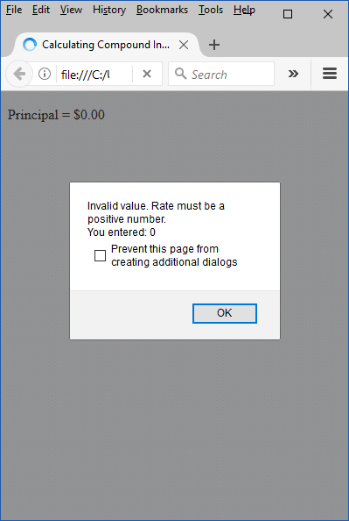
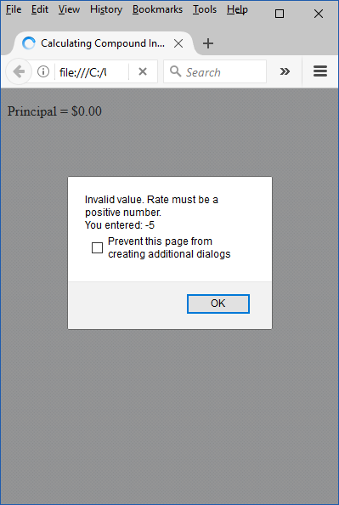

Source Code
<!DOCTYPE html>

<!-- Fig. 8.6: Interest.html -->
<!-- Compound interest calculation with a for loop. -->
<html>
<head>
<meta charset = "utf-8">
<title>Calculating Compound Interest</title>
<style type = "text/css">
table { width: 300px;
border-collapse:collapse;
background-color: lightblue; }
table, td, th { border: 1px solid black;
padding: 4px; }
th { text-align: left;
color: white;
background-color: darkblue; }
tr.oddrow { background-color: white; }
</style>
<script>
/************************************
* Name: Yan Li
* Class: CPMS 319
* Assignment #: Assignment 3, Ch8: Interest
* Date Due: 3/29/16
* Problem: calculate the deposit for n years according to the
rate, principal, year which user entered.
******************************************************************/

var amount; // current amount of money
var principal = 1000.00; // principal amount
var rate = 0.05; // interest rate
// 3-23-17 YL NEW 4L: declaration 3 value to read
var pString;
var rateStr;
var yearStr;
var yearValue;
// 3-23-17 YL NEW 1L: user Continue
var userContinue;

// 3-23-17 YL NEW 1L: do loop if user click yes
do{

// 3-23-17 YL NEW 6L: read amount
do{
pString = window.prompt("Enter the principal","0");
principal = parseFloat(pString);
if(!pString) // 3-24-17 YL NEW 2L: prompt if string is empty
window.alert("You must enter the principal.");
else if( principal<0||isNaN(principal) ) // 3-24-17 YL MOD 1L: prompt error msg
window.alert("Invalid value. Principal must be a non-negative number."+
"\nYou entered: "+pString);
}while(principal<0||isNaN(principal)); // end while

// 3-23-17 YL NEW 1L: echo principal
document.writeln("<p>Principal = $"+principal.toFixed(2)+"</p>");

// 3-23-17 YL NEW 6L: read rate
do{
rateStr = window.prompt("Enter the rate","0.05");
rate = parseFloat(rateStr);
if (!rateStr) // 3-24-17 YL NEW 2L: prompt if string is empty
window.alert("You must enter the rate.");
else if( rate<=0||isNaN(rate) ) // 3-24-17 YL MOD 1L: prompt error msg
window.alert("Invalid value. Rate must be a positive number."+
"\nYou entered: "+rateStr);
}while(rate<=0||isNaN(rate)); // end while

// 3-23-17 YL NEW 1L: echo rate
document.writeln("<p>rate = "+rate+"</p>");

// 3-23-17 YL NEW 6L: read year
do{
yearStr = window.prompt("Enter the year","1");
yearValue = parseInt(yearStr);
if(!yearStr) // 3-24-17 YL NEW 2L: prompt if string is empty
window.alert("You must enter the year.");
else if( yearValue<=0||isNaN(yearValue) // 3-24-17 YL MOD 1L: prompt error msg
window.alert("Invalid value. Year must be a greater than 1 integer."+
"\nYou entered: "+yearStr);
}while(yearValue<=0||isNaN(yearValue)); // end while

// 3-23-17 YL NEW 1L: echo
document.writeln("<p>Year = "+yearValue+"</p>");

document.writeln( "<table>" ); // begin the table
document.writeln(
"<caption>Calculating Compound Interest</caption>" );
document.writeln(
"<thead><tr><th>Year</th>" ); // year column heading
document.writeln(
"<th>Amount on deposit</th>" ); // amount column heading
document.writeln( "</tr></thead><tbody>" );

// 3-23-17 YL NEW 2L: initialize amount and rate = rate +1
amount = principal;
rate ++;

// output a table row for each year
for ( var year = 1; year <= yearValue; ++year )
{
//amount = principal * Math.pow( 1.0 + rate, year );
// 3-23-17 YL NEW 1L: calculate amount
amount *= rate;

if ( year % 2 !== 0 )
// 3-23-17 YL MOD 1L: add dollar sign
document.writeln( "<tr class='oddrow'><td>" + year +
"</td><td>$" + amount.toFixed(2) + "</td></tr>" );
else
// 3-23-17 YL MOD 1L: add dollar sign
document.writeln( "<tr><td>" + year +
"</td><td>$" + amount.toFixed(2) + "</td></tr>" );
} //end for

document.writeln( "</tbody></table><hr>" ); // 3-24-17 YL MOD 1L:add horizontal rule

// 3-23-17 YL NEW 1L: read continue
userContinue = window.prompt("Continue?","y");
} while(userContinue == "Y" || userContinue == "y"); // 3-23-17 YL NEW 1L: end while
</script>
</head><body></body>
</html>

