TABLE: Test plan and results (example) - Verification Matrix:

See my example for Ch2Project (Ch2P) in 1_Project_Submittals-Test_Plan+with_screenshots_ch2P.docx
1. Page #/name –  list all pages | 2. Test item  - list hyperlinks,  fields, buttons, videos,  images,  GUI controls, web pages  Schema: click  action => reaction  Legend:  => means  land in | 3. Validation each web page using http://validator.w3.org and  http://jigsaw.w3.org/css-validator/ - if applicable;  attached screenshots with each page name | 4. Outcome  in Mobile  Phone  - specify a device model, version  and source code web server location (- specify your URL | 5. Outcome in  - tablet.  Resolution  1920x1080  Outcome  in Chrome or/and Firefox or Internet Explorer (Edge)  - specify a browser version  and source code web server location (- specify your URL | 6. Outcome in  - desktop.  Resolution  1440*900.  Outcome  in Chrome or/and Firefox or Internet Explorer (Edge)  - specify a browser version  and source code web server location (- specify your URL
1. index.html | Home txt link => home page  Listings txt link  =>Listings page  Financing txt link => Financing page  Contact txt link => not implemented  Home button img => home  Listings img =>Listings page  Financing img => Financing page  Contact img => not implemented  E-mail => popup an e-mail form | Page #{specify} in your report.  Correct using http://validator.w3.org – attached a screenshot with a page name.  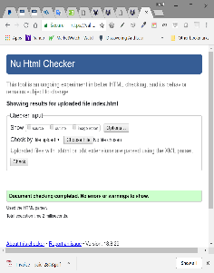 | Page #{specify} in your report.  -Attach a screenshot with a page name.  - Good display.  - All the buttons show without having to drag the horizontal lift on the right or left.  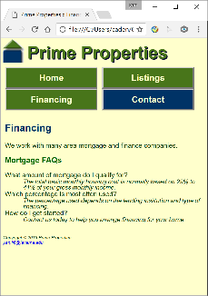 | Page #{specify} in your report.  -Attach a screenshot with a page name.  - Good display.  - All the buttons show without having to drag the horizontal lift on the right or left.  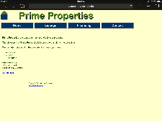 | Page #{specify} in your report.  -Attach a screenshot with a page name.  - Good display.  - All the buttons show without having to drag the horizontal lift on the right or left.  - Good display in Chrome.  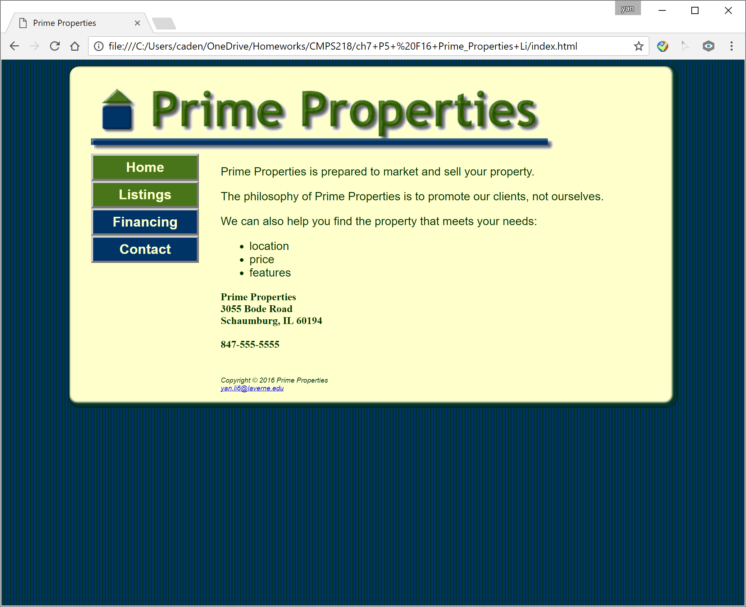  - Good display in Mozilla.  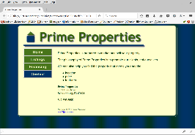
1. index.html | Buttons  (if available) | Test upon completion of individual pages | Test upon completion of individual pages | Test upon completion of individual pages | Test upon completion of individual pages
1. index.html | Text Links  (if available) | ? | ? | ? | ?
1. index.html | Image Links (if available) | ? | ? | ? | ?
2. financing.html | Home txt link => home page  Listings txt link =>Listings page  Financing txt link => Financing page  Contact txt link => not implemented  Home img => home  Listings img =>Listings page  Financing button img => Financing page  Contact img => not implemented  E-mail => popup an e-mail form | Page # {specify} in your report.  Correct using http://validator.w3.org  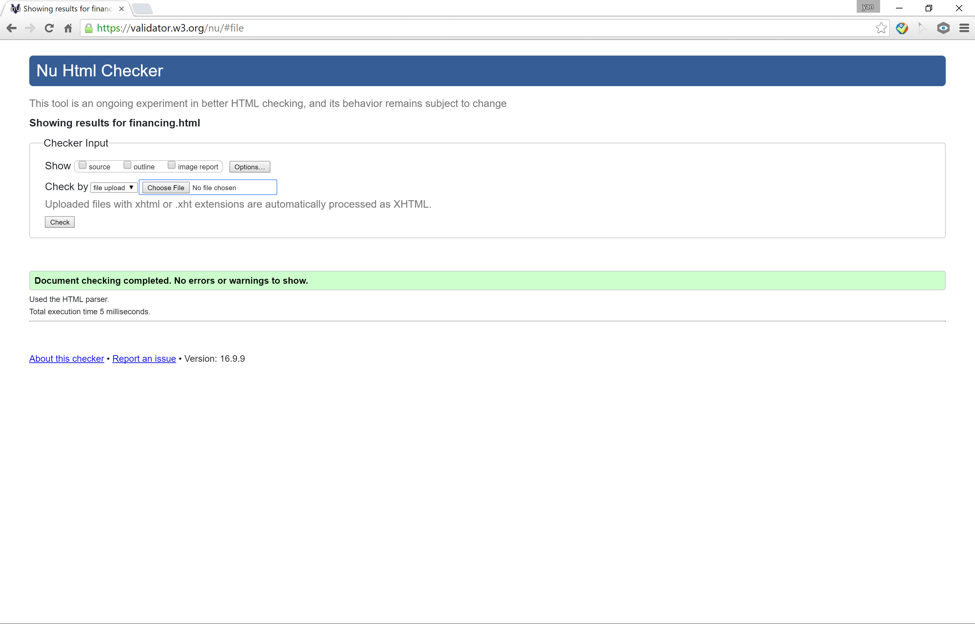. | Page # {specify} in your report.  - Good display in Chrome.  - Good display in  Mozilla  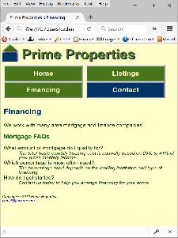 | Page # {specify} in your report.  - Good display in Chrome  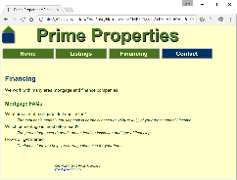  - Good display in  Mozilla  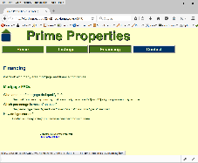 | Page # {specify} in your report.  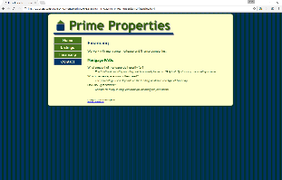  Good display in Mozilla  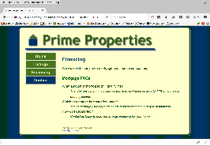
3.  music.html - | Greg Thumbnail Image |  | Load up the Full size image of Greg | Load up the Full size image of Greg | Load up the Full size image of Greg
3.  music.html - | Jobs | None yet as page not made | Comes up with error as page isn’t defined | Page saying Internet Explorer cannot display the web page | Page saying what?
c1. main.css |  | Correct using http://jigsaw.w3.org/css-validator/ – attached a screenshot with a page name
4.  Contact_us.html  -used HTML5 | Name => input name, leaving a blank page will prompt an error msg. |  | Page # {specify} in your report.  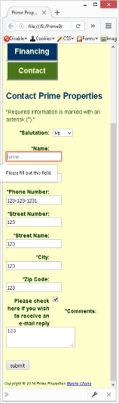 | Page # {specify} in your report.  Show a correct error  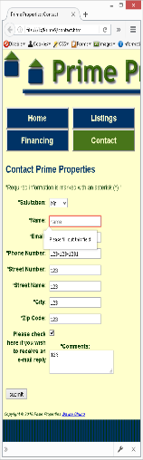 | Page # {specify} in your report.  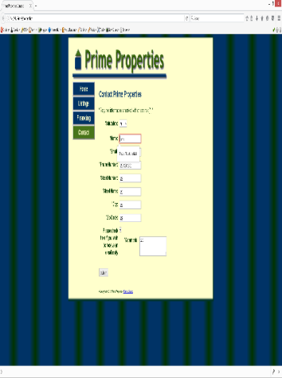  Show a correct error
4.  Contact_us.html  -used HTML5 | Email => input email. Leaving a blank or an email incorrect format will prompt an error msg. |  | 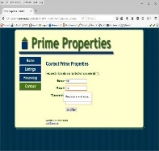  Wrong format | Show a correct error | Show a correct error
  Leave blank
  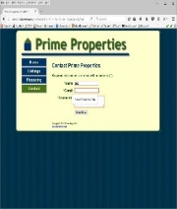
  Leave blank
  Wrong FormatWrong format
4.  Contact_us.html  -used HTML5 | Phone # => input phone #. Leaving a blank or a phone # in incorrect format will prompt an error msg. |  | 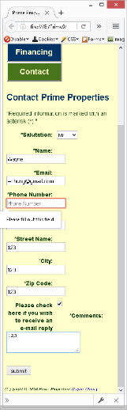 | 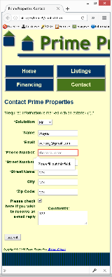 | 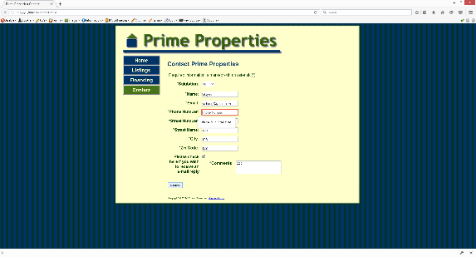
4. Contact_us.html  -used HTML5 | A submit button | Correct using http://validator.w3.org – attached a screenshot with a page name | Show a message from a web server | Show a message from a web server | Show a message from a web server
main.css |  | Correct using http://jigsaw.w3.org/css-validator/ – attached a screenshot with a page name
main.js | JavaScript |  | Validation your JavaScript code ( if applicable) – specify a validator name;  attached screenshots with each page name

