University of La Verne
Connecting to VDI

- Navigate to: https://vdi.laverne.edu/
You may be met with a warning page, it is OK to bypass and proceed to the site:

Google Chrome: click on Advanced
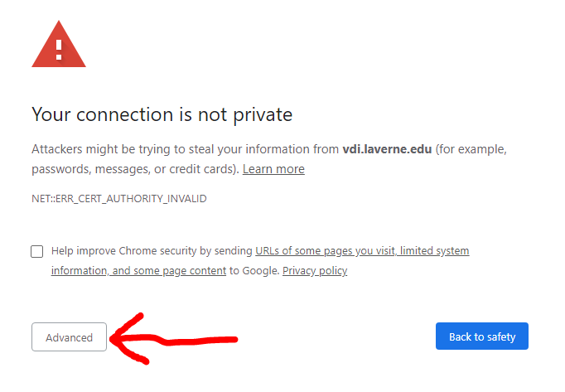
On your connection is not private click on Proceed to VDI.Laverne.edu(unsafe)
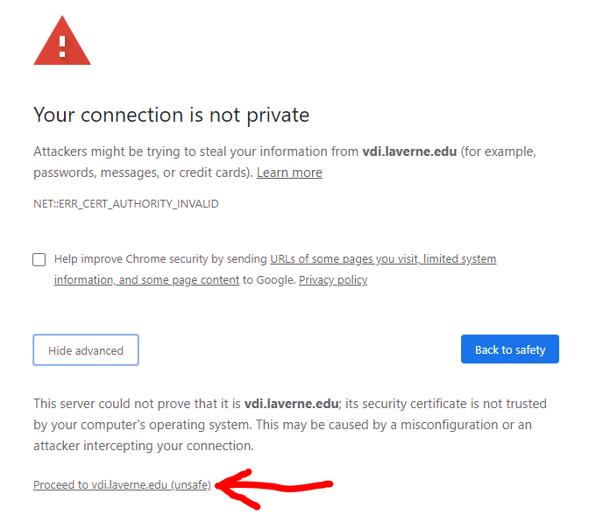

Firefox: Click on Advanced
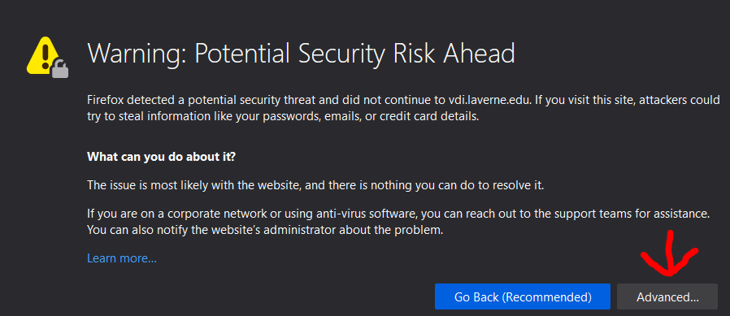
Accept the risks and continue
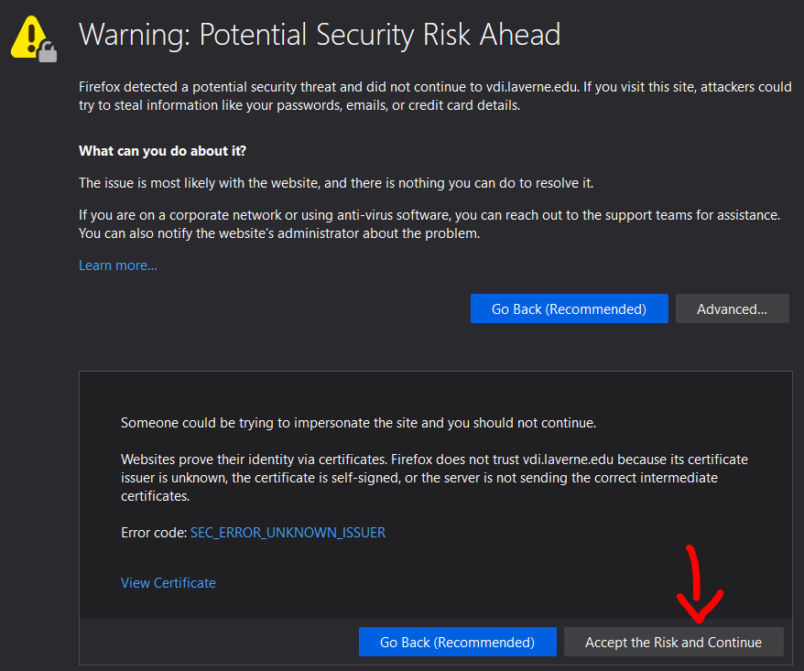

Microsoft Edge: Click on Details
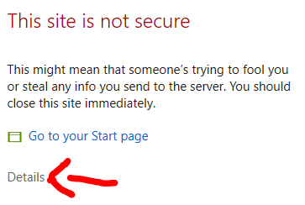
Click on the webpage (Not recommended)
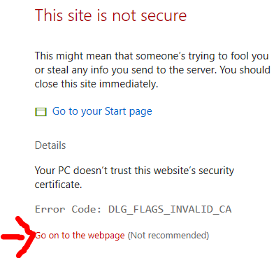

You should be met with this splash screen:

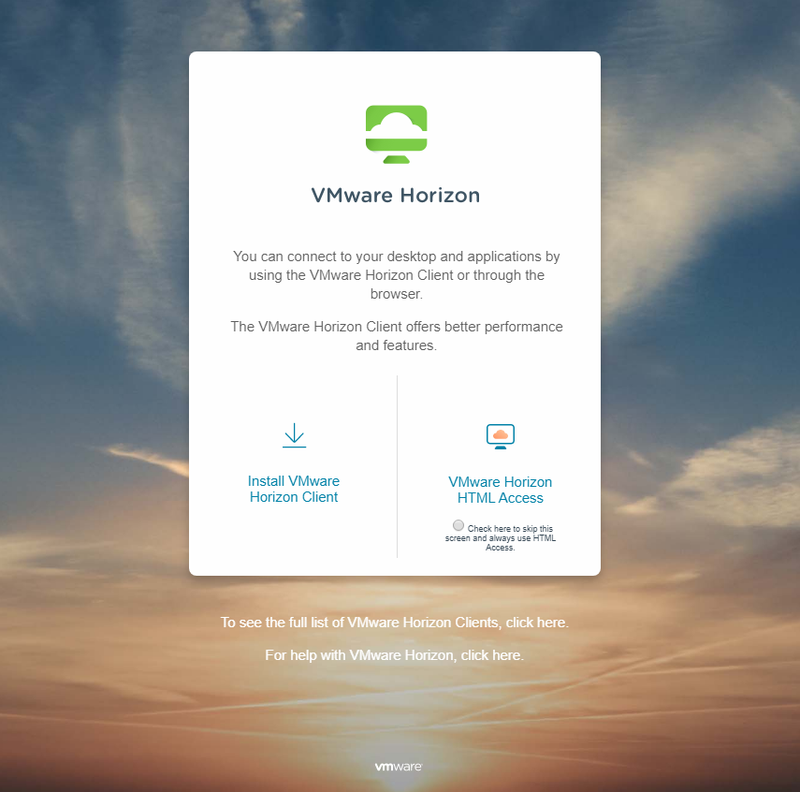

You can login using the web OR using the “VMware Horizon Client”
For web:
Click on “VMware Horizon HTML Access”
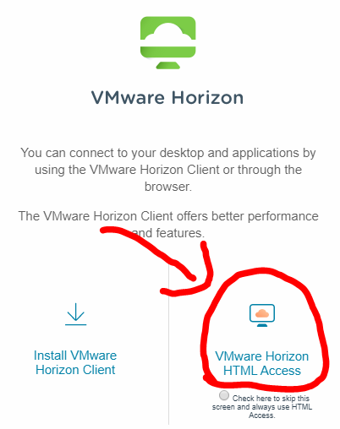
Login using AD credentials:
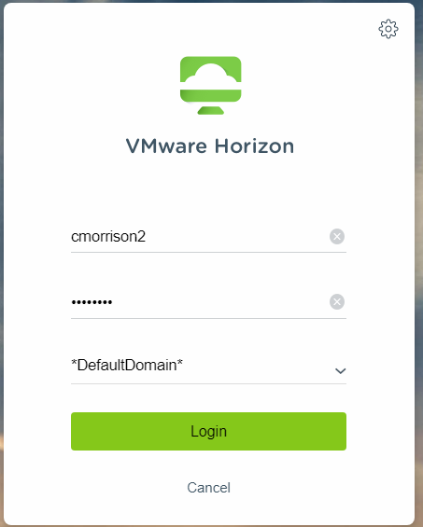

Choose “University of La Verne - …”
(University of La Verne – Administration Staff)
*Do not click on any of the other Labs.
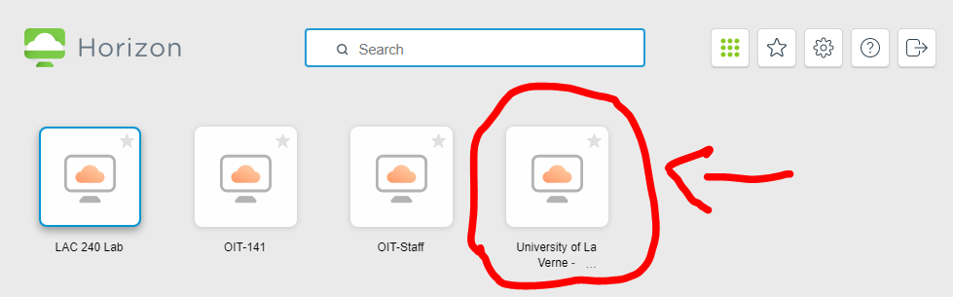
It will launch a web-based connection to the Virtual Desktop.
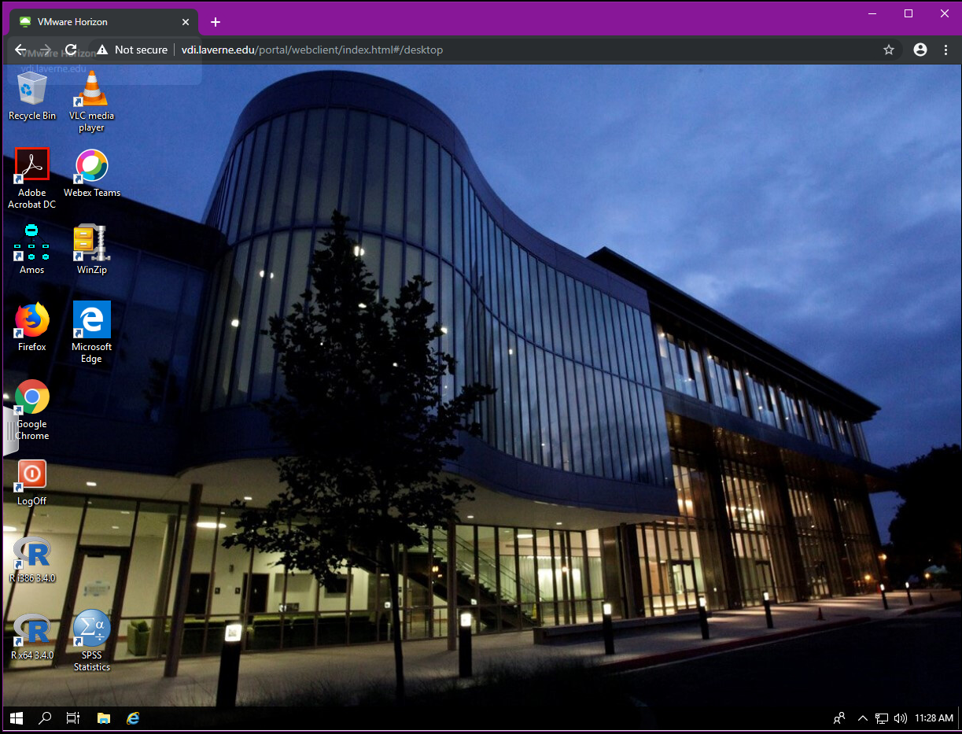

Using the VMware Horizon Client:
Click on “Install VMware Horizon Client”
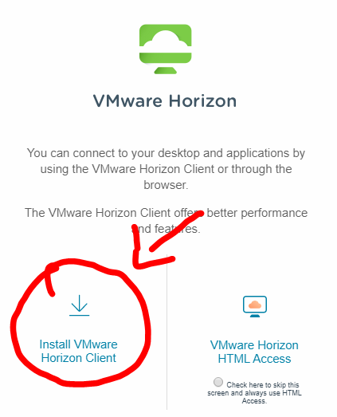

And download the correct client for your system, by clicking on the: “Go to Downloads” link for your device (Windows, Mac, etc.)
(In this example, Windows)
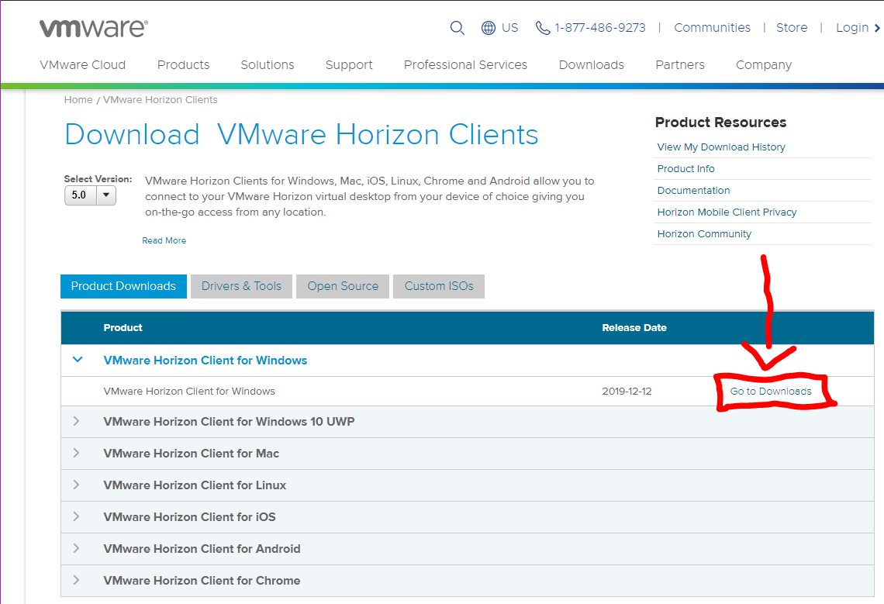
Then click “Download”
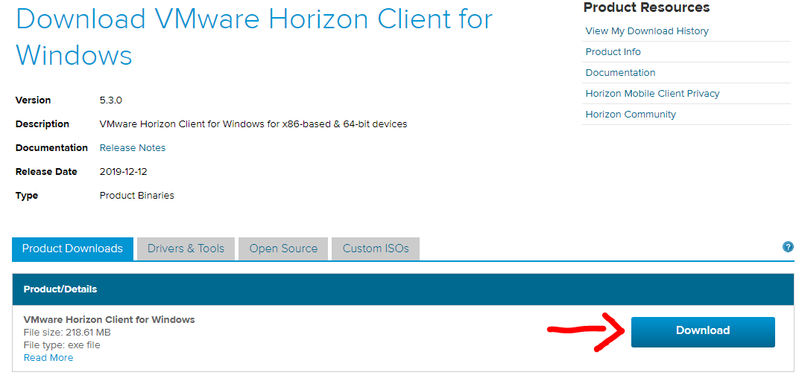
Find the download and run:
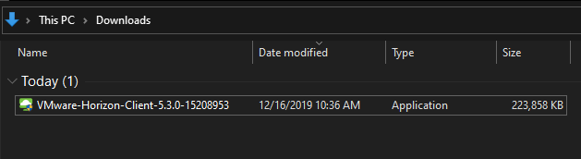
Once the install completes you will need to reboot your computer.
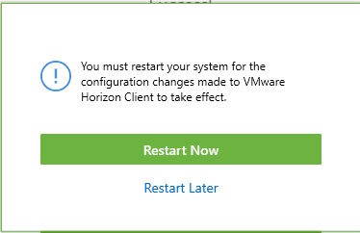
Run the “VMware Horizon Client”:
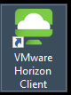

*Before you add the server go to the settings in the top right and click on “Configure SSL”
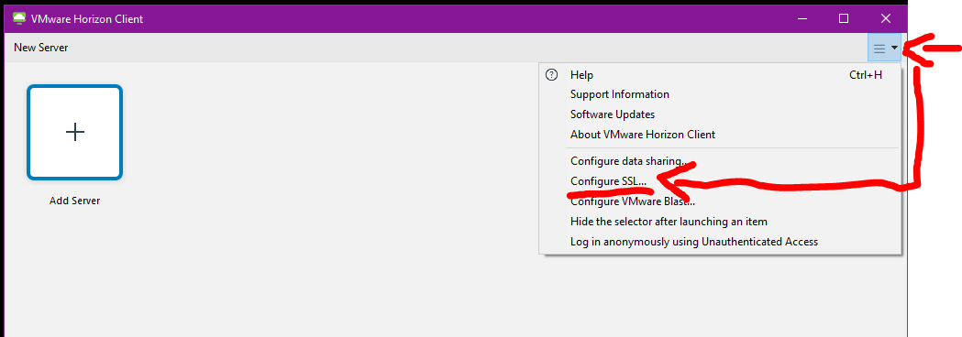
Then make sure to check “Do not verify server identity certificates”
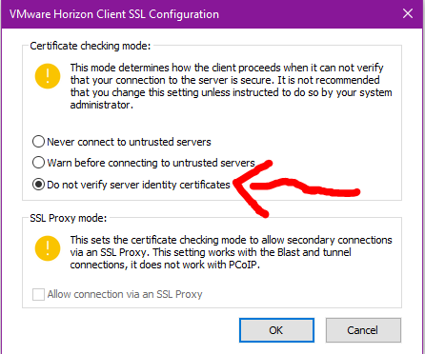

Now you can add ULV’s VDI server: by clicking on “Add Server”
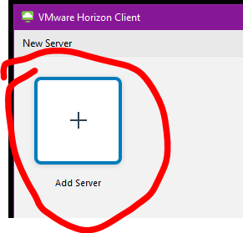
And type: vdi.laverne.edu
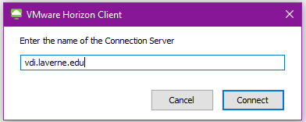
Click “Connect” and you will be brought to the login page, use your AD credentials to login:
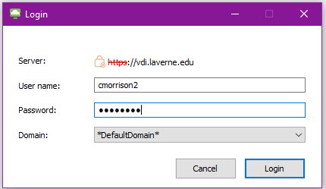
You can now use the “University of La Verne – Administration Staff” Virtual Desktop:
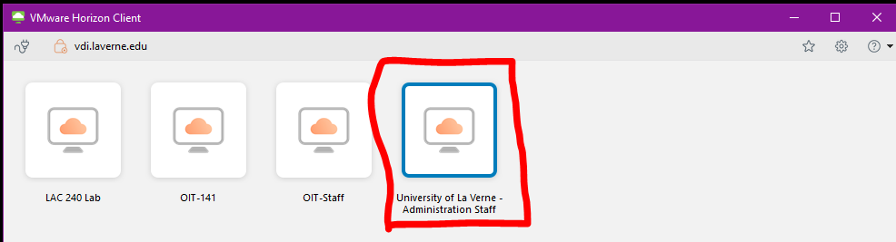

If you have multiple monitors and are using the Horizon client:
You can change the settings so that Horizon only uses one window:
Make sure to choose: “University of La Verne – Administration Staff” Then change the display to “Fullscreen” (See below)
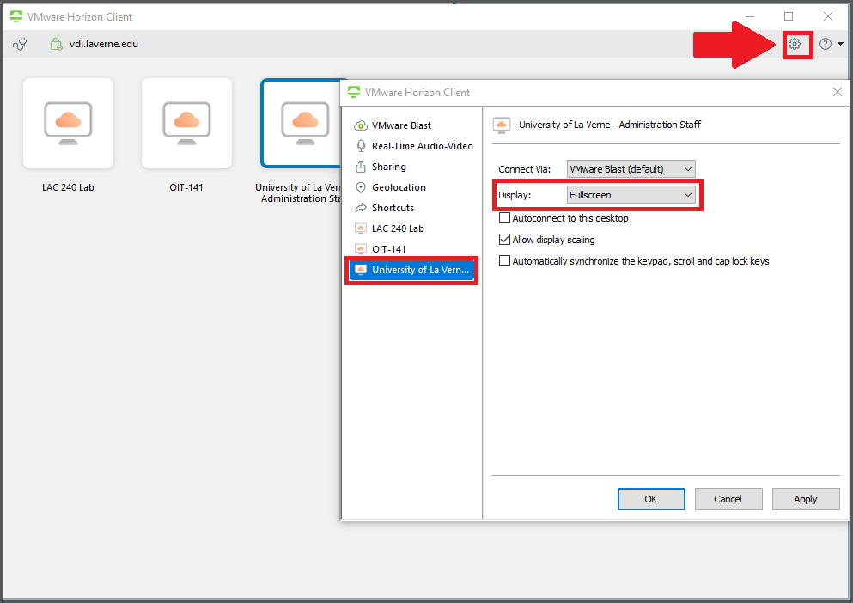

When you click it will connect your session:
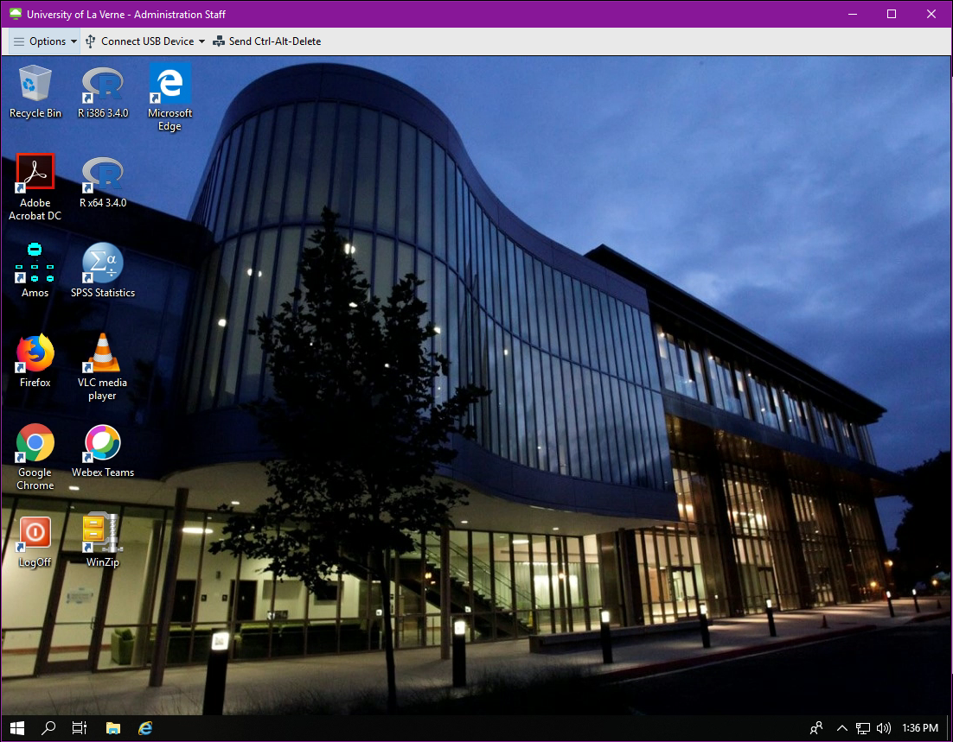
Some important notes:
Once you disconnect from this virtual computer any files that are not saved to OneDrive or the Fileshare/U-Drive will not be saved.
When you log into this desktop, it is like logging in for the first time every time.
Log into OneDrive to ensure all of your data is saved:
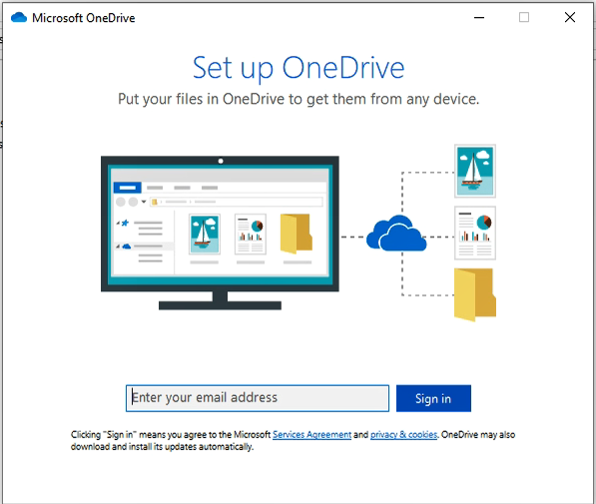
Then just click next to finish setup:
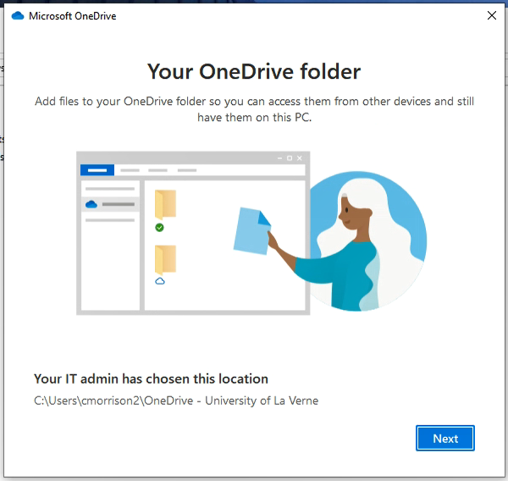

If you do not get the pop up, you can manually login by clicking the “^” on the taskbar and clicking on the gray cloud (OneDrive icon):
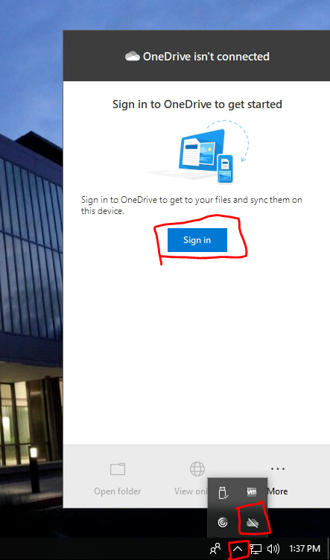

When saving your documents:
Make sure to save to your University OneDrive.EXAMPLE NOTED BELOW.

“OneDrive – University of La Verne”
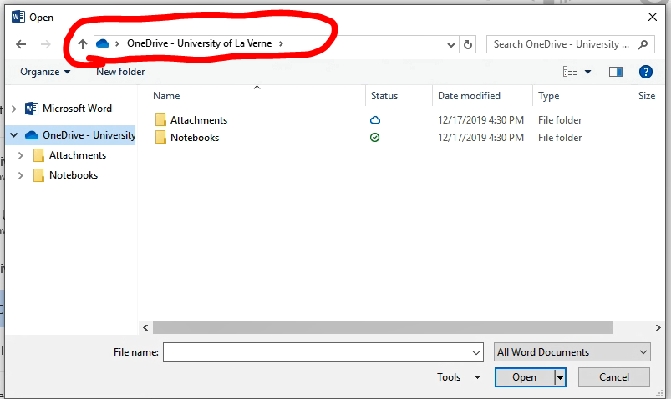
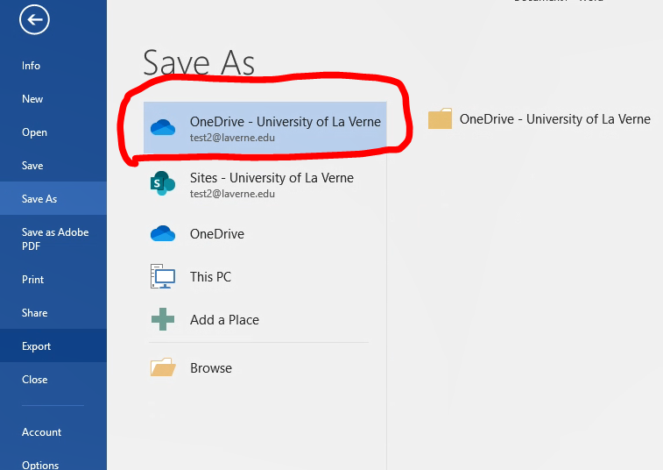

If the screen locks during your session please be sure to use the “Send CTRL+Alt+Delete button (see below)
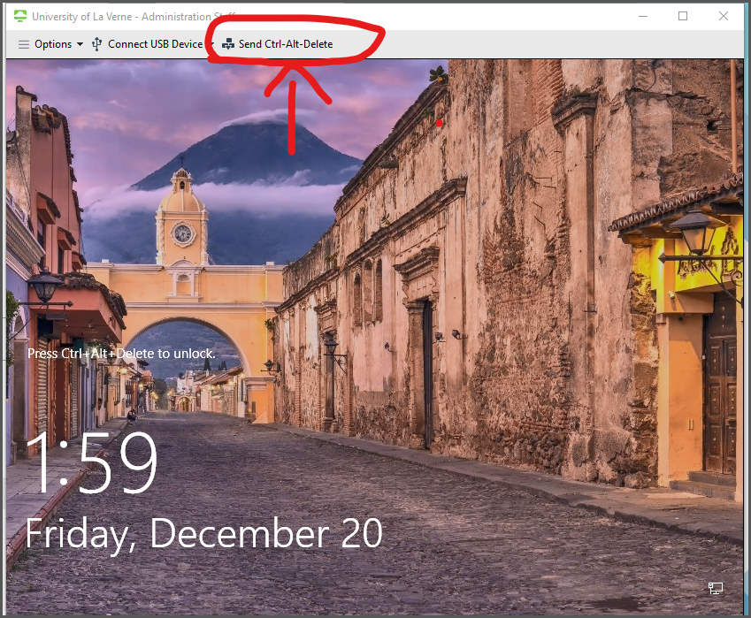
OR
Use the key combination CTRL+Alt+Insert
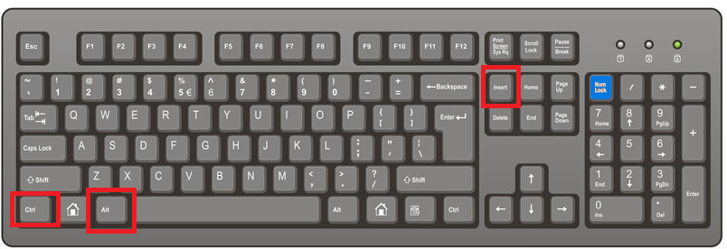
To end your session:
You can use the “Log Off” icon on the desktop:
