Debug in VS Code (#1 best tool at https://kinsta.com/blog/php-editor/#1-visual-studio-code)

We will use Xdebug is a PHP extension (a .so file on Linux and a .dll on Windows) that needs to be installed on your server.
- A. Download and install Visual Studio Code (VS Code) from Microsoft https://code.visualstudio.com/download, you may go through the videos at https://www.youtube.com/watch?v=begPcGfAwzY.
- Run VS Code and install PHP Debug and you may install PHP Intelephense and PHP IntelliSense by selecting extension icon on the left side (or Ctrl+Shift+X) of VS Code:
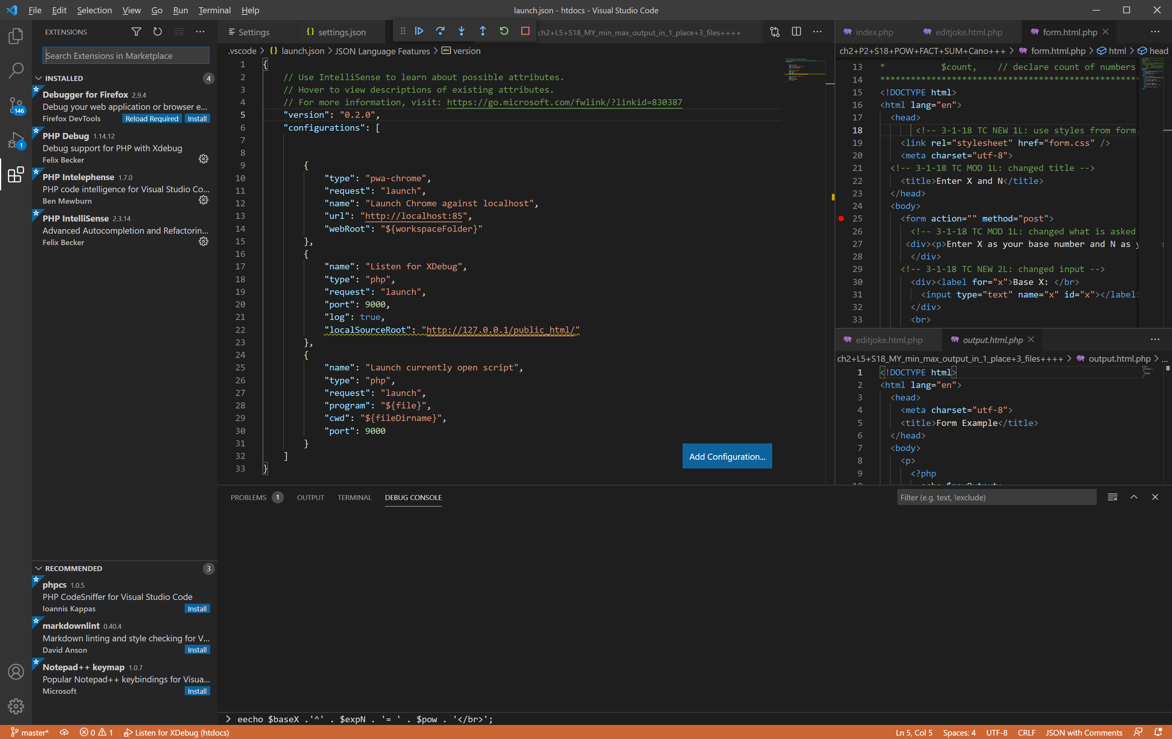
- Get phpino(), enter into your browser
http://localhost/dashboard/ => PHPInfo and copy all info (the header and all 1st 2 columns) according to
http://xdebug.org/wizard => click “Analyse my phpinf() output”.
You will see the instructions below
- Download php_xdebug-3.0.4-7.2-vc15.dll (you may have a different #)
- Move the downloaded file to C:\xampp\php\ext
- Edit C:\xampp\php\php.ini and add the following lines:
[XDebug]
xdebug.mode = debug
xdebug.start_with_request = yes
xdebug.client_port = 9000
zend_extension = C:\xampp\php\ext\php_xdebug-3.0.4-7.2-vc15.dll

The last line should match the version # you have just downloaded.
Listen for Xdebug: this setting will simply start listening on the specified port (by default 9000) for Xdebug. If you configured Xdebug like recommended above, everytime you make a request with a browser to your webserver or launch a CLI (Command Line) script Xdebug will connect and you can stop on breakpoints, exceptions etc.
Please see the Xdebug documentation on remote debugging for more information

- Setup .vscode/launch.json from VS Code directly or configure launch.json from C:\xampp\htdocs\.vscode as follows (in red specify your port number e.g. 8080 or no number):

{
// Use IntelliSense to learn about possible attributes.
// Hover to view descriptions of existing attributes.
// For more information, visit: https://go.microsoft.com/fwlink/?linkid=830387
"version": "0.2.0",
"configurations": [

{
"type": "pwa-chrome",
"request": "launch",
"name": "Launch Chrome against localhost",
"url": "http://localhost:85",
"webRoot": "${workspaceFolder}"
},
{
"name": "Listen for XDebug",
"type": "php",
"request": "launch",
"port": 9000,
"log": true,
"localSourceRoot": "http://127.0.0.1/public_html/"
},
{
"name": "Launch currently open script",
"type": "php",
"request": "launch",
"program": "${file}",
"cwd": "${fileDirname}",
"port": 9000
}
] }
- Add C:\xampp\php to your PATH environment variable:
type search “path System Properties -> Advanced system setting-> Environment Variables->edit path -> New C:\xampp\php OK OK OK.
I recommend to watch
https://stackoverflow.com/questions/31291317/php-is-not-recognized-as-an-internal-or-external-command-in-command-prompt.
- Restart Apache from XAMPP control panel.

You may watch how to debug php on the server: https://www.youtube.com/watch?v=xwrIQkc4fwk

Start debugging:
- Run XAMPP Control Panel
- Setup breakpoint in your files
- Run => Strat Debugging
- On debug menu => Restart (<CTRL>+<SHIFT>+F5
- Run http://localhost:85/yourFile
- Continue debugging (F5)

