CMPS 320 ch11 MY FIX for Session-CheckUser-Secured_LAST

Login:

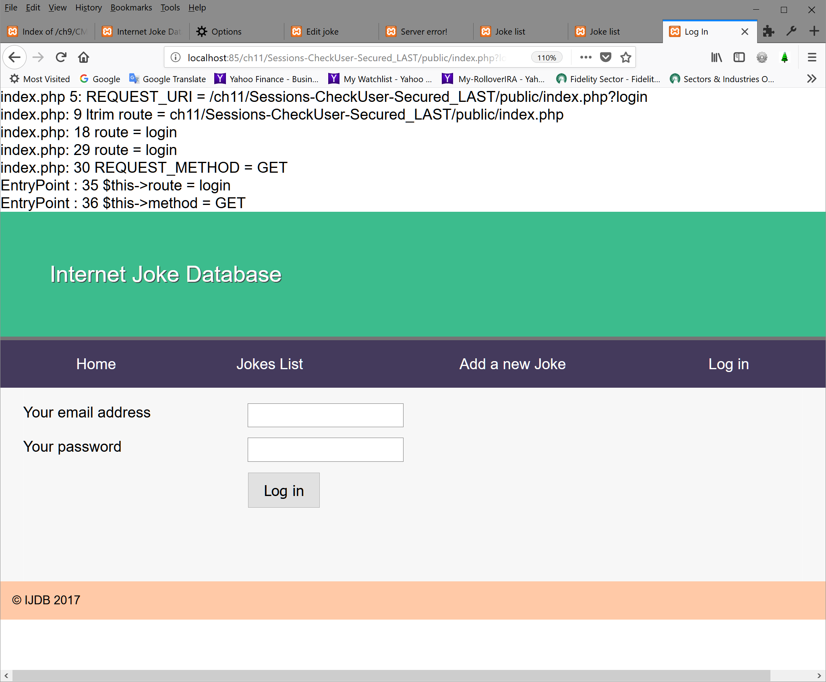

Add a new Joke:
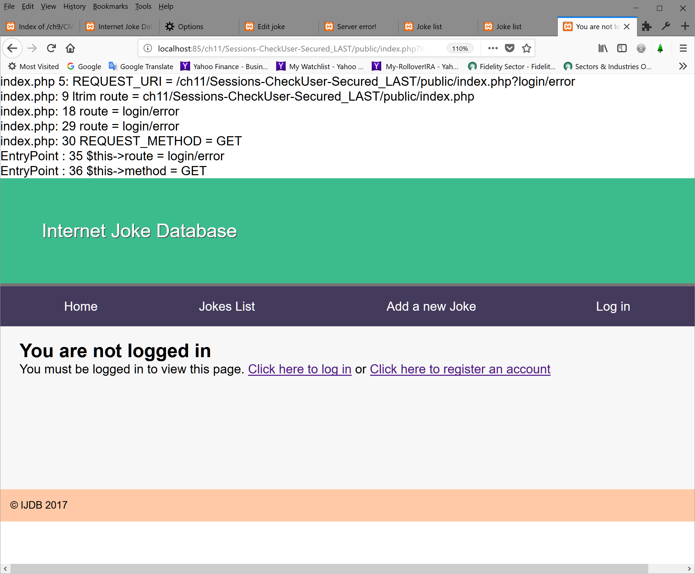

Register an account
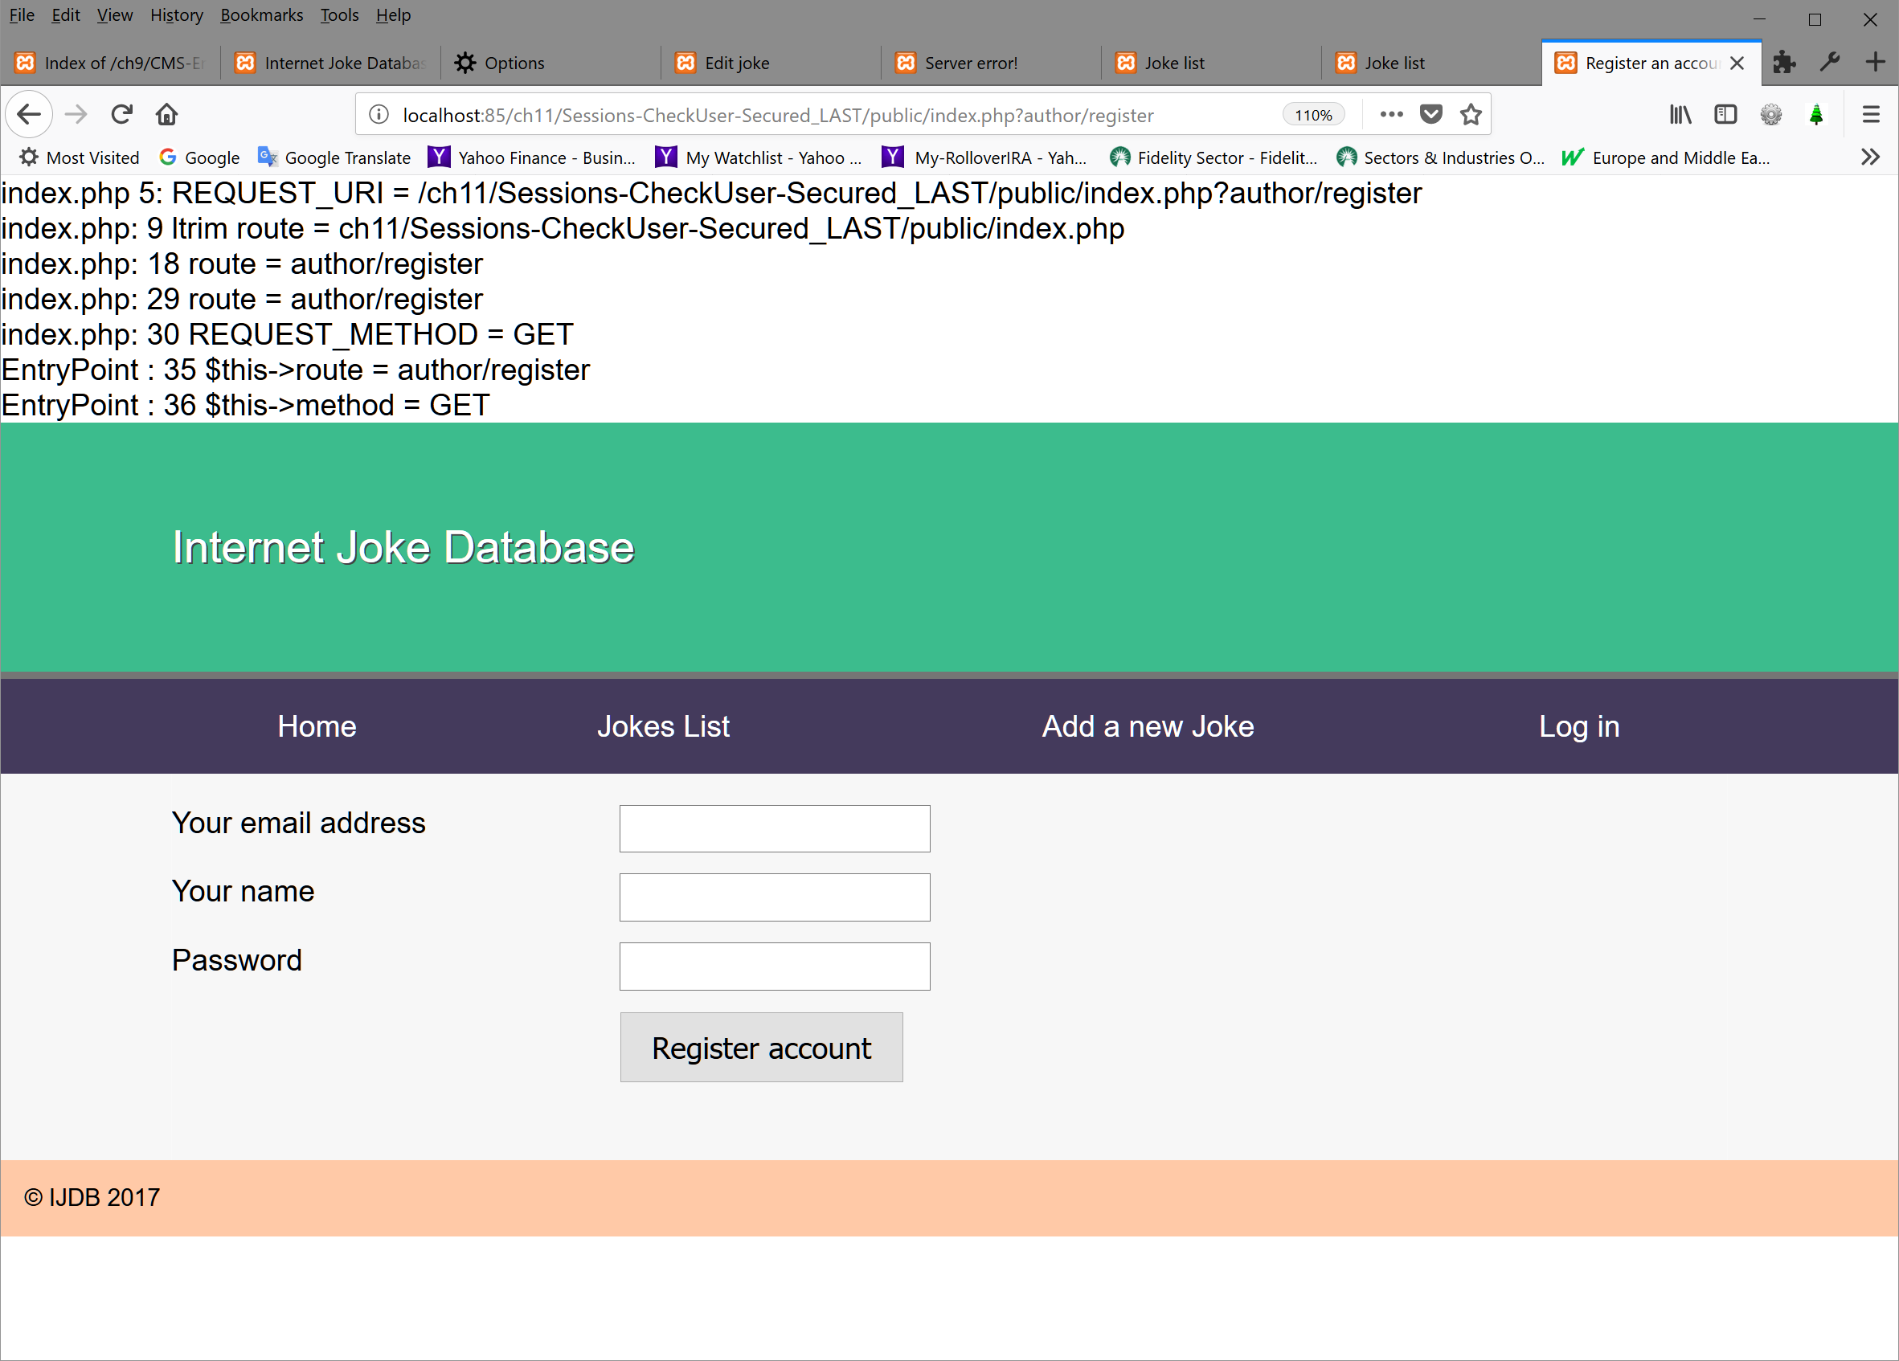

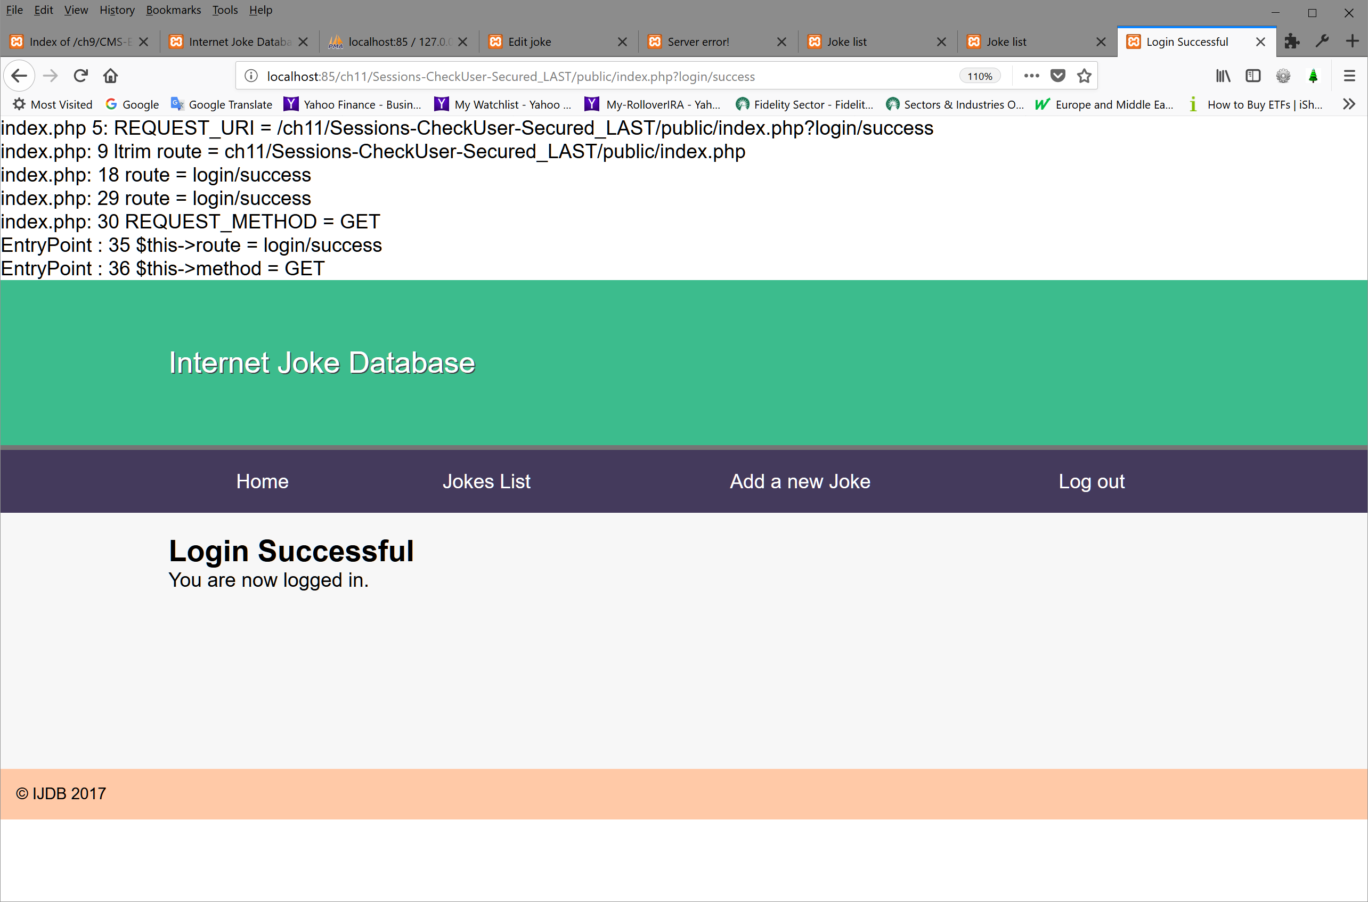
Fixes are as follows (NEW or MOD in bold and yellow):
- index.php:
//****************************JG 5/24/18 NEW line 8 - 30 ADAPTER **************************
print ('index.php 5: REQUEST_URI = ' . $_SERVER['REQUEST_URI'] . '<br>'); // JG test
print ('index.php: 9 ltrim route = ' . $route . '<br>'); // JG test

//5/22/18 JG NEW4l: adapter to the code b/c of the .htaccess is ignored by apache
if ($route == ltrim($_SERVER['REQUEST_URI'], '/') )
$route = ''; //JG 5/21/18 NEW replaces by ''
else
$route = $_SERVER['QUERY_STRING']; // 5/22/18 JG NEW1l: give the query = remaining string

print ('index.php: 18 route = ' . $route . '<br>'); // JG test

//5/22/18 JG NEW6l: adapter to the code b/c of the .htaccess is ignored by apache
if (strlen(strtok($route, '?')) < strlen($route)) // string has additional ?
{
$_GET['id'] = substr ($route, strlen(strtok($route, '?')) + 4, strlen($route)); //5/22/18 JG extract id
print ('index.php: 24 id = ' . $_GET['id']. '<br>'); // test
$route = strtok($route, '?'); //retrieve the string between ? ? - for e.g. index?joke/edit?id=12
}

//$route = substr ($_SERVER['REQUEST_URI'], (strlen($route) + 2 )); // JG give remaining string
print ('index.php: 29 route = ' . $route . '<br>'); // JG test
print ('index.php: 30 REQUEST_METHOD = ' . $_SERVER['REQUEST_METHOD']. '<br>'); // JG test
//****************************END OF JG 5/24/18 NEW line 8 - 30 //****************************************************************************************
- EntryPoint.php:
public function run() {

$routes = $this->routes->getRoutes();
print (' EntryPoint : 35 $this->route = ' . $this->route . '<br>'); // JG test
print (' EntryPoint : 36 $this->method = ' . $this->method . '<br>'); // JG test
$authentication = $this->routes->getAuthentication();
print (' EntryPoint : 38 LoggedIn = ' . $authentication->isLoggedIn() . '<br>'); // JG test
print (' EntryPoint : 39 login = ' . isset($routes[$this->route]['login']) . '<br>'); // JG test

if (isset($routes[$this->route]['login']) && isset($routes[$this->route]['login']) &&
!$authentication->isLoggedIn()) {
//header('location: /login/error'); // 5/25/18 JG DEL1L org
header('location: index.php?login/error'); // 5/25/18 JG NEW1L org
}
else {
//****************************************************************************************
3. layout.html.php:
<!doctype html>
<html>
<head>
<meta charset="utf-8">
<!-- 5/25/18 JG DEL1L: <link rel="stylesheet" href="/jokes.css"> -->
<link rel="stylesheet" href="jokes.css"> <!-- <!--5/25/18 JG NEW1L: otherwise it will not display layout -->
<title><?=$title?></title>
</head>
<body>
<nav>
<header>
<h1>Internet Joke Database</h1>
</header>
<ul>
<!--5/25/18 JG NEW8L: replacement adapter -->
<li><a href="index.php">Home</a></li>
<li><a href="index.php?joke/list">Jokes List</a></li>
<li><a href="index.php?joke/edit">Add a new Joke</a></li>
<?php if ($loggedIn): ?>
<li><a href="index.php?logout">Log out</a></li>
<?php else: ?>
<li><a href="index.php?login">Log in</a></li>
<?php endif; ?>

<!--5/25/18 JG DEL8L: DEL b/c of .htaccess is ignored by Apache
<li><a href="/">Home</a></li>
<li><a href="/joke/list">Jokes List</a></li>
<li><a href="/joke/edit">Add a new Joke</a></li>
<// ?php if ($loggedIn): ?>
<li><a href="/logout">Log out</a></li>
<// ?php else: ?>
<li><a href="/login">Log in</a></li>
<// ?php endif; ?>
-->
</ul>
</nav>
//.*******************************************************************************************
4.Joke.php:
public function delete() {
…
$this->jokesTable->delete($_POST['id']);
//header('location: /joke/list'); 5/25/18 JG DEL1L org
header('location: index.php?joke/list'); // 5/25/18 JG NEW1L

public function saveEdit() {
…
$joke = $_POST['joke'];
$joke['jokedate'] = new \DateTime();
$joke['authorId'] = $author['id'];

$this->jokesTable->save($joke);
//header('location: /joke/list'); 5/25/18 JG DEL1L org
header('location: index.php?joke/list'); //5/25/18 JG NEW1L
}
//********************************************************************************************
5.jokes.html.php:
<!-- <// ?php if ($userId == $joke['authorId']): ?>
<a href="/joke/edit?id=<// ?=$joke['id']?>">Edit</a>
<form action="/joke/delete" method="post"> JG 5/25/18 org -->
<?php if ($userId == $joke['authorId']): ?>
<a href="index.php?joke/edit?id=<?=$joke['id']?>">Edit</a> <!-- JG 5/25/18 MOD2L -->
<form action="index.php?joke/delete" method="post">

//********************************************************************************************
6.Register.php: - last if statement:
//header('Location: /author/success'); 5/25/18 JG DEL1L org
header('Location: index.php?author/success'); //5/25/18 JG NEW1L

//********************************************************************************************So far everything above has been taken from fixes chapter 10 except the login/logout part in layout.html.php +
All thinks below for chapter 11

//********************************************************************************************
7. loginerror.html.php
<h2>You are not logged in</h2>
<!-- <p>You must be logged in to view this page. <a href="/login">Click here to log in</a> or
<a href="/author/register">Click here to register an account</a></p> 5/25/18 JG DEL1L org -->
<p>You must be logged in to view this page. <a href="index.php?login">Click here to log in</a> or
<a href="index.php?author/register">Click here to register an account</a></p> <!-- 5/25/18 JG NEW1L org -->

//****************************************************************************************
8. login.php:
public function processLogin() {
if ($this->authentication->login($_POST['email'], $_POST['password'])) {
//header('Location: /login/success'); //5/25/18 JG DEL1L org
header('Location: index.php?login/success'); //5/25/18 JG NEW1L

}
else {
…

public function logout() {
unset($_SESSION); //5/26/18 JG org DEL1l - it doesn't delete all session info
session_destroy(); //5/26/18 JG NEW1l to kill all session information
return ['template' => 'logout.html.php', 'title' => 'You have been logged out'];
}
//********************************************************************************************

Found under the VS Code debugger:

After entering login info loadTemplate ($templateFileName, $variables) throws the exception because $templateFileName is empty. The problem is not visible if you don’t run under debugger.

Login class =>
public function processLogin() {
if ($this->authentication->login($_POST['email'], $_POST['password'])) {
//header('Location: /login/success'); //5/25/18 JG DEL1L org
header('Location: index.php?login/success'); //5/25/18 JG NEW1L
return ['template' => 'loginsuccess.html.php', 'title' => 'Login Successful']; //5/25/21 NEW 1L: JG
//to avoid complain $templateFileName = null and $page empty.
// loadTemplate($templateFileName, $variables) throws the exception
}
else {
return ['template' => 'login.html.php',
'title' => 'Log In',
'variables' => [
'error' => 'Invalid username/password.'
]
];
}
}

