University of La Verne
COMPUTER SCIENCE & COMPUTER ENGINEERING DEPARTAMENT

AI TOPICS AND RESOURCES MANUAL
Prepared by CMPS 370 students
under supervision of dr. Jozef Goetz

Main Document 1/2024
January 2024

The manual can be used exclusively by January 2024 CMPS 370 students

The manual can be used by the following contributors:

TABLE OF TOPICS

 | Last Name, First Name | TOPIC NAME Column  - Change all topic names to upper cases.  - Highlight your topic name => Right click => Style => Heading2  - Highlight your topic name => right click => paragraph => Spacing section: Before:0, After: 0, Line Spacing: 1 => OK  - General => Alignment: => Center  - Highlight your topic name=> Right click the topic and select link then your topic name will be displayed if you select “Places in This Document” from the left side list.
0 | Hofmann, John | OPEN AI CODEX  Codex uses a neural network to translate plain English into code. I will be exploring its capabilities and discussing its potential impact on software development.
1
Topic style:
- All text including headings must be Times New Roman
- All your section titles should have Styles: heading 1, 2 and 3
- Select Home menu (have a word page width enough) to see Styles: heading 1, 2 and 3
- Use 10 pts for Heading 2 and Heading 3 - heading 1, 2 and 3 will show up in the Table of Content
- Use 14 pts for your topic - Heading 1

TABLE OF CONTENTS
TABLE OF TOPICS 2
TOPIC NAME Column 2
OPEN AI CODEX 2
TABLE OF CONTENTS 2
OPEN AI CODEX by First Last Names 3
I. INTODUCTION 3
II. OBJECTIVES AND MOTIVATION 3
III. OUTLINE 4
1. History and Predecessor 4
2. How Codex works 4
3. Public premiere 4
4. Other applications and capabilities 5
5. Limitations 5
6. Other Similar Technologies 6
7. Future Impact 6
8. Application Demo 7
IV. Conclusion 7
V. References 7

[ Students topics HERE]

Back to Top

OPEN AI CODEX by First Last Names
Abstract
I will be discussing Codex, a neural network software designed by the artificial intelligence research company Open AI. Codex is a translator that takes in plain English from the user and outputs code in several programming languages. This paper provides a look into how Codex works, the technology that enables it, current capabilities and limitations, similar existing software, and the potential impact this technology may have on software development. I conclude that Codex is currently not a useful software development platform on its own, but it is a fun solution for very simple applications, and shows promise as the first step in a future programming paradigm.

I. INTODUCTION
What if nobody needed to learn how to code? What if you could simply tell your computer what to do in plain English, and it could write the equivalent Python/JavaScript/C++ for you? Those are the questions that the Codex project sought to shed light on. Codex is an artificial intelligence model that uses a combination of natural language processing and code completion algorithms to generate valid code given a natural language prompt from the user.

II. OBJECTIVES AND MOTIVATION
The objective of this paper is to provide a realistic assessment of Codex’s current applications and limitations, as well as providing an outlook on how tools like Codex may influence the future of software development.

III. OUTLINE

1. History and Predecessor
Codex was released in the summer of 2021 by Open AI as a descendent of their GPT-3 model. GPT-3 is a machine-learning based software that can accurately replicate seemingly human-written text given a prompt from the user. You could, for example, ask GPT-3 to generate a story about frogs written in the style of JRR Tolkien, and it could do so quite convincingly. This was accomplished by training the AI on hundreds of billions of words from human-written text (articles, novels, scientific journals, etc.). With the success GPT-3, the ability for an AI to generate natural language was clear. Open AI’s next project was to expand this capability; Codex is built on the natural language capabilities of GPT-3, with the added dimension of being able to translate natural language into a variety of programming languages.

2. How Codex works
To talk about how Codex was spawned from GPT-3, I will first go over some AI fundamentals. Artificial intelligences are in part defined by their scope. The more generalized an AI (that is, the wider its scope and the more varied tasks it can manage) the less specialized it will be at any particular task, given equal overall processing power. For example, it is computationally simple at this point to create an AI that plays near perfect chess, if that is the AI’s only task. However, it would be highly difficult to create an AI that perfectly plays an arbitrary number of board games. Training a single AI on chess, checkers, poker, go, and scrabble, and having it succeed across the board, is a much more complicated task.

The inverse is true as well. By narrowing the scope of an AI, you can make it especially powerful along a more defined set of tasks. GPT-3 is trained on basically every type of human generated text there is. It can write novels, technical papers, tweets, poetry, anything. Codex is more focused; it only needs to understand coding instructions and it only needs to know how to autocomplete things that are useful for programming. Those are two of the essential parts of codex: 1) using GPT-3’s natural language processing to understand the user’s input and 2) using GPT-3’s text completion capabilities to write valid code. The secret sauce is the middle step: the actual translation.

The translation step is the part of the process for which there is the least publicly available information. However, we do know that Codex was trained on pairings of natural language and equivalent code. By feeding the AI tons of examples of, for example, a Python function paired with the plain-English comments that explain the function, Codex can build up a neural network that represents an understanding of the relationship between the two languages. From there, it can extrapolate and translate English commands it has never seen before into code.[1]

3. Public premiere
In August 2021, Open AI showcased Codex in a live stream. During this demonstration, they showed a few examples of what Codex can do. They started with a simple Hello World program. By telling Codex to “say hello world,” they got a python print statement that accurately displayed the message. They then showed the contextual memory aspect of codex by simply telling it to “do it again,” and it produced a program with two print statements. By telling Codex “Do it 5 times,” Codex created a for-loop that displayed “hello world” 5 times. Not only did Codex understand English enough to know what “it” meant in the context of the list of commands, it also understood Python well enough to know how to construct a loop. But this was still a very simple example.

The next task they gave it was to “make a web page that says our message and save it to a file. Then start a Python web server to serve that page.” Sure enough, Codex generated the required file management code and even the networking socket code, and they were able to load up the webpage on their local host in a browser. This is an example of a complicated bit of code that is common enough that Codex had plenty of training data to complete the task.

The demonstration would go on to show Codex’s ability to load itself with APIs to extend its capabilities. This was used to send an email to everybody who was watching the livestream with the prompt “now send everyone an email, telling them a) hello world and b) the current bitcoin price.” Codex sent out a request to the email API and the CoinDesk API and successfully emailed over 1400 people the message, complete with the current price of Bitcoin.

The final part of the demonstration involved creating a JavaScript game. By going one step at a time, the developers were able to add a player character controlled by arrow keys, a falling boulder, collision detection, and victory/defeat messages. This was all accomplished by simply given codex commands like “add this picture of a person: URL…” and “make the person controllable with arrow keys” and “make the boulder fall down.” At some points, it became necessary to slightly correct the code generated by Codex.

Above you can see the layout of the Codex JavaScript sandbox. The bottom panel is where the user enters natural language prompts. The right panel shows the JavaScript translations of those prompts, and the center panel shows the resulting app. The generated code can be edited manually as well.

To gain access to the JavaScript sandbox, one must apply for access for either commercial or academic reasons. I was able to obtain access for the purposes of this paper, and so I have been experimenting with game development using Codex as a development platform. I have been able to generate simple asteroid-style games, jumping games with collectables and score counters, and more[4]. I will get more into my experiences in the limitations section.

4. Other applications and capabilities
Codex has been used to create memes, static and animated art, classic games like Snake and Tetris. It is also very good at understanding mathematical word problems and using code to find the answer. You can ask Codex something like “I need to find a number of apples equal to the third largest prime over 1000. How many apples do I need?” and it will solve it immediately. Some users have created entire personal websites using Codex, as well as other web development applications. The important thing to remember in all these examples is the speed at which they were accomplished; some of these tasks were accomplished in under 10 minutes because Codex has so much training data on similar instructions that it already knows what code it needs. When adding a new feature to a website, it can be much faster to simply ask Codex in plain English instead of Googling your way to w3schools or similar online resources.

5. Limitations
Codex is far from perfect. While the examples listed previously are impressive, Codex hovers around 70% accuracy in terms of successfully understanding the user’s intent and generating code that satisfies the desired goal [1]. This stat is based on single-prompt use-cases, as opposed to creating larger applications that would require multiple prompts in succession. Codex often struggles with multi-step tasks [3]. To accomplish a more complicated task, Codex often requires a detailed series of step-by-step inputs, at which point the user is moving closer to simply programming (albeit without caring about syntax and special keywords or function names).

Codex is much better at adding new code than it is at taking in new instructions that require a modification to previously entered code. For example, if you create a loop that writes a message a certain number of times, it is very finicky to tell Codex to change the number of times that loop should run. It becomes necessary to edit the code yourself.

In my experience with the JavaScript sandbox, there were a few frustrating issues. When adding Event Listeners to objects (for things like button clicks, key presses, mouse movement) they seemed to persist even after I deleted those sections of code. This led to a stacking effect where buttons were doing multiple tasks, or arrow key movement was much faster than intended because the document had multiple Listeners for the keypress even though only one existed in the code that was visible to me. Other issues involved importing images correctly as well as continuous events using SetInterval() simply not occurring [4].

Overall, for anything more than a very simple use-case, creating an application using Codex often removes too much flexibility and requires so much editing that one would be better off coding it oneself.

6. Other Similar Technologies
Codex is the backbone of Copilot, a coding assistant plugin for various IDE’s that provides code completion capabilities. It is used by many programmers as a productivity boost, though it has its own issues and can sometimes introduce bugs or vulnerabilities [2]. However, when used wisely it can be a great tool that reduces the need to look up documentation.

Nvidia Canvas is a specialized AI that turns simple doodles into photorealistic works of art. This is a similar concept to Codex, except instead of understanding English and programming languages, Canvas can mediate between simple shapes and photos.

AI dungeon is a game created with GPT-3 as its backbone. This game generates a scenario and responds to the user’s text input actions to tell an interactive, dynamically generated story.

7. Future Impact
It is likely that AI in programming will exist mostly as an assistant like Copilot for the foreseeable future, providing quick references and auto complete features. However, if this technology continues progressing, we may see entire parts of the software development process completely automated by AI. We would still need experienced humans to oversee the outputs, but it is a wild future to imagine.

8. Application Demo
As a quick demonstration, here is a screenshot of an experiment I tried in the Codex JavaScript Sandbox.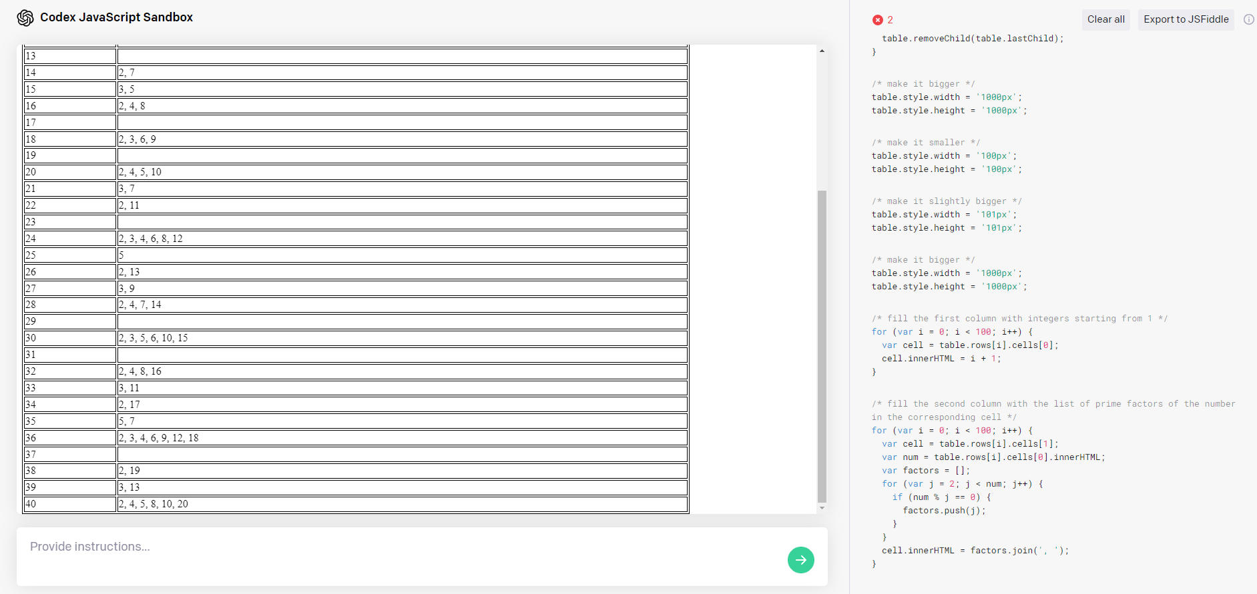
The goal was to create a simple table: in column one, a list of integers 1-40. In column two: a list of the integer’s prime factorization. You can see a few of the prompts I entered into Codex along the right side as comments, with the resulting JavaScript underneath. It took several attempts to get Codex to implement the table somewhat correctly. It often would put every integer into the same cell, or sometimes not even display the table at all due to an error caused by how it handled for loops and tables. In the end, the resulting table is not quite as I intended; Codex did not seem to understand the “prime” part of prime factorization and instead listed nonprime factors as well. Even with these errors, if I were attempting to create this table myself, having the basic outline generated here would give me a good head start and with minimal editing I would have my desired result.

IV. Conclusion
While Codex isn’t here to make our Computer Science degrees useless quite yet, it is still a fascinating technology that we have not heard the last of. I had a lot of fun making games using Codex and I even learned a few JavaScript programming patterns from the ways in which it translated my instructions. AI is the frontier of computing, and projects like Codex are promising examples of what the future holds. For now, though, it’s mostly a toy, and any serious software development is still done by use humans.

V. References

**** | [1] Chen, Tworek, Jun, Yuan & co. “Evaluating Large Language Models Trained on Code” arXiv2107.03374[cs.LG] 7/7/21 (this is Open AI’s own paper on Codex. This was a good resource for understanding the inner workings of the software)
** | [2] Anderson, Tim; Quach, Katyanna (July 6, 2021). "GitHub Copilot auto-coder snags emerge, from seemingly spilled secrets to bad code, but some love it". The Register. 2021-09-04. (This resource was tangential, only used for finding feedback on the usefulness of Copilot which is built from Codex)
***** | [3] Dickson, Ben (August 16, 2021). "What to expect from Open AI's Codex API". VentureBeat. 2021-09-03. (This article provides great context on the content presented in Open AI’s livestream demo of Codex and sheds light on Codex’s many limitations)
***** | [4] https://beta.openai.com/codex-javascript-sandbox (this is the JavaScript sandbox which I was able to gain access to and try out Codex for myself. Getting hands-on experience with the software was a great way to learn about its capabilities and limitations, and I plan on demonstrating those during my presentation)
*** | “13 sick OpenAI Codex use cases I’ve seen so far” YouTube, uploaded by Sandra Kublik, 8/24/21, https://www.youtube.com/watch?v=66xTYJrOxKk. (This was a good source for finding other examples of projects completed using Codex)

Back to Top

