University of La Verne
COMPUTER SCIENCE & COMPUTER ENGINEERING DEPARTAMENT

TOPICS AND RESOURCES MANUAL
Prepared by CMPS 370 students
under supervision of dr. Jozef Goetz

Main Document 1/2025
January 2025

The manual can be distributed exclusively by January 2025 CMPS 370 students

The manual can be used by the following contributors:

TABLE OF TOPICS with student names

 | Last NAME, First NAME | TOPIC NAME with a short description  - Change all topic names to upper cases and to bold.  - Highlight your topic name => Right click => Style => Heading1  - Highlight your topic name => right click => paragraph => Spacing section: Before:0, After: 0, Line Spacing: 1 => OK  - General => Alignment: => Center  - Highlight your topic name=> Right click the topic and select link (or Edit Hyperlink if the link is there) then select your topic name by highline “Places in This Document” from the left side list.
1 | Smith, John  Parke, Andrew | OPEN AI CODEX  Codex uses a neural network to translate plain English into code. I will be exploring its capabilities and discussing its potential impact on software development.
2 | Knightly, Michael | NATURAL LANGUAGE PROCESSING  I would like to talk about the importance of Natural Language Processing and its various use cases and techniques.
Topic style:
- All text including headings must be Times New Roman
- All your section titles should have Styles: heading 1, 2 and 3
- Select Home menu (have a word page width enough) to see Styles: heading 1, 2 and 3
- Use 10 pts for Heading 2 and Heading 3 - heading 1, 2 and 3 will show up in the Table of Content
- Use 14 pts for your topic - Heading 1

TABLE OF TOPICS with students names 1
Last NAME, First NAME 1
TOPIC NAME with a short description 1
OPEN AI CODEX 2
NATURAL LANGUAGE PROCESSING 2
OPEN AI CODEX by John Smith and Andrew Parke 4
Abstract 4
I. INTODUCTION 4
II. OBJECTIVES AND MOTIVATION 4
III. OUTLINE 4
1. History and Predecessor 4
2. How Codex works 4
3. Public premiere 5
4. Other applications and capabilities 6
5. Limitations 6
6. Other Similar Technologies 6
7. Future Impact 7
8. Application Demo 7
IV. Conclusion 8
V. References 8
NATURAL LANGUAGE PROCESSING by First Last Names 8
Abstract 8
I. INTRODUCTION 9
II. OBJECTIVES AND MOTIVATIONS 9
III. OUTLINE 9
1. What is Natural Language Processing? 9
2. NLP Common Use Cases 9
3. General Techniques and Steps 11
4. Keyword Extraction with Python 11
5. How Machine Learning Enhanced NLP 14
6. Business & Everyday Implementations 14
7. Challenges and Pitfalls Facing NLP 15
8. The Future of NLP 16
IV. CONCLUSION 16
V. REFERENCES 16
Back to Top

[ Students topics HERE ] - leave examples at the end of this document

OPEN AI CODEX by John Smith and Andrew Parke

Abstract
I will be discussing Codex, a neural network software designed by the artificial intelligence research company Open AI. Codex is a translator that takes in plain English from the user and outputs code in several programming languages. This paper provides a look into how Codex works, the technology that enables it, current capabilities and limitations, similar existing software, and the potential impact this technology may have on software development. I conclude that Codex is currently not a useful software development platform on its own, but it is a fun solution for very simple applications, and shows promise as the first step in a future programming paradigm.

I. INTODUCTION
What if nobody needed to learn how to code? What if you could simply tell your computer what to do in plain English, and it could write the equivalent Python/JavaScript/C++ for you? Those are the questions that the Codex project sought to shed light on. Codex is an artificial intelligence model that uses a combination of natural language processing and code completion algorithms to generate valid code given a natural language prompt from the user.

II. OBJECTIVES AND MOTIVATION
The objective of this paper is to provide a realistic assessment of Codex’s current applications and limitations, as well as providing an outlook on how tools like Codex may influence the future of software development.

III. OUTLINE

1. History and Predecessor
Codex was released in the summer of 2021 by Open AI as a descendent of their GPT-3 model. GPT-3 is a machine-learning based software that can accurately replicate seemingly human-written text given a prompt from the user. You could, for example, ask GPT-3 to generate a story about frogs written in the style of JRR Tolkien, and it could do so quite convincingly. This was accomplished by training the AI on hundreds of billions of words from human-written text (articles, novels, scientific journals, etc.). With the success GPT-3, the ability for an AI to generate natural language was clear. Open AI’s next project was to expand this capability; Codex is built on the natural language capabilities of GPT-3, with the added dimension of being able to translate natural language into a variety of programming languages.

2. How Codex works
To talk about how Codex was spawned from GPT-3, I will first go over some AI fundamentals. Artificial intelligences are in part defined by their scope. The more generalized an AI (that is, the wider its scope and the more varied tasks it can manage) the less specialized it will be at any particular task, given equal overall processing power. For example, it is computationally simple at this point to create an AI that plays near perfect chess, if that is the AI’s only task. However, it would be highly difficult to create an AI that perfectly plays an arbitrary number of board games. Training a single AI on chess, checkers, poker, go, and scrabble, and having it succeed across the board, is a much more complicated task.

The inverse is true as well. By narrowing the scope of an AI, you can make it especially powerful along a more defined set of tasks. GPT-3 is trained on basically every type of human generated text there is. It can write novels, technical papers, tweets, poetry, anything. Codex is more focused; it only needs to understand coding instructions and it only needs to know how to autocomplete things that are useful for programming. Those are two of the essential parts of codex: 1) using GPT-3’s natural language processing to understand the user’s input and 2) using GPT-3’s text completion capabilities to write valid code. The secret sauce is the middle step: the actual translation.

The translation step is the part of the process for which there is the least publicly available information. However, we do know that Codex was trained on pairings of natural language and equivalent code. By feeding the AI tons of examples of, for example, a Python function paired with the plain-English comments that explain the function, Codex can build up a neural network that represents an understanding of the relationship between the two languages. From there, it can extrapolate and translate English commands it has never seen before into code.[1]

3. Public premiere
In August 2021, Open AI showcased Codex in a live stream. During this demonstration, they showed a few examples of what Codex can do. They started with a simple Hello World program. By telling Codex to “say hello world,” they got a python print statement that accurately displayed the message. They then showed the contextual memory aspect of codex by simply telling it to “do it again,” and it produced a program with two print statements. By telling Codex “Do it 5 times,” Codex created a for-loop that displayed “hello world” 5 times. Not only did Codex understand English enough to know what “it” meant in the context of the list of commands, it also understood Python well enough to know how to construct a loop. But this was still a very simple example.

The next task they gave it was to “make a web page that says our message and save it to a file. Then start a Python web server to serve that page.” Sure enough, Codex generated the required file management code and even the networking socket code, and they were able to load up the webpage on their local host in a browser. This is an example of a complicated bit of code that is common enough that Codex had plenty of training data to complete the task.

The demonstration would go on to show Codex’s ability to load itself with APIs to extend its capabilities. This was used to send an email to everybody who was watching the livestream with the prompt “now send everyone an email, telling them a) hello world and b) the current bitcoin price.” Codex sent out a request to the email API and the CoinDesk API and successfully emailed over 1400 people the message, complete with the current price of Bitcoin.

The final part of the demonstration involved creating a JavaScript game. By going one step at a time, the developers were able to add a player character controlled by arrow keys, a falling boulder, collision detection, and victory/defeat messages. This was all accomplished by simply given codex commands like “add this picture of a person: URL…” and “make the person controllable with arrow keys” and “make the boulder fall down.” At some points, it became necessary to slightly correct the code generated by Codex.

Above you can see the layout of the Codex JavaScript sandbox. The bottom panel is where the user enters natural language prompts. The right panel shows the JavaScript translations of those prompts, and the center panel shows the resulting app. The generated code can be edited manually as well.

To gain access to the JavaScript sandbox, one must apply for access for either commercial or academic reasons. I was able to obtain access for the purposes of this paper, and so I have been experimenting with game development using Codex as a development platform. I have been able to generate simple asteroid-style games, jumping games with collectables and score counters, and more[4]. I will get more into my experiences in the limitations section.

4. Other applications and capabilities
Codex has been used to create memes, static and animated art, classic games like Snake and Tetris. It is also very good at understanding mathematical word problems and using code to find the answer. You can ask Codex something like “I need to find a number of apples equal to the third largest prime over 1000. How many apples do I need?” and it will solve it immediately. Some users have created entire personal websites using Codex, as well as other web development applications. The important thing to remember in all these examples is the speed at which they were accomplished; some of these tasks were accomplished in under 10 minutes because Codex has so much training data on similar instructions that it already knows what code it needs. When adding a new feature to a website, it can be much faster to simply ask Codex in plain English instead of Googling your way to w3schools or similar online resources.

5. Limitations
Codex is far from perfect. While the examples listed previously are impressive, Codex hovers around 70% accuracy in terms of successfully understanding the user’s intent and generating code that satisfies the desired goal [1]. This stat is based on single-prompt use-cases, as opposed to creating larger applications that would require multiple prompts in succession. Codex often struggles with multi-step tasks [3]. To accomplish a more complicated task, Codex often requires a detailed series of step-by-step inputs, at which point the user is moving closer to simply programming (albeit without caring about syntax and special keywords or function names).

Codex is much better at adding new code than it is at taking in new instructions that require a modification to previously entered code. For example, if you create a loop that writes a message a certain number of times, it is very finicky to tell Codex to change the number of times that loop should run. It becomes necessary to edit the code yourself.

In my experience with the JavaScript sandbox, there were a few frustrating issues. When adding Event Listeners to objects (for things like button clicks, key presses, mouse movement) they seemed to persist even after I deleted those sections of code. This led to a stacking effect where buttons were doing multiple tasks, or arrow key movement was much faster than intended because the document had multiple Listeners for the keypress even though only one existed in the code that was visible to me. Other issues involved importing images correctly as well as continuous events using SetInterval() simply not occurring [4].

Overall, for anything more than a very simple use-case, creating an application using Codex often removes too much flexibility and requires so much editing that one would be better off coding it oneself.

6. Other Similar Technologies
Codex is the backbone of Copilot, a coding assistant plugin for various IDE’s that provides code completion capabilities. It is used by many programmers as a productivity boost, though it has its own issues and can sometimes introduce bugs or vulnerabilities [2]. However, when used wisely it can be a great tool that reduces the need to look up documentation.

Nvidia Canvas is a specialized AI that turns simple doodles into photorealistic works of art. This is a similar concept to Codex, except instead of understanding English and programming languages, Canvas can mediate between simple shapes and photos.

AI dungeon is a game created with GPT-3 as its backbone. This game generates a scenario and responds to the user’s text input actions to tell an interactive, dynamically generated story.

7. Future Impact
It is likely that AI in programming will exist mostly as an assistant like Copilot for the foreseeable future, providing quick references and auto complete features. However, if this technology continues progressing, we may see entire parts of the software development process completely automated by AI. We would still need experienced humans to oversee the outputs, but it is a wild future to imagine.

8. Application Demo
As a quick demonstration, here is a screenshot of an experiment I tried in the Codex JavaScript Sandbox.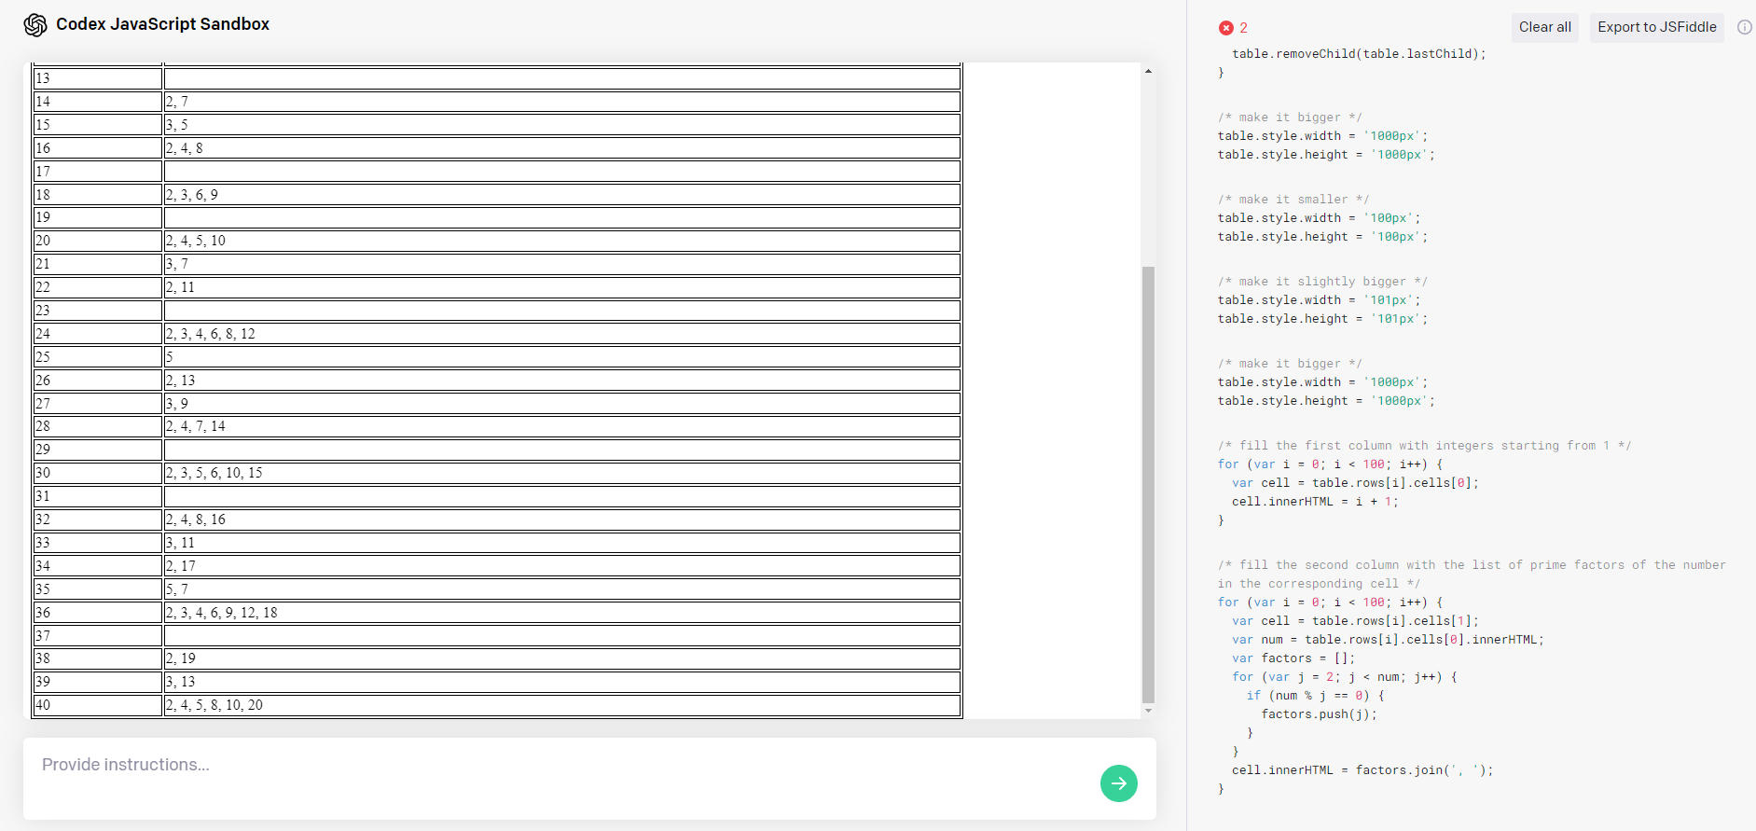
The goal was to create a simple table: in column one, a list of integers 1-40. In column two: a list of the integer’s prime factorization. You can see a few of the prompts I entered into Codex along the right side as comments, with the resulting JavaScript underneath. It took several attempts to get Codex to implement the table somewhat correctly. It often would put every integer into the same cell, or sometimes not even display the table at all due to an error caused by how it handled for loops and tables. In the end, the resulting table is not quite as I intended; Codex did not seem to understand the “prime” part of prime factorization and instead listed nonprime factors as well. Even with these errors, if I were attempting to create this table myself, having the basic outline generated here would give me a good head start and with minimal editing I would have my desired result.

IV. Conclusion
While Codex isn’t here to make our Computer Science degrees useless quite yet, it is still a fascinating technology that we have not heard the last of. I had a lot of fun making games using Codex and I even learned a few JavaScript programming patterns from the ways in which it translated my instructions. AI is the frontier of computing, and projects like Codex are promising examples of what the future holds. For now, though, it’s mostly a toy, and any serious software development is still done by use humans.

V. References

**** | [1] Chen, Tworek, Jun, Yuan & co. “Evaluating Large Language Models Trained on Code” arXiv2107.03374[cs.LG] 7/7/21 (this is Open AI’s own paper on Codex. This was a good resource for understanding the inner workings of the software)
** | [2] Anderson, Tim; Quach, Katyanna (July 6, 2021). "GitHub Copilot auto-coder snags emerge, from seemingly spilled secrets to bad code, but some love it". The Register. 2021-09-04. (This resource was tangential, only used for finding feedback on the usefulness of Copilot which is built from Codex)
***** | [3] Dickson, Ben (August 16, 2021). "What to expect from Open AI's Codex API". VentureBeat. 2021-09-03. (This article provides great context on the content presented in Open AI’s livestream demo of Codex and sheds light on Codex’s many limitations)
***** | [4] https://beta.openai.com/codex-javascript-sandbox (this is the JavaScript sandbox which I was able to gain access to and try out Codex for myself. Getting hands-on experience with the software was a great way to learn about its capabilities and limitations, and I plan on demonstrating those during my presentation)
*** | “13 sick OpenAI Codex use cases I’ve seen so far” YouTube, uploaded by Sandra Kublik, 8/24/21, https://www.youtube.com/watch?v=66xTYJrOxKk. (This was a good source for finding other examples of projects completed using Codex)

Back to Top

NATURAL LANGUAGE PROCESSING by First Last Names

Abstract
NLP stands for Natural Language Processing, which is a field in computer science that is concerned with the linguistic interactions between computers and humans. With the help of Artificial Intelligence (AI), programmers and computer scientists aim to give computers the capability of fully understanding human language and which includes documents, books, and even direct speech.
The paper provides an overview of NLP, and its different applications, including optical character recognition, speech recognition, morphological analysis, word sense disambiguation, and more. The paper will dive deeply into one of the most important applications of NLP, which is chatbots, by explaining the different types of them and providing python-code examples.

I. INTRODUCTION

Natural Language Processing dates back to the 17th century, where mathematicians and scientists such as Leibniz and Descartes introduced proposals for codes that can relate words between different languages, all their work remained theoretical, and no machine was developed based on their research back then. However, NLP has its main roots in the 1950s when the famous computer scientist and mathematician Alan Turing published a paper that discusses AI and NLP. Since then, the field of NLP has been developing rapidly.
Today in 2022, we use applications that involves NLP every day. Google and other search engine use NLP to return the best search results for our keywords, translator apps (like Google Translate) use NLP to understand the word contexts and return an accurate translation. Using text-to-speech instead of typing in the characters on our phones also involves NLP technologies. And most importantly, virtual assistants (like Siri, Google Assistant, Amazon’s Alex, Bixby…) use NLP deeply to understand and interpret our requests.
Further advancements and breakthroughs in the field of NLP will greatly influence our lives and enhance our capabilities in research.

II. OBJECTIVES AND MOTIVATIONS

The objective of this paper is to provide the reader an overall understanding of the importance of NLP by discussing its various uses and applications. The wide use of NLP in our daily life, and its importance in scientific data research in various fields are the main motives for writing this paper.

III. OUTLINE

1. What is Natural Language Processing?
NLP is a branch of artificial intelligence that focuses on giving computers the ability to understand any form of text and spoken words in the same way humans can. NLP combines computational linguistics with statistical, machine learning, and deep learning models, to enable computers to process any form of human language and be able to understand its full meaning by extracting the speaker or writer’s intent and sentiment.
Even though the main purpose of NLP focuses on understanding human languages, NLP also aims to give computers the ability to process even generate language. What that means is that a computer can have the ability to write its own stories, or articles.
The field of NLP has advanced a lot in the past few decades. Today subcategories of NLP do exist, they include natural language generation (NLG) – a computer’s ability to create a form of communication of its own – and natural language understanding (NLU) – a computer’s ability to understand the different forms and variants of a language including slang, in addition to mispronunciations, and misspellings.

2. NLP Common Use Cases
As discussed earlier, NLP has a wide range of uses and applications, some have direct real-world applications, while others do not. Here is a list of some NLP uses:
- Optical Character Recognition (OCR):
OCR is the conversion of images of typed, handwritten, or printed text into machine-encoded text. With its applications, OCR helps in various divergent fields like literature and self-driving cars. These applications include:
- Automatic number plate recognition
- Assistive technology for blind and visually impaired users
- Making scanned documents, and images searchable by converting them to searchable PDFs
- Extracting business card information into a contact list
- Traffic signs recognition
There are several types of OCR depending on the way they tackle the problem – recognizing the characters – and the type of characters the technique can recognize.
- Optical character recognition: targets typewritten text, one character at a time.
- Optical word recognition: it also targets typewritten text, but one word at a time instead of a character.
- Intelligent character recognition: uses machine learning to enable the computer to understand cursive text in addition to print script one character at a time.
- Intelligent word recognition: is the most advanced form of OCR, it involves heavy machine learning to enable computers to also understand written languages where glyphs are not separated in cursive script.
The process of OCR will be further explained in the next section.
- Keyword extraction:
Also known as text-tagging, is a text analysis technique that automatically extracts the most important words and expressions from a text, mainly to figure out the topic or topics that are being discussed. Keyword extraction uses machine learning and NLP to break down large texts into separate words so they can be analyzed by NLP algorithms. The exact process will be explained in the next two sections with a real program.
To further explain the concept, here is an example of a keyword extraction software applied on an article titled “China to Launch Asteroid-Mining Robot” from the website independent.co.uk.
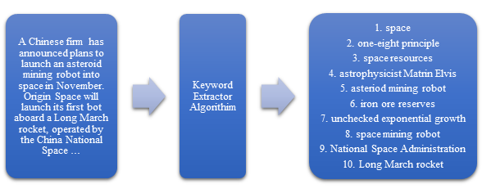
By looking at the 10 keywords that the algorithm extracted readers can have a better idea of what the article is about without having to read the whole article. This technology can be used to automatically suggest articles or posts for a user with similar keywords to the ones the user has read before.
Other uses of Keyword extraction include text summarization, information extraction and retrieval, and text mining.
- Machine Translation (MT):
MT is a subfield of computational linguistics that focuses on building software to translate text from one language to another. The applications of MT are various, and they include:
- Translation software like Google Translate
- Simultaneous translator software
- Chatting apps with instant translation
- Spoken language to signed language translation and vice versa
To date no system provides an accurate fully automatic high-quality machine translation of an unrestricted-domain text, because of the tedious challenges that face the field of MT such as ambiguity and non-standard speech, these challenges will be further explained in a later section. A lot of However, restricting the domain/topic of a text gradually improves the translation’s accuracy.
- Speech Synthesis:
Speech synthesis is a subfield of NLP and computational linguistic that focuses on the artificial production of human speech. A text-to-speech (TTS) system is implemented to convert text into speech. This technology was originally developed to aid people with disabilities. Later, speech synthesis was used in many different fields, such as virtual assistants like Siri, screen readers in addition to accessibility features on electronic devices. Speech synthesis is also used for transportation and electronic appliances for ease of use.
Early speech synthesizers create speech by concatenating pieces of recorded speech, which will sound fragmented because the generated speech lacks the different tones. New speech synthesizing techniques were invented that involve deep learning, with these new technologies artificial speech sounds more and more natural.

3. General Techniques and Steps
Most NLP tasks involve three main steps:
- Pre-processing:
Is the process of preparing the data for the task that is going to be executed in the next step. In the case of OCR, the software will attempt to pre-process the image in order to increase the chances of successful recognition. The software may start with de-skewing a not-properly aligned document by tilting it. The software will attempt to remove light and dark spots and will apply noise reduction algorithms to improve the image quality. Most OCR software will convert the image from color or greyscale to black-and-white with a process called binarization. Image artifacts especially the ones that may appear between letters will also be removed. Even additional techniques may be applied to improve the accuracy of text recognition.
In the case of keyword extraction, the pre-processing phase involves removing numbers and punctuation and converting all characters into lowercase. Then the text will be separated into words in a process called tokenization. Then words like “the”, “a”, “is”, and “to” will be removed. Finally, words will be reduced to their base form or root, for example, the words “learning” and “dictionaries” will become “learn”, and “dictionary” respectively.
- The Main Process:
This phase differs from task to task. In the case of OCR, text recognition algorithms will be applied to the preprocessed image. One of the well-known algorithms for OCR is matrix matching which involves comparing the image to stored images of a glyph or character on a pixel-by-pixel basis. In the case of feature extraction, the main process is to find relevant words and phrases. One of the simplest approaches is a statistical one called word frequency also known as bag-of-words, which basically returns the most repeated words and phrases, of course, such simple approaches have a lot of pitfalls, so more advanced algorithms were introduced like tf-idf, RAKE, and TextRank model.
- Post-processing:
This phase may vary from mere data representation by organizing the data in tables or in a human-readable form to applying algorithms to check the results of the main process. In the case of OCR, the resultant text will be scanned to check and correct spelling errors, other algorithms can be applied such as near-neighbor analysis that makes use of co-occurrence frequencies to correct errors by noting that certain words are often seen together, for example, “Washington D.C.” is far more common than “Washington DOC”.

4. Keyword Extraction with Python
Step 1: Pre-processing
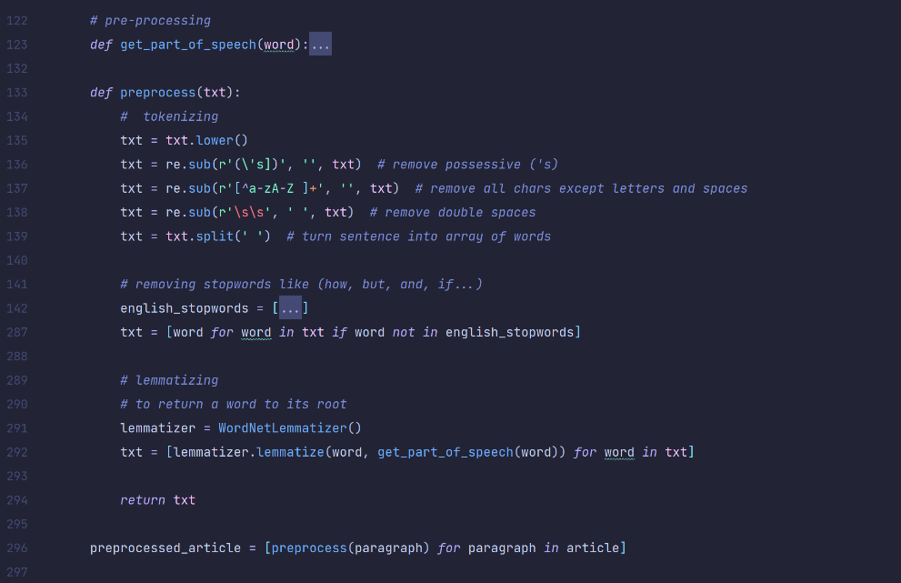
Step 2: Creating tf-idf table


Step 3: Calculating tf, and idf values
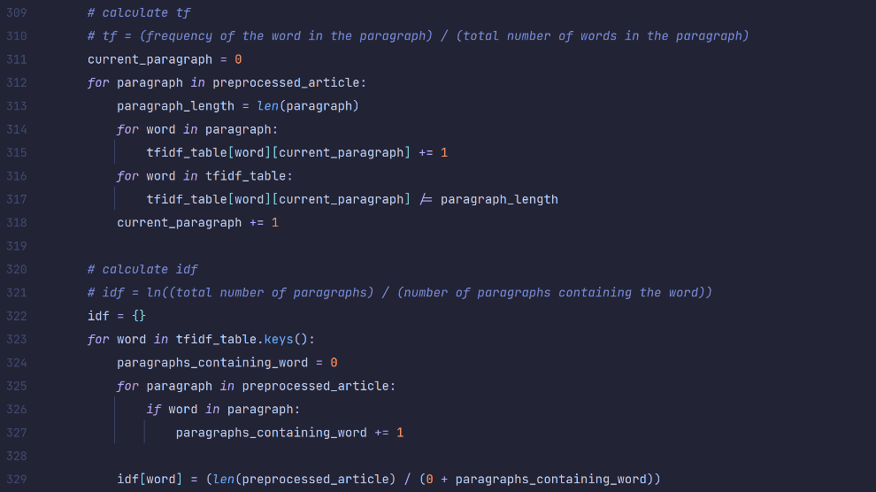
Step 4: Calculating the tfidf value, and their sum, then sort the data
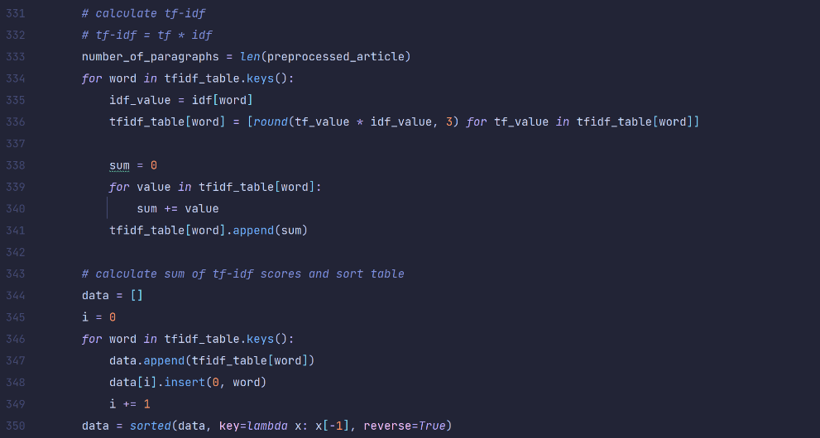
Step 5: Print the table and get the keywords
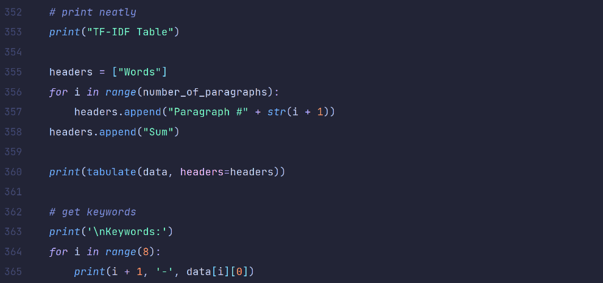
The output:
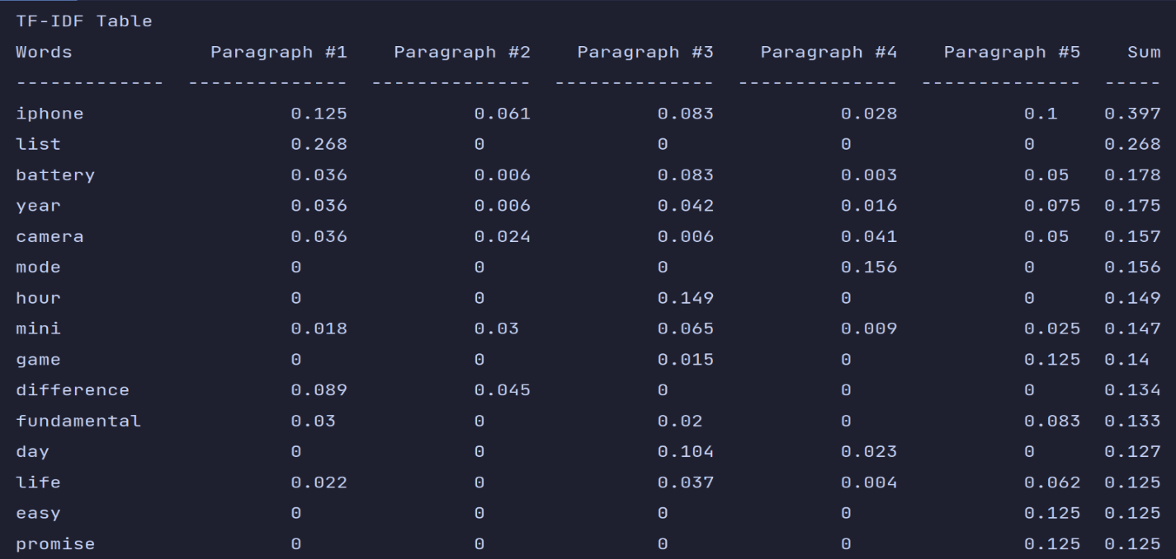
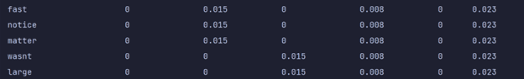
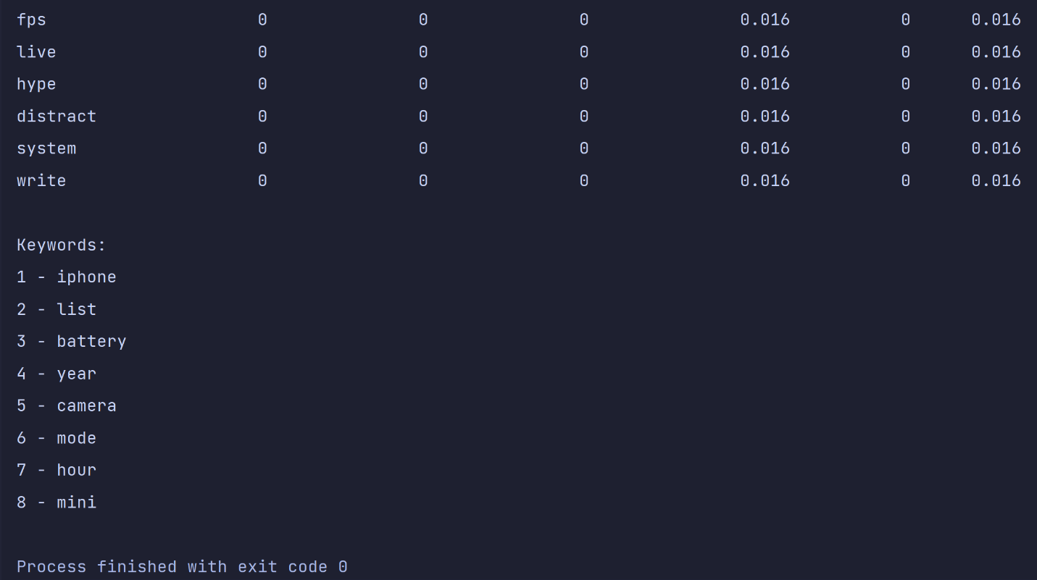

5. How Machine Learning Enhanced NLP
The definitions of ML, NLP, and AI will be discussed before explaining how ML has enhanced NLP. Both machine learning and natural language processing are subsets of artificial intelligence. AI is an umbrella term for any task where the machines simulate human intelligence or behavior. NLP deals with how computers understand and process human language. ML is the process of applying algorithms that teach machines how to automatically learn and improve from experience without being explicitly programmed.
In sections 3 and 4, the word frequency approach for feature extraction was discussed, this approach doesn’t use ML, thus a feature extraction program that uses this approach will not have its accuracy improved as its being run over and over again with different text. By adding ML or deep ML algorithms, the software will get better over time by providing more accurate results. For example, in contrast with the word frequency approach, conditional random fields (CRF) is an approach the uses ML, CRF can generalize what it learned from texts in a specific domain on other texts from different domains, and a program implementing the CRF algorithm will get better and better as its being used on text documents.

6. Business & Everyday Implementations
Nowadays, computers are involved in almost every aspect of our lives, and due to the need for automation and the attempts to make programs, electronic devices, and appliances easier to use, a lot of advanced computing technologies had to be implemented including NLP. We almost use or interact with applications or devices that use NLP on a daily basis. Here are some examples:
- Grammar Checking:
Grammar checking is the process of detecting and correcting grammatical errors in a text. Usually, these tools also check for spelling mistakes. Recently, grammar checking tools check for issues in conciseness, clarity, and readability of a text and provide suggestions. Grammarly is one example of such a tool.
- Chatbots and Virtual Assistants:
Most large businesses use chatbots for 24/7 customer support and will only direct the customer to a human in cases of more complex issues that chatbots still cannot handle. Sometimes customers cannot even tell if they are talking to a bot or a human. Building such bots involves a lot of NLP subtasks mainly text-preprocessing, speech synthesis, and speech recognition. A similar concept is virtual assistants which is technically a chatbot that will help the user with everyday tasks like calling someone, setting up an alarm, and answering questions by searching them up for the user. Almost every phone and laptop are equipped with a virtual assistant nowadays.
- Autocorrect and Autocomplete:
Search engines (like Google, and Bing), and smartphones keyboard use autocorrect and autocomplete technologies to make searching and texting an easier task.
- Analytics:
Business decisions are difficult to make, and the best decisions are made by data-driven insights. However, it is nearly impossible for a human to look over the large amounts of data that businesses generate over time and extract meaningful insights from this data. To make the process possible and effective, NLP-powered tools were introduced. These tools can scan all this data way faster than a human or a group of humans can, in addition to that these tools are not only faster but can reach conclusions and insights that humans cannot easily get because of the large amounts of data present.

7. Challenges and Pitfalls Facing NLP
The field of NLP has a long way to go, teaching computers to understand human language has been proven to be a very difficult and tedious task to do. Every single subtask of NLP faces a lot of challenges. Here are some linguistic challenges that NLP faces.
- Contextual words and phrases and homonyms:
The same words or phrases can have different meanings according to the context of a sentence.
“I ran to the store because I ran out of milk.”
In the example above, the word “ran” has two different meanings, and that poses a challenge for NLP programs, especially the subtasks where understanding the meaning of every single word is important like machine translation.
A similar challenge appears because of homonyms – words that are pronounced the same but have different definitions and spelling like “there” and “their”. This can be problematic for speech recognition and hence for any application that uses this technology like virtual assistants.
- Irony and sarcasm:
Irony and sarcasm present problems for NLP applications because they generally use words and phrases that may be positive or negative, but actually mean the opposite. Even though models can be trained using ML to understand sarcastic phrases, but still it is a tricky process, especially since facial expressions and voice tone are sometimes the only difference between sarcasm and normal speech.
- Ambiguity:
Ambiguity refers to sentences, phrases, or words that potentially have two or more possible interpretations. There are two main types of ambiguity.
- Lexical: The same word can be used as a verb, noun, or adjective. In this case, algorithms such as POS-tagging should be implemented to determine the part of speech of the words in a text.
- Semantic and syntactic: This type of ambiguity is harder to solve. Even humans do face this problem while engaging in discussions. For example,

“The girl saw the boy on the beach with her binoculars.”

This sentence can have different meanings. This could either mean that the girl saw the boy and the boy had the girl’s binoculars, or that the girl using her binoculars saw the boy on the beach.
This sentence alone without context can pose a challenge even for humans. But for humans, it is easy to get the meaning from the context in most cases, but for a machine it is difficult. In this case, the program has to have a full understanding of the story or context in order to know who has “the binoculars” at the moment.
- Errors in text and speech:
Misspelled or mispronounced words in addition to misused words can pose a challenge for machines. Autocorrect and grammar correction technologies can help solve some mistakes. But in some misusing cases, the misused word can actually fit in the sentence, and the error will only be noticeable if the listener or reader has understood the context.
Spoken language adds extra challenges in addition to mispronunciation. Different accents and stutters can confuse machines. These issues can only be solved by training the machines with more and more examples using deep learning.
In addition to linguistic challenges, NLP and especially chatbots face moral and ethical problems. For example, an AI chatbot that was once developed by Microsoft started tweeting racist tweets in less than 24 hours after it was deployed on Twitter. Here are some racist tweets made by the bot TayTweets.



8. The Future of NLP
Around 80% of the information around us is unstructured. For this reason, NLP is one of the largest fields of data science and artificial intelligence. Cleaning up, and organizing this data is a major challenge that many professionals face daily. In the coming years, NLP will become even more widespread with ready-to-use, pre-trained models. companies will continue to benefit from NLP, from improving their operations and customer satisfaction to reducing costs and making better decisions, and virtual assistants will become handier.
NLP researchers are looking more into abstract, and cognitive aspects of natural language, in addition to that there is an increasing interest in multilinguality.

IV. CONCLUSION
NLP is a subset of AI that aims to give computers the ability to understand, process, and even speak or write human languages. NLP has a lot of applications that have impacted our lives in many aspects. In recent years, NLP has gained more and more interest and focus from researchers of various fields due to its wide applications, and businessmen due to its wide uses in business such as analytics. Still, a lot of challenges face NLP programs to this day.

V. REFERENCES
***** | [1] https://en.wikipedia.org/wiki/Natural_language_processing  [This article provides an overview of NLP, its main techniques, and a list of its use cases.]
** | [2] https://en.wikipedia.org/wiki/History_of_natural_language_processing
*** | [3] https://en.wikipedia.org/wiki/Optical_character_recognition  [This article explains the various types, applications, and techniques of optical character recognition, in addition to explaining the pre-processing and post-processing phases as well as text-recognition algorithms.]
* | [4] https://www.independent.co.uk/life-style/gadgets-and-tech/asteroid-mining-robot-china-origin-space-b572318.html  [This article is used as an example for keyword extraction.]
***** | [5] https://monkeylearn.com/keyword-extraction/  [This article deeply explains the concept of keyword extraction, its methods, the libraries used to apply it in code, and more. In addition, the website provides an online keyword extractor that is used for the example provided in this article.]
*** | [6] https://en.wikipedia.org/wiki/Machine_translation
** | [7] https://en.wikipedia.org/wiki/Speech_synthesis
** | [8] https://vivoka.com/how-to-speech-synthesis-tts/
***** | [9]lhttps://medium.com/analytics-vidhya/text-preprocessing-for-nlp-natural-language-processing-beginners-to-master-fd82dfecf95  [This article is explaining the process of text preprocessing.]
*** | [10] https://monkeylearn.com/blog/nlp-ai/  [This article defines and explains the difference between NLP, AI, and ML]
*** | [11] https://www.section.io/engineering-education/five-real-life-use-cases-of-natural-language-processing-nlp/  [This article explains some uses of NLP]
**** | [12] https://monkeylearn.com/blog/natural-language-processing-challenges/
* | [13] https://www.theverge.com/2016/3/24/11297050/tay-microsoft-chatbot-racist  [This article talks about the Microsoft AI chatbot and how it learnt to tweet racist tweets.]
* | [14] https://www.future-processing.com/blog/the-future-of-natural-language-processing/  [This article talks about the future aspects of NLP.]

Back to Top

