From: http://www.socialresearchmethods.net/kb/dedind.php

Deduction & Induction

Deductive and Inductive Thinking

In logic, we often refer to the two broad methods of reasoning as the deductive and inductive approaches.
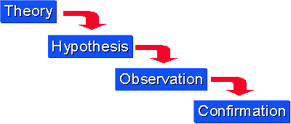
Deductive reasoning works from the more general to the more specific. Sometimes this is informally called a "top-down" approach. We might begin with thinking up a theory about our topic of interest. We then narrow that down into more specific hypotheses that we can test. We narrow down even further when we collect observations to address the hypotheses. This ultimately leads us to be able to test the hypotheses with specific data -- a confirmation (or not) of our original theories.
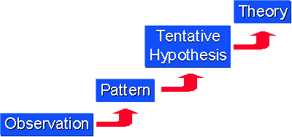
Inductive reasoning works the other way, moving from specific observations to broader generalizations and theories. Informally, we sometimes call this a "bottom up" approach (please note that it's "bottom up" and not "bottoms up" which is the kind of thing the bartender says to customers when he's trying to close for the night!). In inductive reasoning, we begin with specific observations and measures, begin to detect patterns and regularities, formulate some tentative hypotheses that we can explore, and finally end up developing some general conclusions or theories.
These two methods of reasoning have a very different "feel" to them when you're conducting research.
Inductive reasoning, by its very nature, is more open-ended and exploratory, especially at the beginning.
Deductive reasoning is more narrow in nature and is concerned with testing or confirming hypotheses.
Even though a particular study may look like it's purely deductive (e.g., an experiment designed to test the hypothesized effects of some treatment on some outcome), most social research involves both inductive and deductive reasoning processes at some time in the project.
In fact, it doesn't take a rocket scientist to see that we could assemble the two graphs above into a single circular one that continually cycles from theories down to observations and back up again to theories. Even in the most constrained experiment, the researchers may observe patterns in the data that lead them to develop new theories.

