PricewaterhouseCoopers says AI is expected to add $15.7 trillion to the global economy over the next decade. That's more than the GDPs of China and India combined.
AI is already one of the fastest-growing sectors of the economy – and it's just warming up. Economist Robert Hanson says AI will speed up the world economy by as much as 250 times its normal rate.
The world economy – which now doubles every 15 years or so – will soon double in somewhere from a week to a month, he says.
So while ASI will send millions of unprepared Americans begging for government handouts, it will also create an entire generation of millionaires.
Yes – there will be very big winners… and unfortunately, very big losers. That's why I'm sending out this emergency video.
Now, take a look at ChatGPT – the new kind of AI. Here's the last version: ChatGPT-3. It was powered by 175 billion data parameters.
And just four months later, ChatGPT-4 has over 1 trillion data parameters. That means AI is now growing six times more powerful in almost half the time. And that's just the start.
Because while the new industry is split between risky startups and giant expensive stocks like Apple, NVIDIA, Google… this parallel industry is much safer and more affordable.
Meta just completed their AI supercomputer build – and at the same time, they announced a new data center 500% more powerful than their current system.
And when IBM recently announced its new watsonx.ai, it described the system as – and I quote – an AI and data platform.

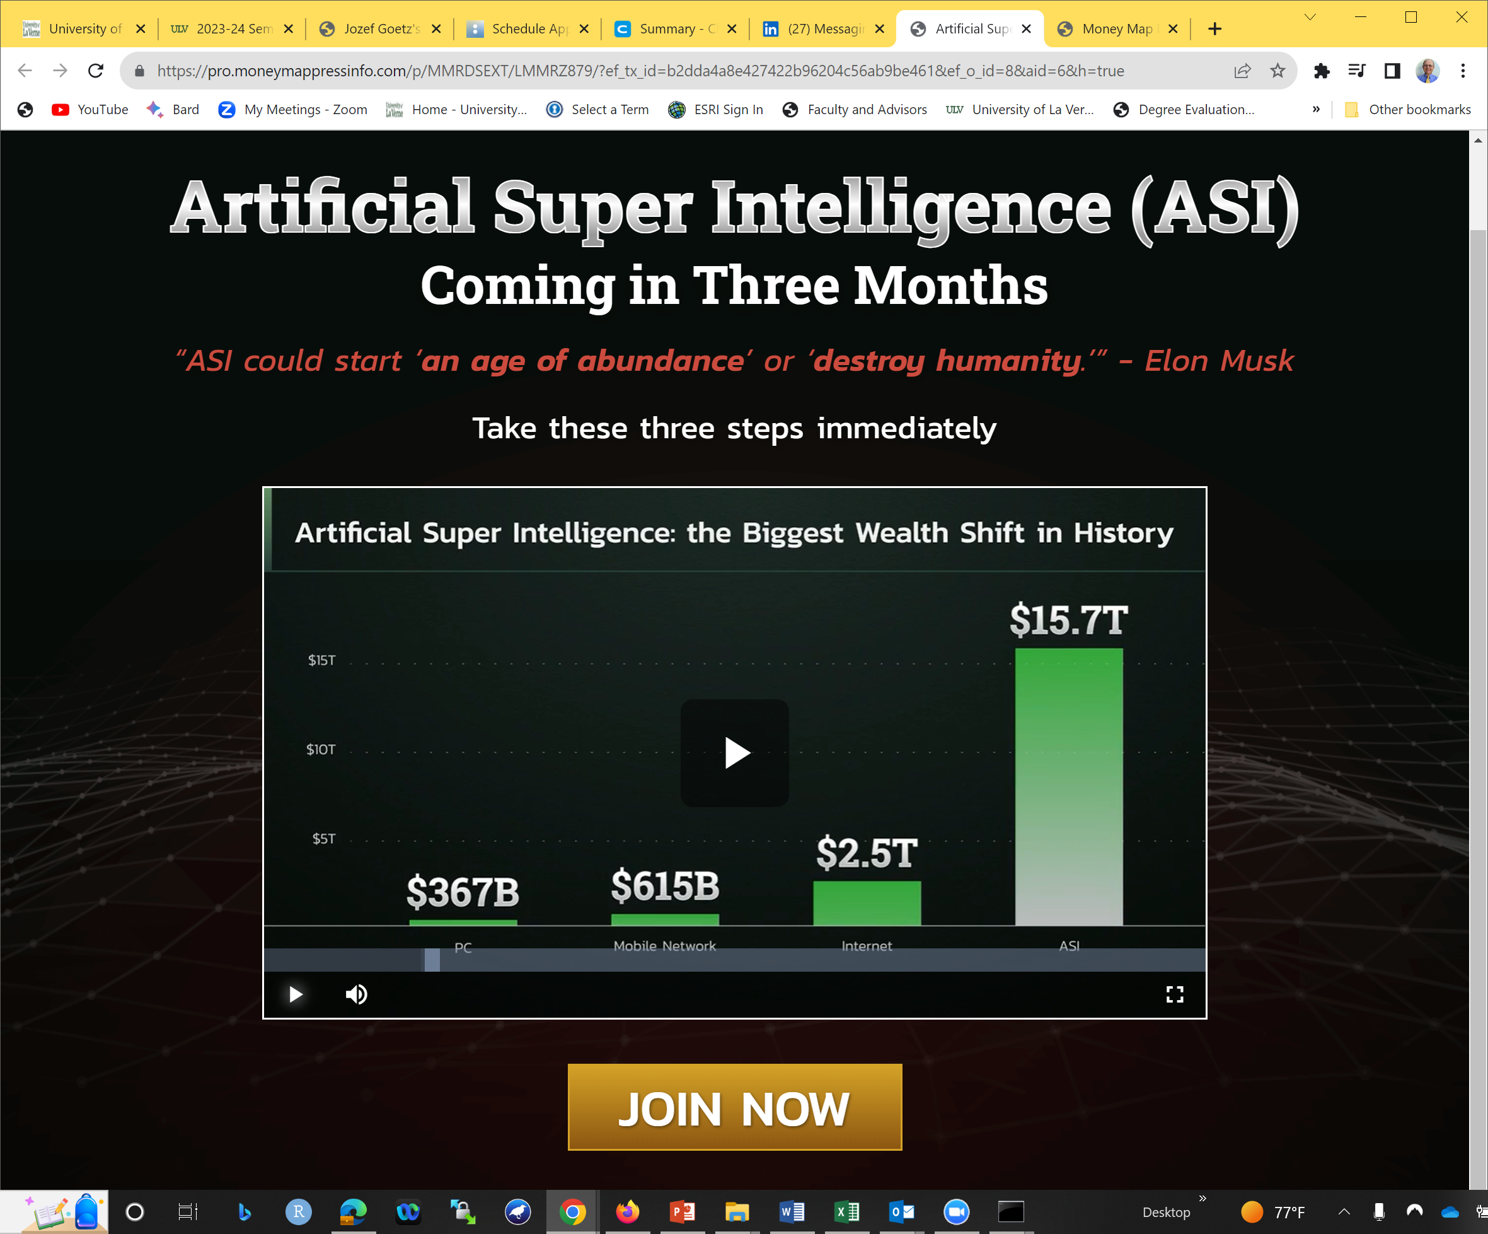

https://www.linkedin.com/pulse/15-amazing-real-world-applications-ai-everyone-should-bernard-marr/?midToken=AQFcDZ7qb-pgBg&midSig=3XSsuprszjvGM1&trk=eml-email_series_follow_newsletter_01-newsletter_content_preview-0-readmore_button_&trkEmail=eml-email_series_follow_newsletter_01-newsletter_content_preview-0-readmore_button_-null-p496~li1dfe5b~92-null-null&eid=p496-li1dfe5b-92

15 Amazing Real-World Applications Of AI Everyone Should Know About



Bernard Marr

📖 Internationally Best-selling #Author🎤 #KeynoteSpeaker🤖 #Futurist💻 #Business, #Tech & #Data Advisor
1,351 articles Follow
May 24, 2023
Thank you for reading my latest article 15 Amazing Real-World Applications Of AI Everyone Should Know About. Here at LinkedIn and at Forbes I regularly write about management and technology trends.
To read my future articles simply join my network here or click 'Follow'. Also feel free to connect with me via Twitter, Facebook, Instagram, Slideshare or YouTube.
---------------------------------------------------------------------------------------------------------------
Artificial intelligence (AI) is no longer a buzzword; it has become an integral part of our lives, influencing every aspect of society in ways we could only dream of just a few years ago.
Let’s explore the top 15 extraordinary real-world applications of AI that are driving change and revolutionizing industries this year.

Healthcare
In 2023, AI has made significant strides in healthcare by improving diagnostics, enabling personalized medicine, accelerating drug discovery, and enhancing telemedicine. Machine learning algorithms are now facilitating early disease detection and more accurate diagnoses, while personalized medicine is helping healthcare practitioners customize treatment plans for each patient's unique genetic makeup.
AI has also made a substantial impact on healthcare through the integration of wearable devices and IoT-enabled health monitoring systems. These technologies continuously collect valuable patient data like heart rate, blood pressure, and glucose levels, so healthcare providers can monitor and manage chronic conditions more effectively.
Providers have also been able to significantly improve mental health care by using AI to create accessible, personalized support systems. Chatbots and virtual therapists, powered by natural language processing and machine learning, can engage users in therapeutic conversations, helping to alleviate symptoms of anxiety, depression, and other mental health issues.

Customer Service
In the customer service realm, AI-powered virtual assistants and chatbots have streamlined and improved support by providing instant, 24/7 answers to customer queries. Call center automation has increased productivity, while sentiment analysis allows businesses to better understand customer emotions and tailor their responses accordingly.
Businesses can also use AI to analyze consumer data — including patterns in buyer behavior, preferences, and purchase history — and use that data to provide hyper-personalized customer experiences.
Algorithms can also automatically generate customized product recommendations, promotions, and content for customers and prospects.

Finance
Finance professionals are employing AI in fraud detection, algorithmic trading, credit scoring, and risk assessment. Machine learning algorithms can identify suspicious transactions in real time, and algorithmic trading has enabled faster and more accurate trade executions.
With AI, financial institutions can more accurately assess risk, so they can improve loan decisions and investment strategies.
AI has also revolutionized the field of financial planning and wealth management by creating intelligent robo-advisors that cater to a diverse range of clients, from novice investors to seasoned professionals. These AI-powered platforms use advanced algorithms to analyze market trends, assess client risk tolerance, and provide personalized investment recommendations.
Because finance is a heavily regulated industry, staying on top of complex compliance rules is challenging. AI can help financial institutions simplify this type of regulatory compliance by automating the analysis of documents and monitoring transactions for potential violations.

Manufacturing
AI applications in manufacturing include quality control, predictive maintenance, supply chain optimization, and robotics. Advanced algorithms ensure quality by detecting defects in products, while predictive maintenance minimizes equipment downtime. Companies can optimize their supply chains, so they can allocate resources more efficiently. Manufacturing facilities can also use robotics to increase productivity and precision in their processes.
Manufacturing companies are using digital twins to create virtual replicas of physical items, processes, or systems — and these digital representations enable manufacturers to simulate, monitor, and optimize the performance of their production lines in real time.

Transportation
On the roads, self-driving cars and trucks are set to minimize human error and improve safety, and intelligent traffic management systems can help reduce congestion. Route optimization saves time and fuel, and drone delivery offers a fast, eco-friendly alternative to traditional drop-offs.
AI is also enhancing and improving public transportation systems by predicting passenger demand and optimizing schedules.

Agriculture
Out in the fields and in the AgTech world, farmers and scientists are using AI to monitor crops, predict yields, and keep pests at bay. AI-enabled precision farming helps farmers make data-driven decisions so they can optimize irrigation, improve fertilization, and reduce waste.
Farmers are also embracing autonomous tractors and machinery, which are revolutionizing traditional agricultural practices. Self-driving tractors — equipped with advanced sensors, GPS, and AI-driven control systems — can perform tasks like plowing, seeding, and spraying with increased precision and efficiency.

Retail
Retail companies are already using AI applications for inventory management and targeted marketing, and they are leveraging artificial intelligence to create personalized recommendation systems and customer service chatbots.
Retailers are also integrating visual search technologies into their online stores, so customers can find products by uploading images instead of relying on text-based queries. These types of AI-powered visual search engines can analyze the features of the uploaded image and provide a list of similar products available for purchase.

Education
In classrooms and training centers, AI-powered adaptive learning tailors educational content to each student's needs, while plagiarism detection ensures academic integrity. Teachers and trainers can even leverage data analytics to predict student performance so they can intervene early if they spot problems.
AI has also played a significant role in democratizing access to education, especially for those in remote or underprivileged areas. AI-driven language translation tools and real-time transcription services have broken down language barriers, enabling students worldwide to access educational content from anywhere in the world. AI-powered virtual tutors can provide one-on-one support and guidance, supplementing traditional classroom instruction and making quality education accessible to a broader audience.

Energy
AI has already had a significant impact on energy management, with applications in smart grid management, demand forecasting, renewable energy optimization, and energy conservation. AI-driven systems can balance energy supply and demand, predict usage patterns, optimize renewable energy resources, and recommend energy-saving measures, leading to a more sustainable future.
AI has also been instrumental in improving the performance and efficiency of energy storage systems like batteries and thermal storage solutions. By analyzing historical performance metrics and data from sensors, AI-powered algorithms can optimize charging and discharging cycles and extend the life of energy storage systems.

Human Resources
AI tools can help organizations automate many time-consuming HR tasks like resume screening and workforce planning. HR professionals can also use AI to streamline recruitment processes and monitor employee performance.
Artificial intelligence has started to play a critical role in supporting diversity and inclusion initiatives within organizations. HR departments can use algorithms to assess job postings and recruitment materials for potential bias, so their companies can create more inclusive hiring processes that attract a diverse pool of candidates.

Environment
AI has become a critical tool for addressing environmental challenges, with applications in climate modeling, pollution tracking, wildlife conservation, and natural disaster prediction. These technologies provide insights into climate patterns, help monitor pollution levels, protect endangered species, and forecast potential natural disasters, enabling proactive mitigation strategies.

Security
AI is a game-changer in the security world. Law enforcement agencies and cybersecurity firms can use AI for facial recognition, surveillance, and threat detection. These technologies enhance public safety and combat cybercrime by identifying and neutralizing potential threats in real time.
Engineers have also used AI to develop advanced biometric authentication systems like fingerprint, iris, and voice recognition. These AI-driven solutions provide a higher level of security compared to traditional methods, like passwords or access cards, by relying on unique biological features that are difficult to replicate or forge.

Entertainment
AI is the real “name of the game” in the entertainment industry. With AI-generated content, game designers can create more immersive experiences for players, including games that include virtual reality (VR) and augmented reality (AR) elements. With AI-powered recommendation systems, companies can curate content for users, so they have more personalized and engaging entertainment experiences.
AI is also enhancing the way we interact with and experience art and music, through applications like generative art, interactive installations, virtual concerts, and more.

Law and Legal Services
AI-driven tools can efficiently process large volumes of legal documents, identify potential issues in contracts, and expedite legal research by extracting relevant information. Additionally, AI is increasingly utilized in dispute resolution so legal professionals can streamline mediation or arbitration processes and reduce costs.

Space Exploration
AI's applications in space exploration are nothing short of groundbreaking. Scientists are already using AI for spacecraft navigation, satellite imaging, mission planning, and identifying new astronomical phenomena.
AI has also played a crucial role in enhancing the detection and tracking of near-Earth objects (NEOs) like asteroids and comets. By analyzing vast amounts of astronomical data, machine learning algorithms can identify and predict the trajectories of these objects, so we can send out alerts and avoid disastrous impacts.

AI Is Revolutionizing Our World
AI has stepped out of the realm of science fiction, and now we’re seeing it practically every day, across every industry. From healthcare to agriculture, entertainment to transportation, these top 15 real-world applications of AI are shaping our present and redefining our future.

To stay on top of the latest on new and emerging business and tech trends, make sure to subscribe to my newsletter, follow me on Twitter, LinkedIn, and YouTube, and check out my books, Future Skills: The 20 Skills and Competencies Everyone Needs to Succeed in a Digital World and Future Internet: How the Metaverse, Web 3.0, and Blockchain Will Transform Business and Society.
-----------------------------------------------------------------------------
Einstein Platform: Salesforce
https://www.salesforce.com/content/dam/web/en_us/www/documents/datasheets/einstein-features-cheat-sheet.pdf from https://www.salesforce.com/products/einstein-ai-solutions/

