Artificial Intelligence (AI):

WEEK 1 1/03/24:

+ComputerScience.org/resources/landing-a-job-in-artificial-intelligence+++ - good description

+What Is AI? | Artificial Intelligence | What is Artificial Intelligence? | AI In 5 Mins, 4:45 min, 1.7M views 4 years ago, rate5.
[This video on "What is Artificial Intelligence" will give you a brief overview of artificial intelligence as a technology in just 5 minutes]

+What Is Artificial Intelligence? | Artificial Intelligence (AI) In 10 Minutes | Edureka
1.4M views 4 years ago, 11:16 min, rate5.

++Introduction To Artificial Intelligence | What Is AI?| Artificial Intelligence Tutorial |Simplilearn, 19.14 min, 62K views3 years ago, rate5+.
#IntroductionToArtificialIntelligence #WhatIsAI? #ArtificialIntelligenceTutorial #ArtificialIntelligence

WEEK 2 – 1/10/24:

++Google’s AI Course for Beginners (in 10 minutes)!
285,975 views Nov 14, 2023 https://www.youtube.com/watch?v=Yq0QkCxoTHM, rate5+
- We unravel the layers of AI, Machine Learning, Deep Learning, and their applications in tools like #ChatGPT and Google #Bard.
- We first go through how AI is a broad field of study that encompasses #MachineLearning as a sub-field.
- We then break down Machine Learning into supervised and unsupervised models, using real-world examples to illustrate their functions and differences.
- We move deeper into Deep Learning: Learn about artificial neural networks and the power of semi-supervised learning in applications like fraud detection in banking.
- Then we delve into Generative AI, differentiating it from discriminative models and demonstrating its capabilities in creating new, innovative outputs.
- Finally we walk through Large Language Models (LLMs) and uncover the significance of LLMs in AI, their pre-training processes, and their customization for specific industry applications.

TIMESTAMPS 00:00 Google’s AI Course in 10 Minutes 00:38 What is Artificial Intelligence? 01:27 What is Machine Learning? 03:28 What is Deep Learning? 05:15 What is Generative AI? 07:05 What are Large Language Models?
- Google’s AI Course for Beginners_JG 2024.ppt at http://classes.jgspectrum.com/classes/370_TJan24/LectureNotes/.

- +Machine Learning | What Is Machine Learning? | Introduction To Machine Learning | 2021 | Simplilearn, 7.52 min, 4.1M views5 years ago, rate5-, January 3, 2024.

+ChatGPT Tutorial - A Crash Course on Chat GPT for Beginners
- ChatGPT Tutorial - A Crash Course on Chat GPT for Beginners_JG_2024.ppt at http://classes.jgspectrum.com/classes/370_TJan24/LectureNotes/.
34.05 min, 5.4M views 1 year ago, Adrian Twarog, rate5.
00:00 - Introduction
00:17 – Signup
02:27 - ChatGPT Details
06:52 - How to use Prompts
12:28 - Shopping List
14:55 - JavaScript
18:04 - Errors with ChatGPT
19:13 - Short Story
20:41 - Text Video Game
21:42 - Legal and Copyright Templates
22:59 - Jokes and Humor
24:31 - Cover Letters and Resumes
27:28 - Summarization and Keyword Extraction
29:34 - Blogging Articles and Editing
33:46 – Conclusion

++Master the Perfect ChatGPT Prompt Formula (in just 8 minutes)!
779,116 views Aug 1, 2023, https://www.youtube.com/watch?v=jC4v5AS4RIM, rate5+
- Here are the 6 key components that make up the perfect formula for ChatGPT and Google Bard: Task, Context, Exemplars, Persona, Format, and Tone.
- We go through real-world examples and demonstrate how each component contributes to the effectiveness of the prompt (aka the better the prompt, the better the output)!
- The Task sentence needs to articulate the end goal and start with an action verb.
- Use three guiding questions to help structure relevant and sufficient Context.
- Exemplars can drastically improve the quality of the output by giving specific examples for the AI to reference.
- For Persona, think of who you would ideally want the AI to be in the given task situation.
- Visualizing your desired end result will let you know what format to use in your prompt.
- And you can actually use ChatGPT to generate a list of Tone keywords for you to use!

- Master the Perfect ChatGPT Prompt Formula_JG_2024.ppt at http://classes.jgspectrum.com/classes/370_TJan24/LectureNotes/.

- ++Ilya: the AI scientist shaping the world, The Guardian, 11:45 min, 473K views 2 months ago, rate5+.

======================================= Extra in Week 3 ==============================

++Why AI Will Spark Exponential Economic Growth | Cathie Wood | TED
14:41 min, 242K views1 month ago, rate5+, 1-18-24.
Investor Cathie Wood explores this unique moment in technology, which she sees as being marked by the simultaneous evolution of five pivotal innovation platforms — a scenario unparalleled in history. Exploring the role of AI in reshaping economic paradigms, she predicts a surge in global GDP growth and productivity, underscoring the need for businesses and investors to adapt in order to keep up.

11. ++Introduction to Generative AI Studio,
16.06 min, 154K views 6 months ago, rate5+, 1-20-24. Good to create a .ppt of the video.
Prototype and customize generative AI models with Generative AI Studio, a product on Vertex AI. This video gives an overview of Generative AI Studio and demonstrates how to use the tool [to tune model].
Generative AI is a type of artificial intelligence technology that broadly describes machine learning systems capable of generating text, images, code or other types of content, often in response to a prompt entered by a user. It uses neural networks to learn the patterns and structure of the training data and then generate new data that has similar characteristics. For example, generative AI can produce realistic images of animals, faces, or landscapes from text descriptions, or write stories, poems, or code from keywords or prompts.
https://www.cloudskillsboost.google/course_templates/536: This is an introductory level microlearning course aimed at explaining what Generative AI is, how it is used, and how it differs from traditional machine learning methods. It also covers Google Tools to help you develop your own Gen AI apps.

Video: Introduction to Generative AI, 22 minutes

Introduction to Generative AI: Reading, 30 minutes
  - Quiz: Introduction to Generative AI: Quiz
======================================================================

++Godfather of AI" Geoffrey Hinton: The 60 Minutes Interview
13.11 min, 1,279,781 views Oct 9, 2023 #AI #artificialintelligence #news, rate5+, 1-19-24.
There’s no guaranteed path to safety as artificial intelligence advances, Geoffrey Hinton, AI pioneer, warns. He shares his thoughts on AI’s benefits and dangers with Scott Pelley.

[We didn’t design a system we designed a learning algorithm to learn from data. Predict the next word. To do that you need to understand the content.]

- Jeremy Chapman - director 365, Mark Russinovicz- CTO: Microsoft Mechanics, What runs ChatGPT? Inside Microsoft’s AI supercomputer, 611K views 7 months ago, rate5+, YouTube, 16:27 min, May 24, 2023.

- Elon Musk tells Tucker potential dangers of hyper-intelligent AI, 11.10 min, 2.9M views 8 months ago.

- What AI is Making Possible | Ilya Sutskever and Sven Strohband, 25:56 min, 60K views 5 month ago.

- Ilja Sutskever (OpenAI Chief Scientist), Building AGI, Alignment, Spies, Microsoft, & Enlightenment, published March 27, 23, 560K views 9 months ago, 47.40 min, rate5+, June 4, 2023.

- ChatGPT Tutorial: How to Use Chat GPT For Beginners 2023, https://www.youtube.com/watch?v=Gaf_jCnA6mc, rate5+, YouTube, 27:50 min, guided by Charlie Chang to follow commands. 2.6 mln viewers for 8 months, January 3, 2024.

18. Complete ChatGPT Tutorial - [Become A Power User in 30 Minutes]
27.32 min, 2.6M views 10 months ago
TIMESTAMPS: 0:00 Getting Started 1:40 Understanding The Interface 4:15 Command Type 1 7:30 Command Type 2 9:45 ...
Getting Started | Understanding The Interface | Command Type 1 | Command Type 2 | Command Type 3 | Command Type 4 | Command Type 5 | Command Type 6 | Command Type 7 | Command Type 8 | Command Type 9 | Command Type 10 | Two TIPS For Better Answers

19. +[1hr Talk] Intro to Large Language Models rate5+-specifically to 33min
1.1M views 1 month ago, Andrej Karpathy
This is a 1 hour general-audience introduction to Large Language Models: the core technical component behind systems like ...
Intro: Large Language Model (LLM) talk | LLM Inference | LLM Training | LLM dreams | How do they work? | Finetuning into an Assistant | Summary so far | Appendix: Comparisons, Labeling docs, RLHF, Synthetic data, Leaderboard | LLM Scaling Laws | Tool Use (Browser, Calculator, Interpreter, DALL-E) | Multimodality (Vision, Audio) | Thinking, System 1/2 | Self-improvement, LLM AlphaGo | LLM Customization, GPTs store | LLM OS | LLM Security Intro | Jailbreaks | Prompt Injection | Data poisoning | LLM Security conclusions | Outro

- SPE: ChatGPT Tutorial – A Crash Course on Chat GPT for Beginners, rate5+, YouTube, 34:04 min, May 24, 2023.

IN SPE ChatGPT Tips for Beginners in 2023! (Become a PRO!), 30:59 min, rate5+, 12/3/23.
- Kurdiez Space, How ChatGPT Works Technically for Beginners, rate5+, YouTube, 33:10 min, May 24, 2023.
- Digital Engine, This AI says it’s conscious and experts are starting to agree with Elon Musk, published on Jun 5, 2022, YouTube, 19:28 min, rate5, May 25, 2023.
- This is Why GPT 5 will Change the World (Chat GPT 5), YouTube, rate5, 12:33 min, May 24, 2023.
- Unveiling GPT-5: The Most Inteligent AI Tool Ever Created, rate5, YouTube, 10:21 min, November 18, 2023.
- What is the Most Advanced AI Right Now?, YouTube,12:58 min, September 10, 2023.
- IN SPE OpenAI GPt-5: The Most Advanced AI Yet – Live with Tesla & Elon Musk, YouTube, rate5+, 1:23:56 min, May 24, 2023
- Sam Altan: CEO, Google Open AI, The AI Revolution: Google’s Development on of the Future Artificial Intelligence, published April 16, 23, 27.20 min, rate5, June 4, 2023.
- Greg Brockman, The inside Story of ChatGPT’s Astonishing Potential, YouTube, 30.10 min, rate5, May 31, 2023.
- Ian Beacraft – futurist, See How AI and Metavese will Shape Society with Ian Beacraft, SXSW 2023, YouTube, 58 min, rate5, May 27, 2023.
- Luke Monington, Google AI Document LEAKED: How Open Source is Quietly Defeating Google and OenAI, YouTube, 26:44 min, rate5, May 26, 2023.

- Teaching & Learning in the Age of genAI: https://genai.sites.gettysburg.edu/resources/.

genAI 101
The resources below are a good starting point if you haven’t yet been able to spend much time using or thinking about genAI tools. Because these materials were generated in January, many of them are specific to ChatGPT, though most principles apply to the many other genAI tools that now exist.
For further information, head on over to our genAI 201 section.

Intro to ChatGPT (300 billion words from books, Wikipedia, articles, web I believe in Twitter was involved there) and Large-Language Models
We started our on-campus conversations about generative AI with a session back in January.
- Access link to Zoom recording of the entire session. (Recommendations on “what to do” start at 23:30).
- ++Pressed for time? Take a look at this 3-minute video segment of CS professor Clif Presser explaining how large language models like ChatGPT work.
- Access link to session slides; Recommendations on what to do here
- What is ChatGPT? A helpful primer. (Washington Post)

How accurate is ChatGPT?
A disclaimer pops up when you start to use the technology, warning users that ChatGPT is not always accurate.
“While we have safeguards in place, the system may occasionally generate incorrect or misleading information and produce offensive or biased content,” it reads. “It is not intended to give advice.”

- https://elevenlabs.io/ - Piotr Dabkowski cofounder and chief technology. Convert text to speech online for free with our AI voice generator. Create natural AI voices instantly in any language - perfect for video creators, developers, and businesses.

- ChatGPT vs Bard vs Copilot
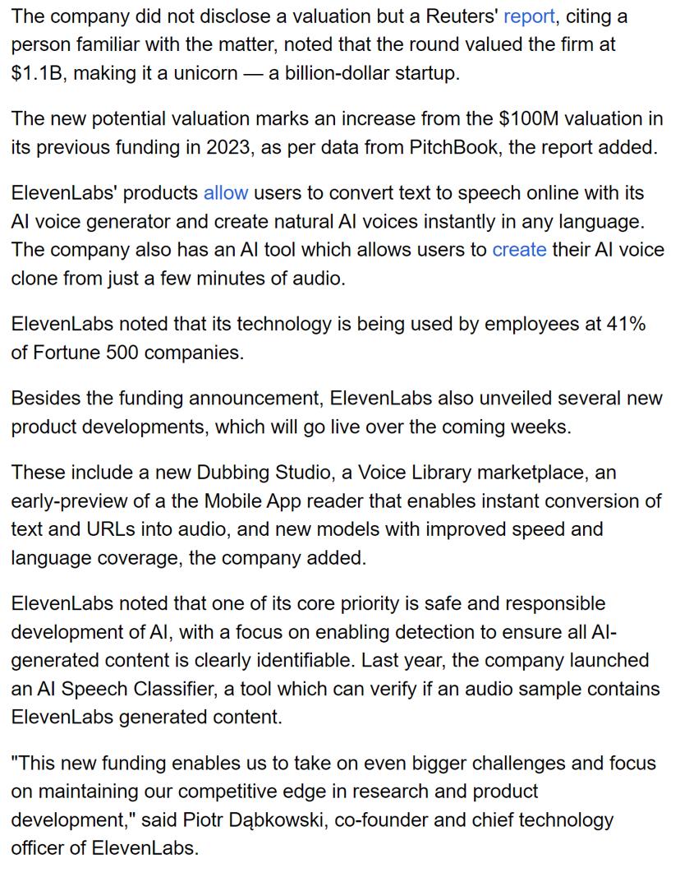
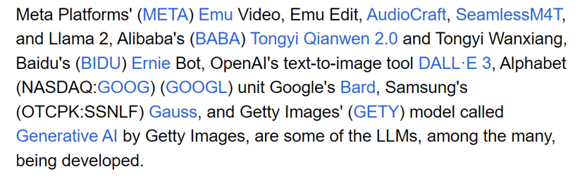
At their core, computers are just a bunch of 1s and 0s coded in sequence, with each number corresponding to a certain action for the computer to perform. Humans, similarly, are a bunch of As, Gs, Cs, and Ts strung together – or the four base types found in human DNA molecules – with each determining a person’s characteristics, traits, and even actions.
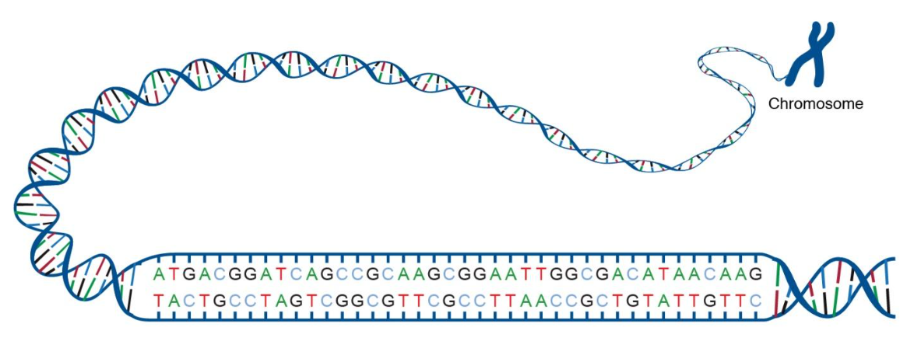
Humans are full of data.
AI:
- Increase productivity
- Change work flow
- Better assistant in health, regulations advising etc.

Student selected topics for CMPS 370 in January 2024:
AI COMPUTER VISION (SELF DRIVING CARS)
AI computer vision in the context of self-driving cars refers to the technology that enables these vehicles to perceive and interpret their surroundings, much like human vision does. This involves the use of cameras, sensors, and sophisticated algorithms. We will discuss its capabilities and its effects on the market.
AI IN FINANCE
AI is used in banking to help control manual errors in data processing, analytics, document processing, identify patterns in the stock market and make trading decisions. We will be analyzing how AI is implemented in Finance and how the impact banking and the stock market.
AI IN CYBERSECURITY
AI is used in Cybersecurity to help analyze massive amounts of risk data which results in improved security. We will analyze how AI is implemented in Cybersecurity and how this will impact security in today’s world.

AI IN HEALTHCARE
AI is used in healthcare to enhance various aspects of the delivery of healthcare. We will be analyzing the ways AI applications are implemented and how they impact today's health field.
MULTIMODAL AI
Multimodal AI integrates various data forms like text, images, and audio for comprehensive understanding. We'll examine how this AI processes diverse data types to enhance accuracy in applications like content moderation and multimedia analysis.
AI IN AUGMENTED REALITY
AI is used in Augmented Reality to help precisely recognize and track items in the real world. We will analyze how AI can help AR process and interpret data from sensors and cameras and how it results in smoother and more accurate experiences with AR.
AI IN AUDIO
AI can be used to manipulate, edit, create, and enhance audio; ranging from music to voice. We will be analyzing the ways audio can be generated, analyzed, and enhanced through AI.

Internet Programming (IP) alumnus talking about advantage to take IP at
https://www.youtube.com/watch?v=63VV82VERwc.

AI can be used in my classes:
- Analyze data of the specific data file
- Teach AI what I need in my code
- Teach how to test my code the easiest way
- Preparing my lecture testing with AI
- Ask AI to express something in an image or video
- Tell me what should be the next paragraph in my word report
- AI as your personal tutor.

