Use Times New Roman, regular text font size 10, title font size 12
Use Star Ratings Interpretation for evaluating content
***** = Comprehensive, expert-level walkthrough with high production value and broad app coverage.
**** = Strong tutorial with good depth and clarity, but slightly narrower in scope.
*** = Solid overview for beginners, practical but not exhaustive.
** = High-level demo, useful for quick orientation but limited in depth.
* = Minimal content or unclear presentation.

Use any format for assignments below and save each assignment in the following format and post to OneDrive under CMPS471 and your name:
25F_A#_Topic_Name+YourFirstNameInitial_LastName.docx
Ex: F25_A1_Copilot+J_Smith.docx

Ass # | ASSIGNMENT CPMS 471 AI Internship – Fall ‘25  http://classes.jgspectrum.com/ => Classes => CMPS 471: | Due | Points
#1 | - Syllabus, course overview  - Review 4. CMPS 471 GUIDE to find an internship.docx at https://jgspectrum.com/classes/classes/471_Internship/Guidelines/.  - Learning capabilities of Microsoft 365 Copilot | 8/28
#2 | - Prompt Grok: Give me three best Grok videos and compare them and showcase its capabilities in the table format.  - Specify why should use Grok and give me the best simple example or usage?  - Watch one of the best videos  Create a report called F25_A1_Grok_capabilities+J_Smith.docx..  Each time copy the text, not screenshots. | 9/4
#3 | - Give me three best Grok finance learning videos and compare them and showcase its capabilities in the table format. Watch two of them. Specify why should Grok be used in finance.  - Give me a tabular comparison of which model (Grok, chatGPT, Gemini, Copilot or Elicit AI can predict better NVDIA stock for the last 10 years.  - Ask the same question 2 above to chatGPT, Gemini, Copilot and Elicit. Compare results and see recommendation.  All document in F25_A1_Copilot+Finance-NVDIA_.J_Smith.docx. Provide a reference as follows: [date][source]; for example: 9-18-25 chatGPT. | 9/11
#4 | - What is a bot?  - Give me the best recommendation to create a bot.  - Select the best two videos on the bot subject and watch – provide the info  - Ask the same as above to the following AI assistant platforms:  - chatGPT,  - Grok (added later)  - Gemini,  - Copilot,  - AI Chat,  - Perplexity  - Claude,  - Elicit.  - What fields are the best to use a bot.  - Provide an example for the possible usage in your ULV class choice.  - Your opinion (added later)  All document in F25_A1_Bot_J_Smith.docx. Provide a reference as follows: [date][source]; for example: 9-18-25 chatGPT. | 9/18
#4 B | Custom GPT in ChatGPT (simplest) for your selected CMPS class  - You can upload your course files (syllabus, assignments) into a Custom GPT.  - Students can then type questions in plain English (“When is Assignment 1 due?”) and the bot looks up the answer in your materials.  - Pro: No coding needed, fast to set up.  - Con: Students need ChatGPT accounts to access it  Test after implementation with at least 5 questions.  All document in F25_A1_Practice_Bot_J_Smith.docx. Provide a reference as follows: [date][source]; for example: 9-18-25 chatGPT. | 10/2
#5 | - What is an AI agent?  - Give me the best recommendation to create an agent.  - Select the best two videos on the agent subject and watch – provide the info  - Ask the same as above to the following AI assistant platforms:  - chatGPT,  - Grok  - Gemini,  - Copilot,  - AI Chat,  - Perplexity  - Claude,  - Elicit.  - What fields are the best to use an agent and multiple agents.  - Provide an example for the possible usage in finance/stock field.  - Your opinion.  All document in F25_A1_Agent_J_Smith.docx. Provide a reference as follows: [date][source]; for example: 10-02-25 chatGPT. Each time copy the text, not screenshots. | 10/16
#6 | In Gemini: Give me a simple task for students using the Cursor professional platform for the 1st time within Visual Studio Code, and provide a step-by-step solution with all explanations. First, guide me on how to get the Cursor professional platform within Visual Studio Code.  Compare the same solution process with a process done by ChatGPT and specify the differences.  Expand F25_A1_ CURSOR_example.docx posted in the same directory as it is this document to F25_A1_CURSOR_example_yourLastName.docx. | 10/23
+7 | Robots in general and specific Optima - ability to perceive the 3D world. Watch two best videos. Explore separately on  - chatGPT,  - Grok,  - Gemini,  - Copilot.  Your comments and opinion. Which AI assistant platform is the best in that field.  Expand F25_A1_ ROBOT_example.docx posted in the same directory as it is this document to F25_A1_ROBOT_example_yourLastName.docx.  Think about your concrete project topic of your choice using AI by next week. You could present it on November 13.  I may suggest “Predictive AI Modeling for Subset-Selected Stocks or Cryptocurrencies Using Historical Data.” | 10/30
#8 | Work on your AI topic of your choice and show me your progress next time. Your presentation and final report are due on November 20.  See AI_Project_and_Presentation_Guidelines.docx soon in same as this doc is located.  See #9 below. | 11/6
#9 | Bring 15 – 20 Best Charts or Diagrams used in AI. See an example below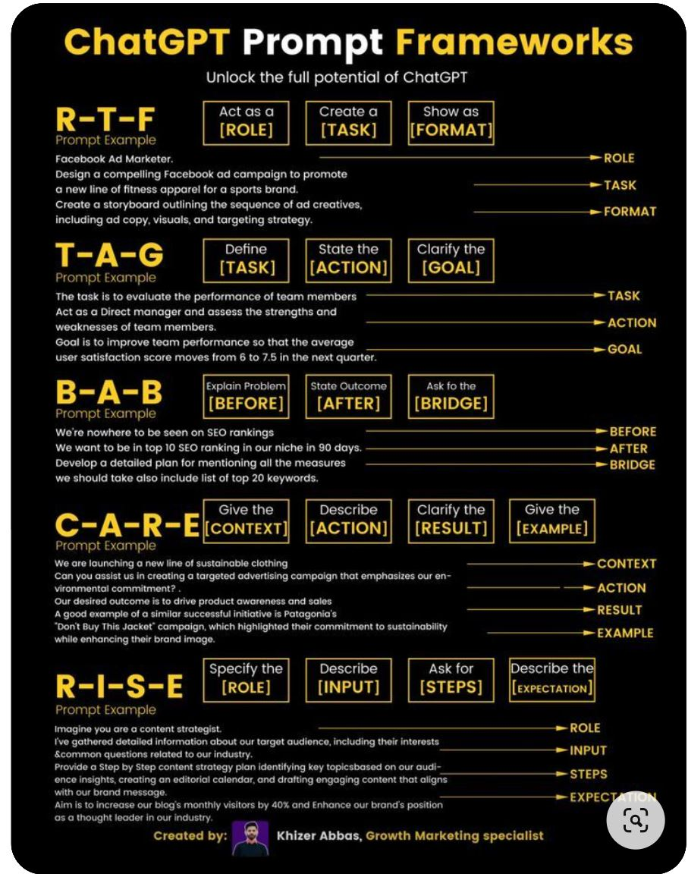.  Prompt the following AI assistant platforms:  - chatGPT,  - Grok  - Gemini,  - Copilot,  - Claude.  Create a report called F25_A1_Diagrams+Your name.docx. | 11/13
#10 | Presentation of your project by displaying your step by step report and demo according to AI Guidelines_Reports.docx.  Save your project as F25_CMPS471_A1_Final_Project+Your name.docx. | 11/20
Sora (video maker)– generate your own short video

Real time examples using AI assistants platforms.
 | Gemini Agent.

Follow the following FORMAT (title, indented: # of views, link, author, | listed DESCRIPTIONS | TIMESTAMPS :

****Google’s AI Course for Beginners (in 10 minutes)!, 10 min.
Today 8-28-2025; 2.4M views Nov 14, 2023 https://www.youtube.com/watch?v=Yq0QkCxoTHM, by Jeff Su, rate5+.
- We unravel the layers of AI, Machine Learning, Deep Learning, and their applications in tools like #ChatGPT and Google #Bard.
- We first go through how AI is a broad field of study that encompasses #MachineLearning as a sub-field.
- We then break down Machine Learning into supervised and unsupervised models, using real-world examples to illustrate their functions and differences.
- We move deeper into Deep Learning: Learn about artificial neural networks and the power of semi-supervised learning in applications like fraud detection in banking.
- Then we delve into Generative AI, differentiating it from discriminative models and demonstrating its capabilities in creating new, innovative outputs.
- Finally we walk through Large Language Models (LLMs) and uncover the significance of LLMs in AI, their pre-training processes, and their customization for specific industry applications.

TIMESTAMPS if available
00:00 Google’s AI Course in 10 Minutes
00:38 What is Artificial Intelligence?
01:27 What is Machine Learning?
03:28 What is Deep Learning?
05:15 What is Generative AI?
07:05 What are Large Language Models?

Another preferable FORMAT:

🏆 Top Pick: Ultimate Guide to Microsoft 365 Copilot (2025)
- Creator: Maksims Sics
- Length: 2 hours 11 minutes
- Overview: This comprehensive walkthrough covers Excel, Word, PowerPoint, Teams, Outlook, and the Copilot App. It’s ideal for users who want a deep dive into all major features and use cases.
- Watch here: Microsoft 365 Copilot ULTIMATE Guide (2025)
🧭 Official Microsoft Tour of the Copilot App
- Presenter: Jon Friedman, Corporate VP of Design & Research at Microsoft
- Length: ~5 minutes
- Overview: A sleek, official demo of the Copilot App, showcasing features like Copilot Chat, Search, and Create. Perfect for a high-level overview of the app’s design and functionality.
- Watch here: Take a tour of the Microsoft 365 Copilot App

🧭 Official Microsoft Tour of the Copilot App
- Presenter: Jon Friedman, Corporate VP of Design & Research at Microsoft
- Length: ~5 minutes
- Overview: A sleek, official demo of the Copilot App, showcasing features like Copilot Chat, Search, and Create. Perfect for a high-level overview of the app’s design and functionality.
- Watch here: Take a tour of the Microsoft 365 Copilot App

or better in the table format:
Feature / Video Title | Ultimate Guide (Maksims Sics) | Beginner Tutorial (Shiv Pal) | Official App Tour (Microsoft)
Length | 2h 11m | 24m | ~5m
Depth | ⭐⭐⭐⭐⭐ Full walkthrough | ⭐⭐⭐ Practical overview | ⭐⭐ High-level demo
Apps Covered | Word, Excel, PowerPoint, Outlook, Teams, Copilot App | Word, Excel, PowerPoint, Outlook, Teams | Copilot App only
Style | In-depth, hands-on, advanced | Step-by-step, beginner-friendly | Polished, official presentation
Best For | Power users, educators, IT pros | New users, quick learners | Executives, decision-makers
Unique Highlights | Real-world examples, advanced tips | Easy-to-follow instructions | Design philosophy, app overview
Link | Watch here | Watch here | Watch here

🔍 Recommendation:
- If you're looking for depth and mastery, go with the Ultimate Guide.
- If you want a quick and practical intro, the Beginner Tutorial is perfect.
- If you're curious about the Copilot App’s design and vision, the Official Tour is a great watch.

Add Charts in the future.- ignore it.

