My ANDROID installation 9-15
- Install JDK 7 from
don’t do => http://www.oracle.com/technetwork/java/javase/downloads/index.html
- JDK Download but now is JDK 8 which officially Android doesn’t support
So go http://www.oracle.com/technetwork/java/javase/downloads/jdk-7-netbeans-download-432126.html and install JDK 7 u80 with NetBeans 8.0.2 Windows x64
done 10-1-15
- Download Android Studio from https://developer.android.com/sdk/index.html =>click Download Android Studio for Windows => gets
(you can get the above links from https://developer.android.com/sdk/installing/index.html )
============================== 12-11-2015 ===============================
Android™ 6 for Programmers: An App-Driven Approach, Third Edition
By: Paul Deitel; Harvey Deitel; Alexander Wald
Publisher: Prentice Hall
Publication Date: 11-DEC-2015

INSTALLING THE JAVA DEVELOPMENT KIT (JDK)
Android requires the Java Development Kit version 7 (JDK 7). All Java language features in JDK 7 are supported in Android Studio, but the try-with-resources statement is supported only for Android platform versions with API levels 19 and higher. To download JDK 7 for Windows, OS X or Linux, go to
- http://www.oracle.com/technetwork/java/javase/downloads/java-archive-downloads-javase7-521261.html Jozef’s note: => Java SE Development Kit 7u80
Choose the appropriate 32-bit or 64-bit version for your computer hardware and operating system. Be sure to follow the installation instructions at
http://docs.oracle.com/javase/7/docs/webnotes/install/index.html
Android does not yet support Java 8 language features, such as lambda expressions, new interface features and the stream APIs. You can use JDK 8 (as we did when developing this book’s apps), provided that you use no Java 8 language features in your code.
INSTALLING ANDROID STUDIO - i got ver. 1.5
Google’s Android Studio comes with the latest Android Software Development Kit (SDK) and is based on the popular Java IDE from JetBrains called IntelliJ® IDEA. To download Android Studio, go to
http://developer.android.com/sdk/index.html
and click the Download Android Studio button. When the download completes, run the installer and follow the on-screen instructions to complete the installation. If you previously installed an earlier Android Studio version, a Complete Installation window will appear at the end of the install process and give you the option to import your previous settings. At the time of this writing, Android Studio 1.4 is the current released version and Android Studio 1.5 is available as an early access release.
[ Jozef’s notes:
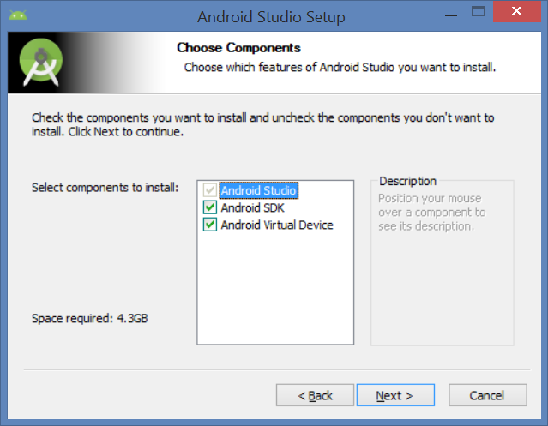

Installing Android SDK Build-tools, revision 23.0.2
Installed Android SDK Build-tools, revision 23.0.2
Installing Android SDK Platform-tools, revision 23.1.0
Stopping ADB server succeeded.
Installed Android SDK Platform-tools, revision 23.1.0
Stopping ADB server succeeded.
Starting ADB server succeeded.
Done. 2 packages installed.
Installing Archives:
Preparing to install archives
Installing SDK Platform Android 6.0, API 23, revision 2
Installed SDK Platform Android 6.0, API 23, revision 2
Done. 1 package installed.
Android SDK is up to date.
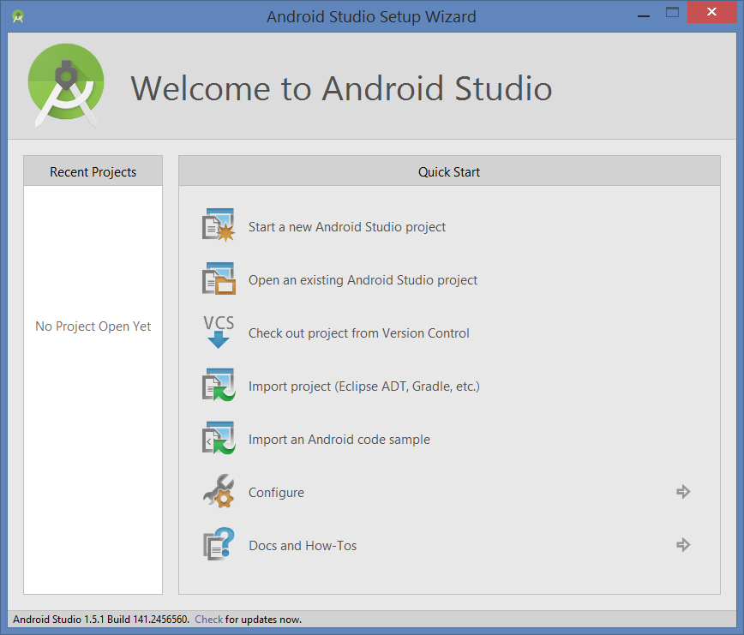
Configure => Update
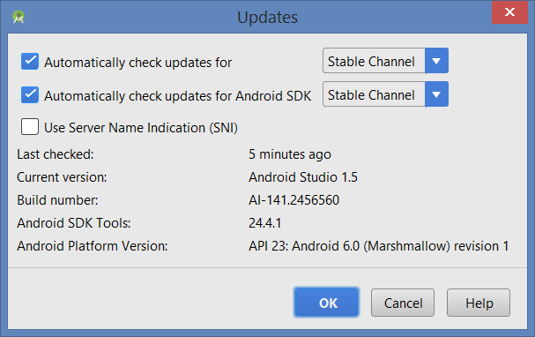
Click Update
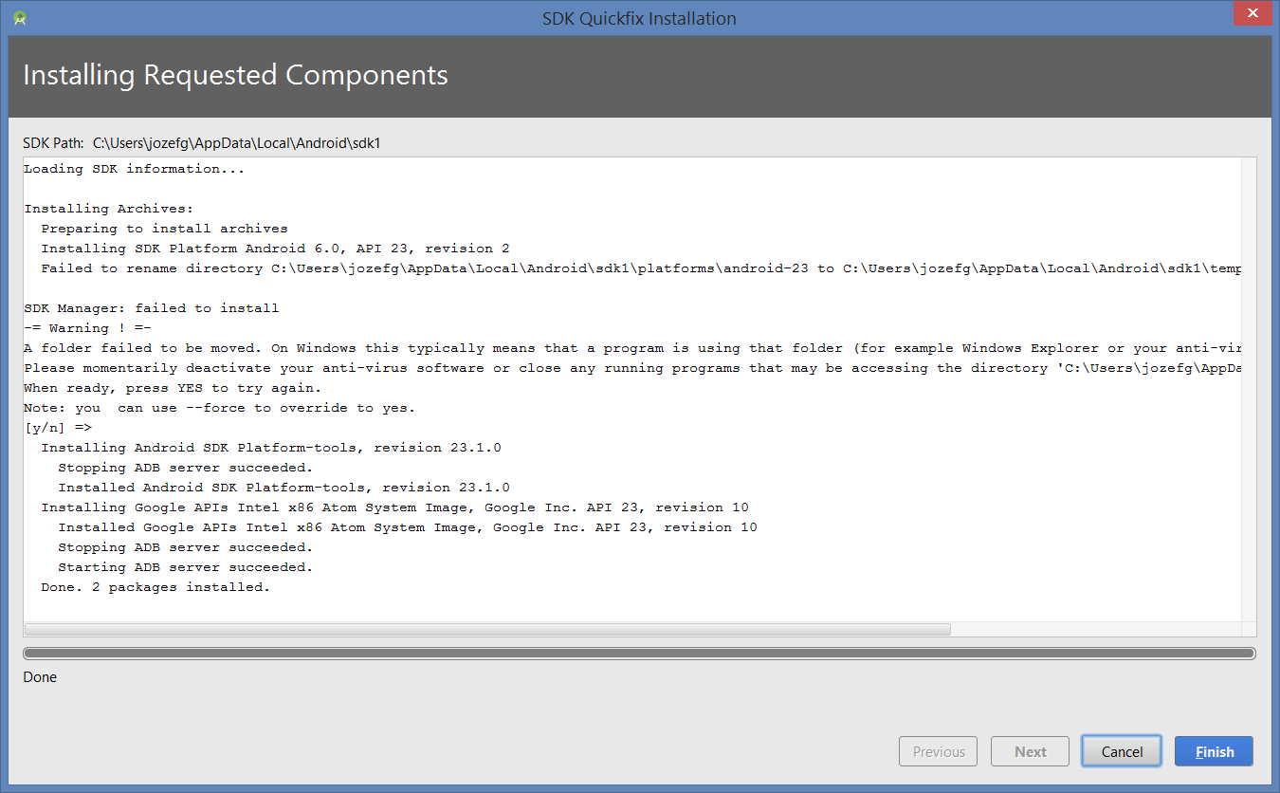
the above right side is:
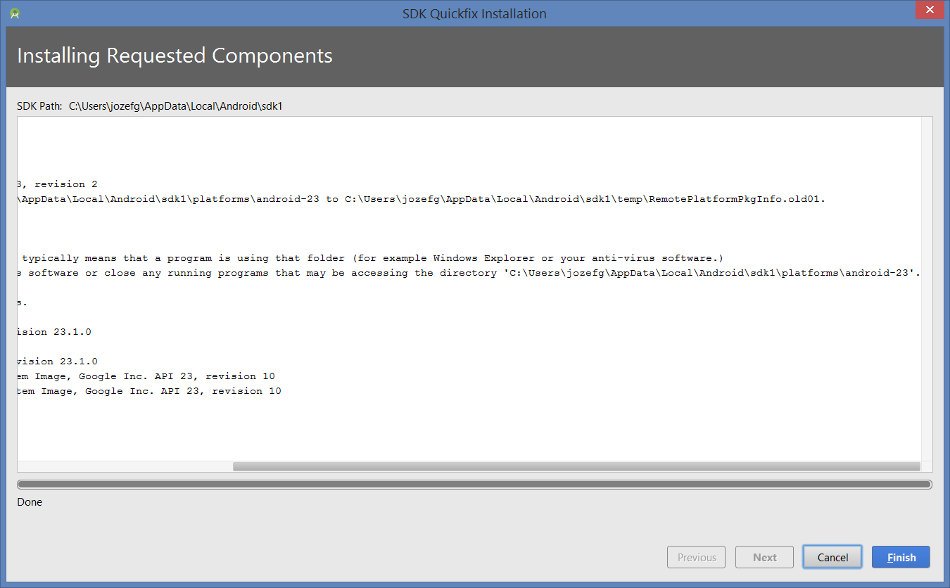
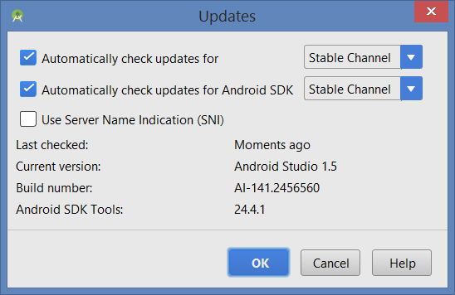]
After installation Android VirtDevice Nexus 6 API 25:
C:\Users\jozefg\AppData\Local\Android\sdk1\tools\emulator.exe -netdelay none -netspeed full -avd Nexus_6_API_23
emulator: ERROR: x86 emulation currently requires hardware acceleration!
Please ensure Intel HAXM is properly installed and usable.
CPU acceleration status: HAX kernel module is not installed!
[all info below is based on https://www.youtube.com/watch?v=Z7xoPCv3sYs :
Go and run Android SDK Manager from the directory in the title below:
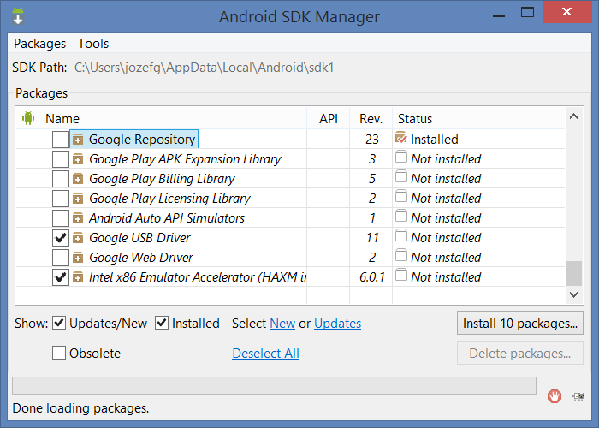
Go to Hardware_Accelerated_Execution_Manager
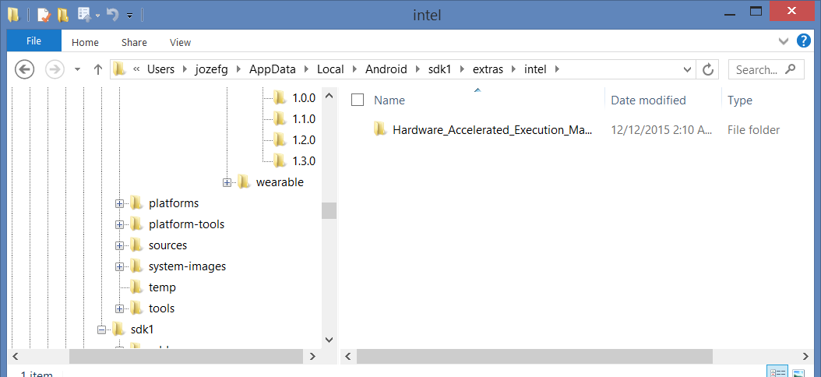
and run by double clicking intelhaxm-android.exe
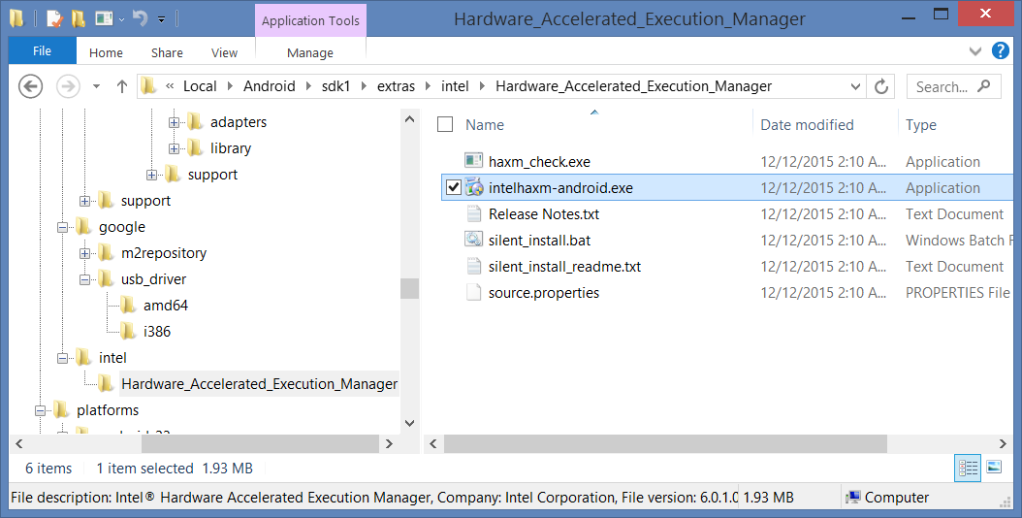
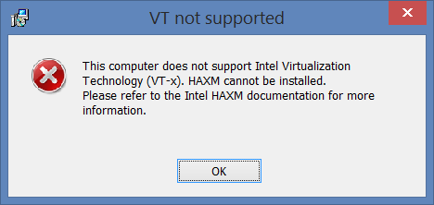
To fix it go to:
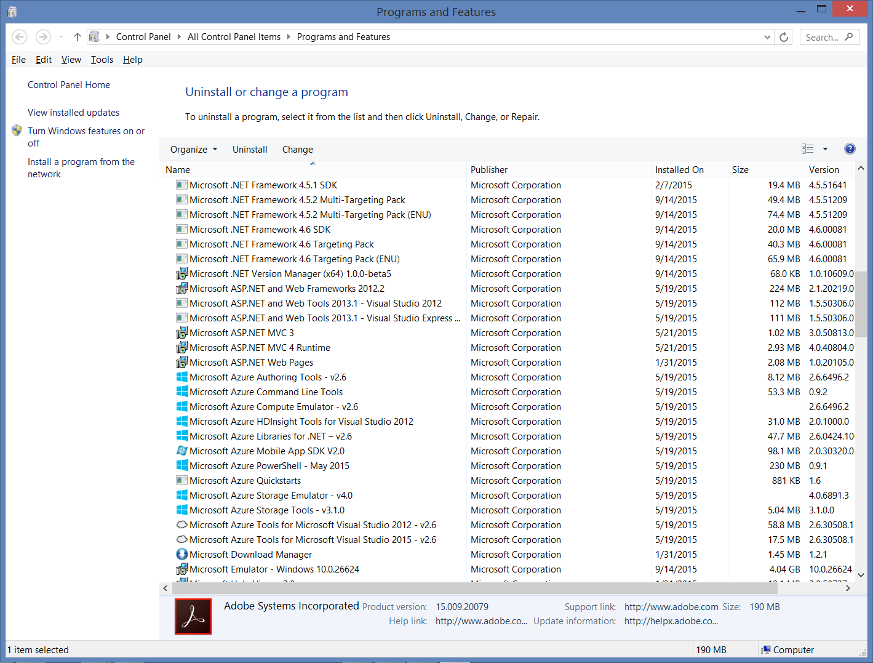
click on “Turn Windows features on or of” => uncheck Hyper-V
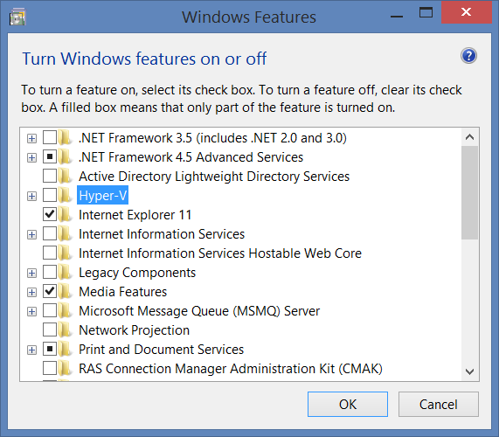
Go back and run intelhaxm-android.exe and leave default RAM memory (2 GB here).
Now, go to AVD manager of Android Studio => Nexus 6 => edit button => Show Advanced Settings => set up RAM 2 GB.
Now from Android Studio: click blue icon >at the toolbar to run
The fix is successful, all TipCalculator is running.

