Step 1:
Open the Android Studio, go to Build -> Build APK. Then the apk file will be generated.
It will pop up a success message, through it you can access the output folder which includes the apk file. (the folder name may vary according to the different version of Android Studio)

When we redo the whole project from the beginning, then there should be no problem in the step 1. If we use the code from the book, perhaps we need to update the gradle or sdk version. After update, it should work.
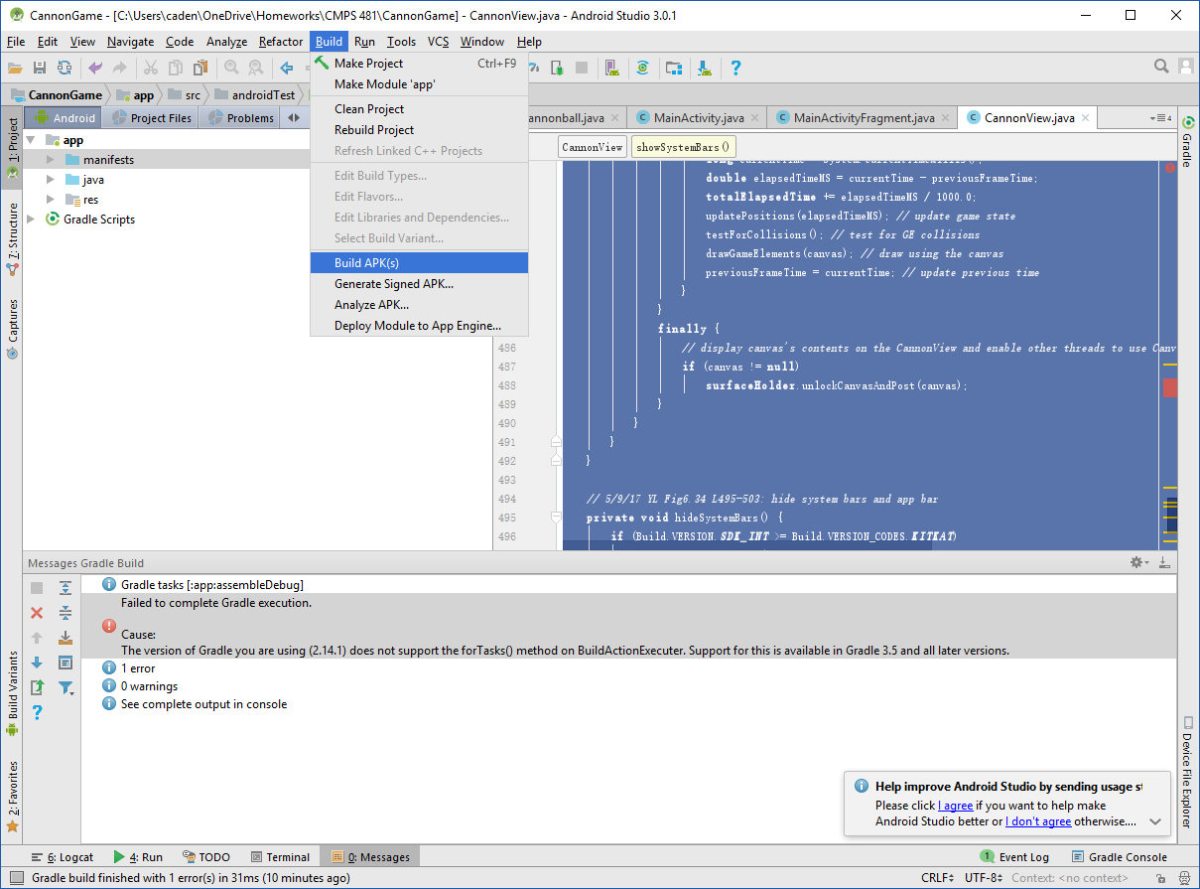
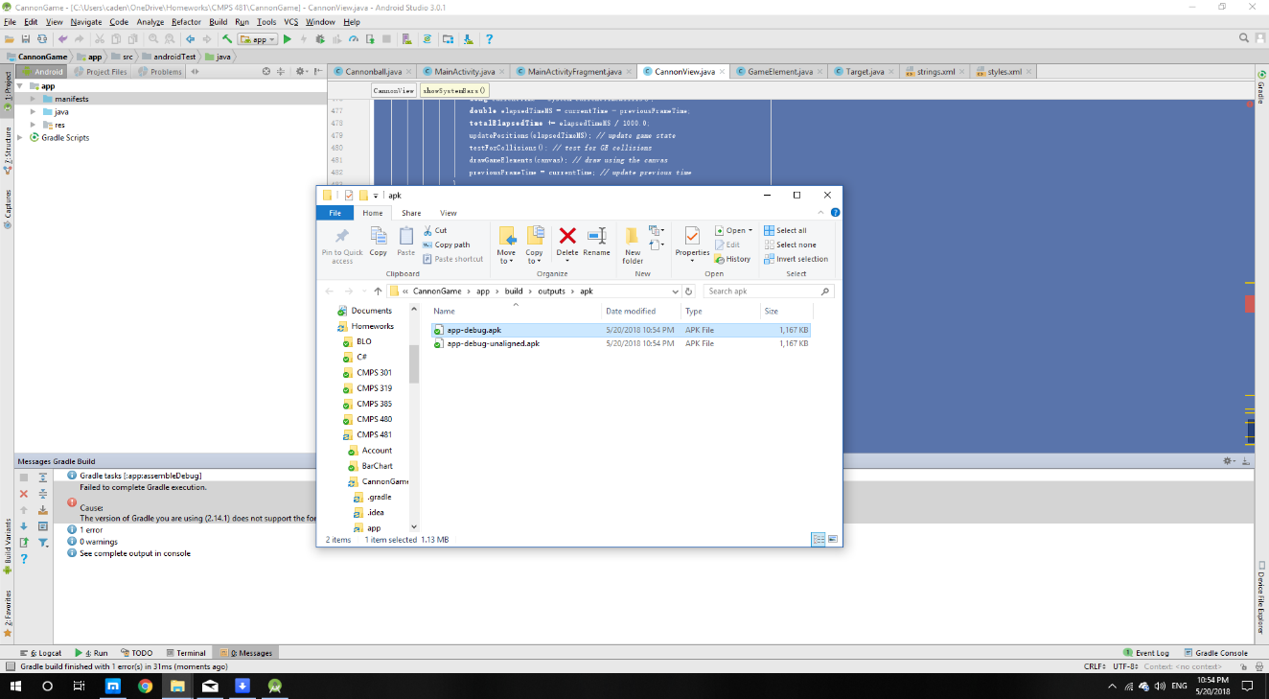
After we generate .apk file, we will copy the file into our Android Phone.
Step 2:
Connect our phone and computer using USB cable.
Step 3:
On the laptop/workstation:
- Open the external storage device. There should be a folder (directory) called download in the device
- Copy the APK file into the download folder
- Disconnect (unmount) the external storage device

Step 4. Install File Explorer on your Android phone if you don’t have it.
Some phone comes with built-in File Explorer, if not, we have to download one from Google Play. Recommend is the ES File Explorer.
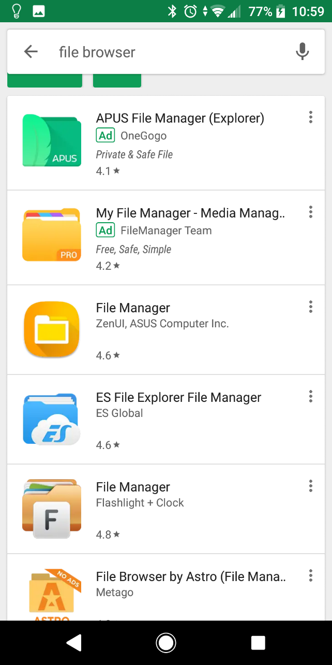

Step 5: In the File Explorer click on APP then find the .apk file you have copied before. Go to the menu (the left upper icon). Navigate into the download folder. Select tap the .apk file. Then select install.

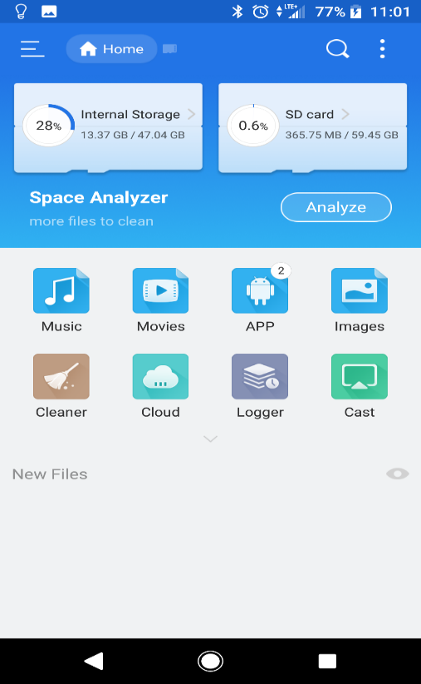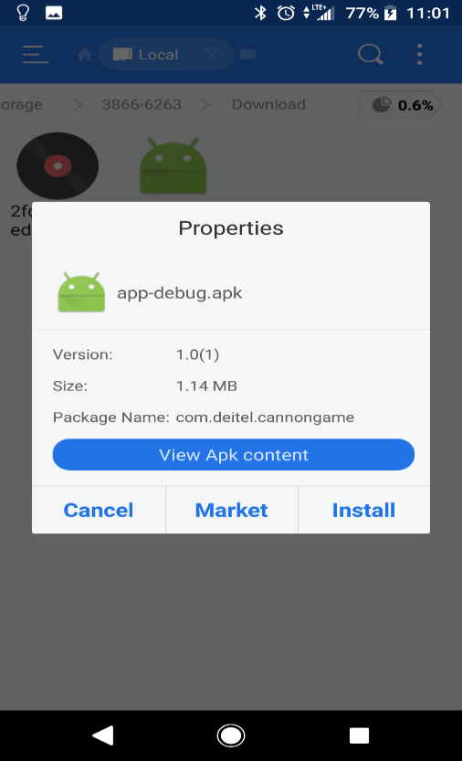

For some phones, we might need to allow the installation from unknown source.
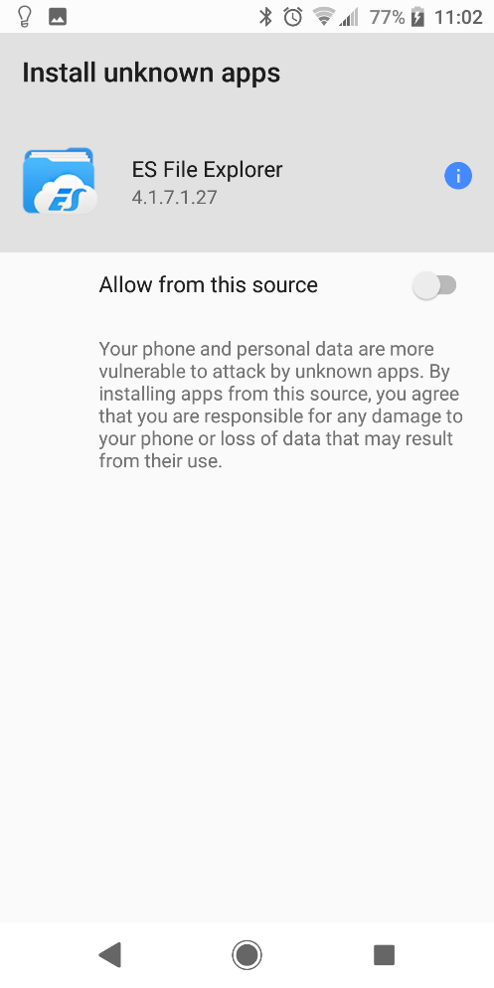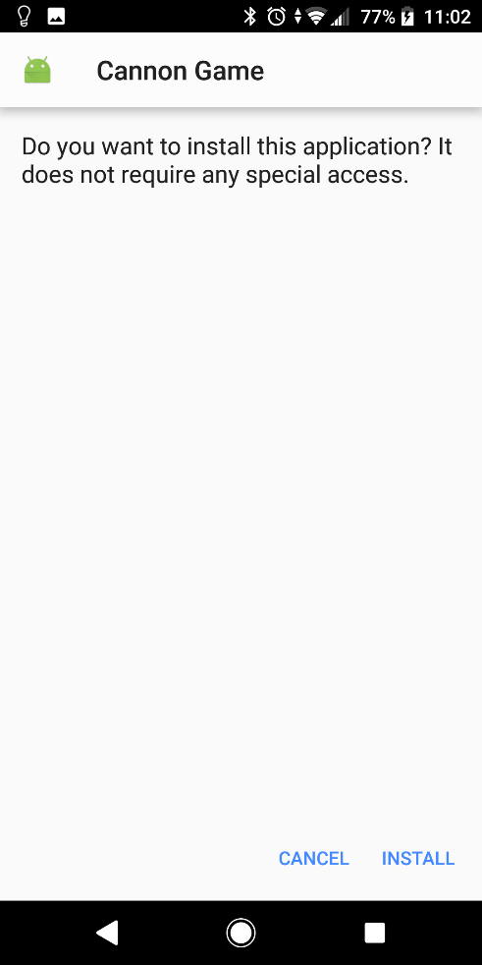
Finally, we have it on our phone.
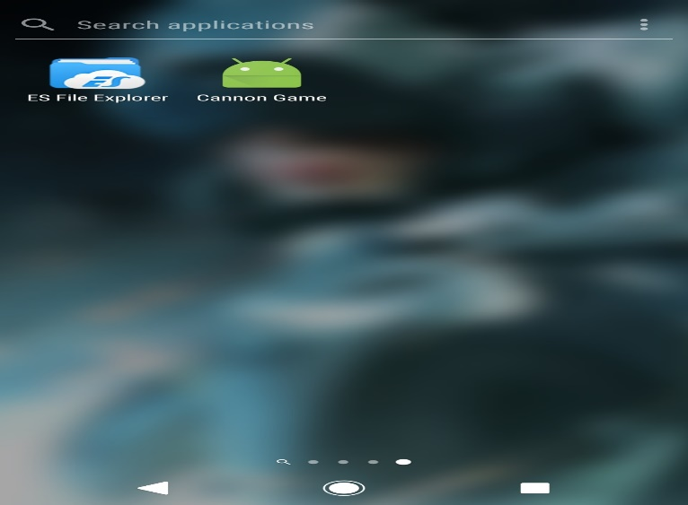
More details: http://developer.servalproject.org/dokuwiki/doku.php?id=content:android:tips:install_apk
More details: http://developer.servalproject.org/dokuwiki/doku.php?id=content:android:tips:install_apk

